**Hopi Health Care Center**

**Polacca, Arizona**

**Laboratory Department**

**POC Testing Procedure**

|  |  |  |  |
| --- | --- | --- | --- |
| **Title: Electronic Health Record POC Lab Entry Button for Entering Point of Care Test Results**  **Procedure** | | | |
| **Responsible Person: Kendrick Fritz, Laboratory Supervisor** | | | |
| **Standards/Regulations:** | | | |
| **Distribution: ED/UC, IPU, OPD and Laboratory** | | | |
| **Original Effective Date:**  **03/2014** | **Reviewed/Revised:**  **02/2018** | **Review Interval:**  Annual | **Due for Review:**  **02/2019** |
| **HHCC Website: Chapter: Departmental Policies and Procedures**  **Folder: Laboratory** | | | |

PURPOSE:

The point of care (CLIA-waived) testing staff will follow this procedure to ensure that test results are entered correctly under the right patient name, chart number, location of service and the ordering medical provider for timely result review.

PROCEDURE:

Log into EHR:

1. Select patient, visit, and enter the primary provider (highlighted red) and yourself as another provider.

2. After performing point of care laboratory testing, click on the POC Lab Entry button to open up the **Lab Point of Care Data Entry Form**.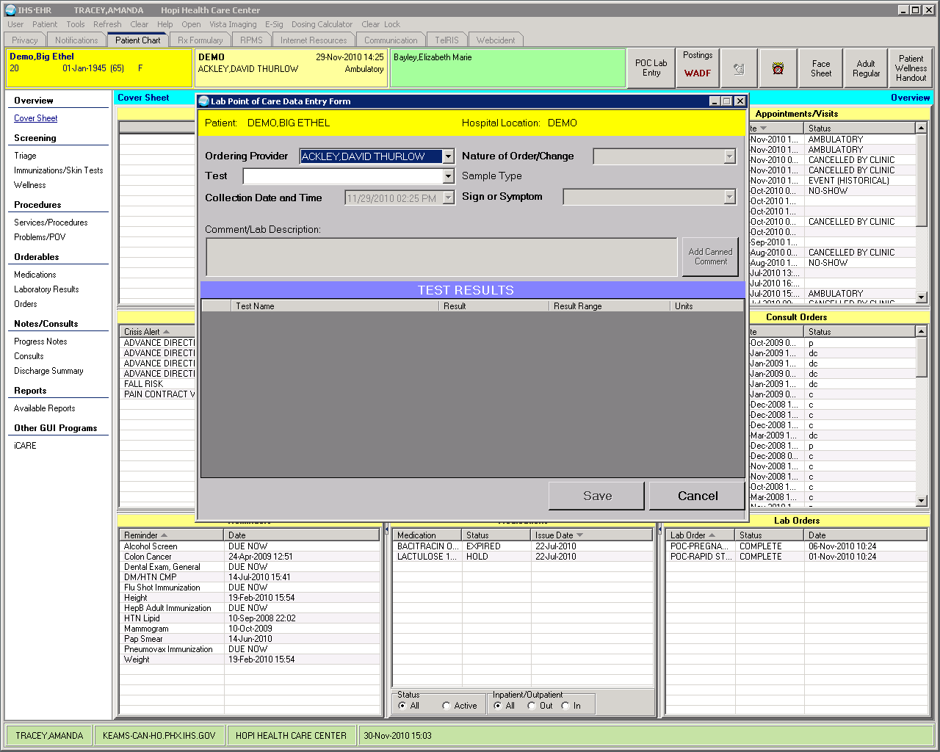

3. The **Lab Point of Care Data Entry Form** will appear, select the ordering provider from the drop down list.

4. Select POC test by selecting drop down arrow.

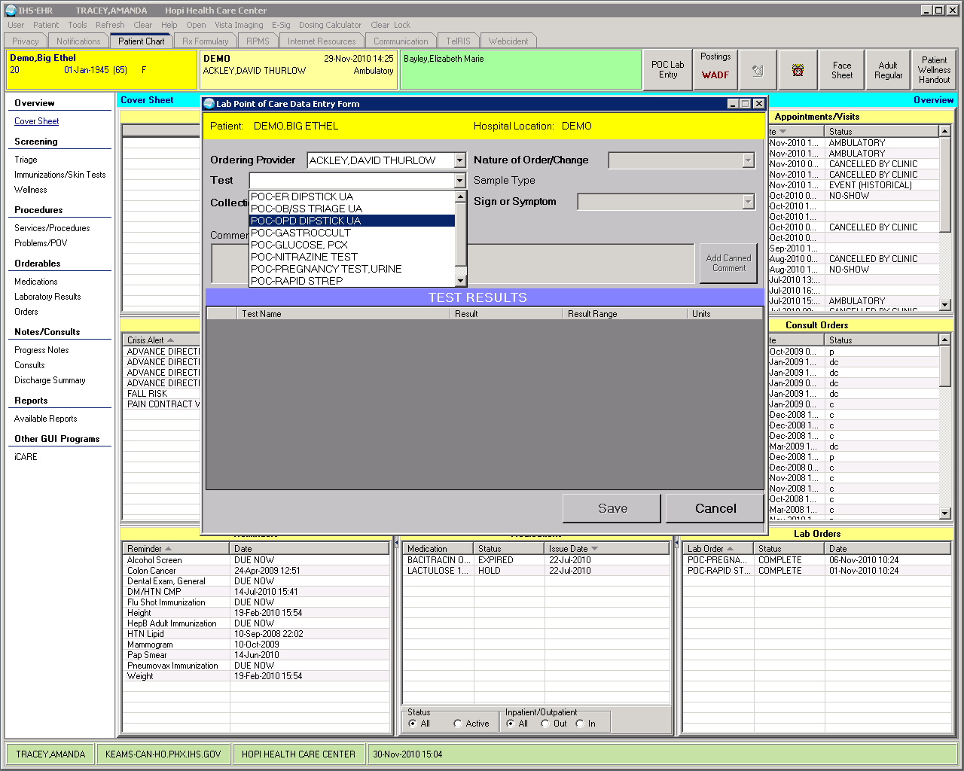

4. The **TEST RESULTS** box will open up. The **Nature of Order/Change** will default to “WRITTEN”.

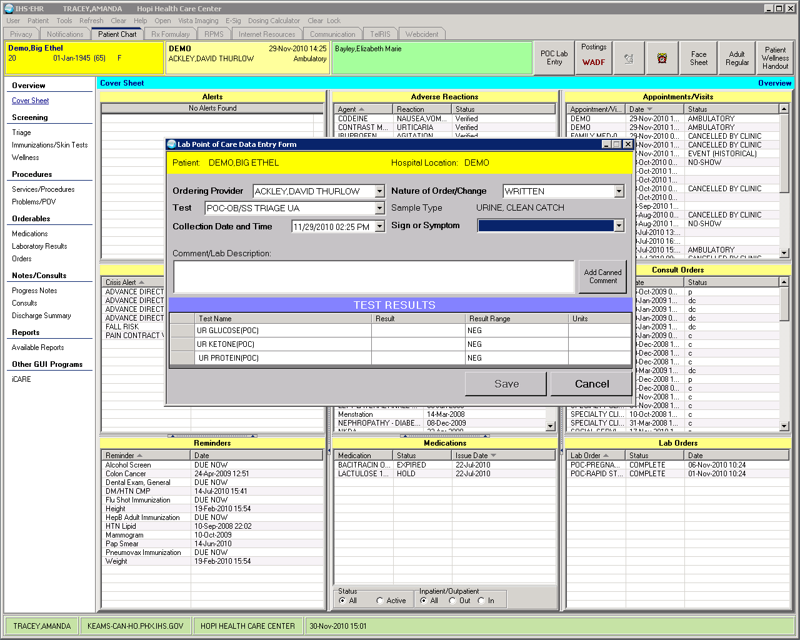

5. Enter the correct date and time the specimen was collected using the **Collection Date and Time box** by clicking on the drop down arrow. The current date and time will display. Enter the correct time by highlighting the time and free-texting time or use the arrow button to move the hour and minute.

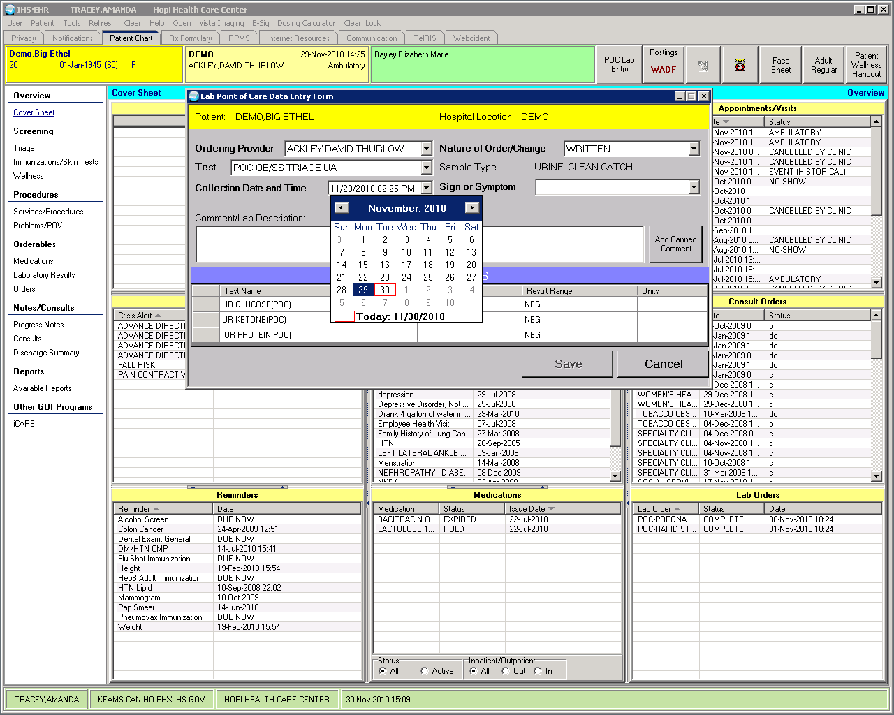

6. Next, enter the Sign or Symptom for the test selected by clicking on the drop down arrow. It may be necessary to add a new one not on the list by selecting Other… Another box titled **Lab Point of Care “Other Sign or Symptom” Entry** will open up.

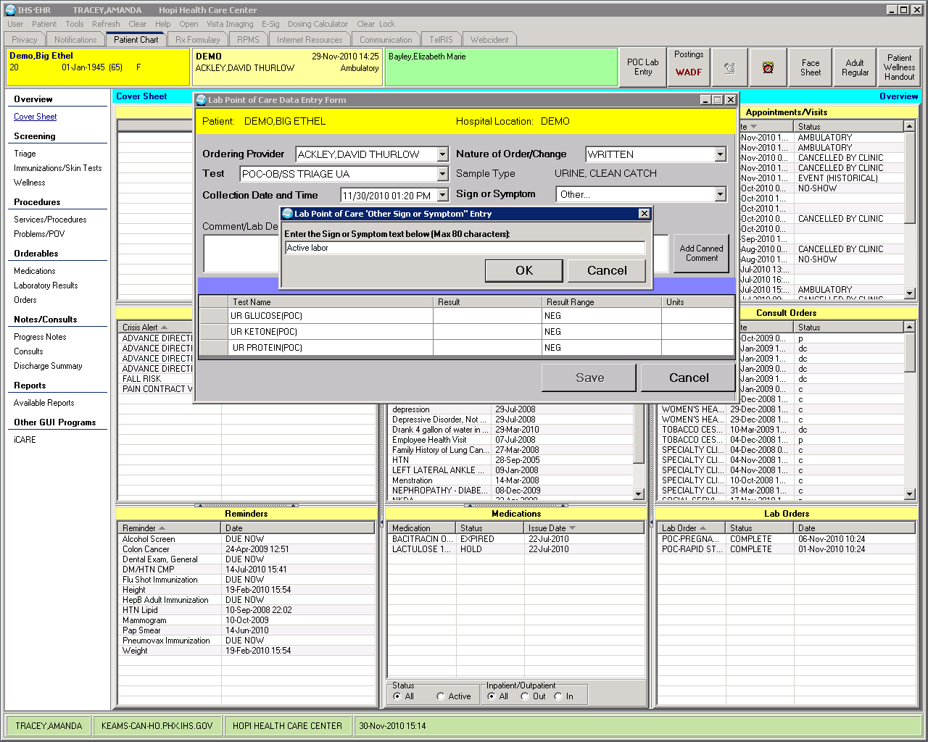

7. Free text the sign or symptom and click on the OK button to save.

8. Go to the **TEST RESULTS** box and enter the lab results in the appropriate column. If necessary, click on the Tab button to navigate through the data entry form.

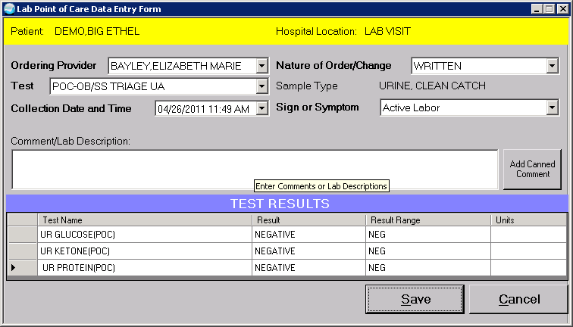

9. Enter appropriate comments in the Comment/Lab Description section by clicking on the “Add Canned Comment” button.

a. The “Choose a Lab Comment” box opens and displays your choices.

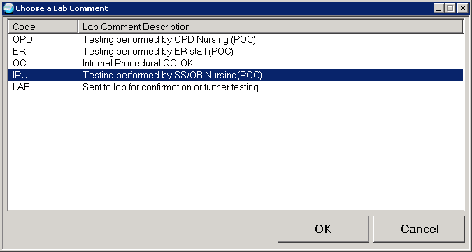

1. Click on your selection to add the lab comment description to the comment section and click on the OK button to save.
2. If need to add another comment, repeat above steps.

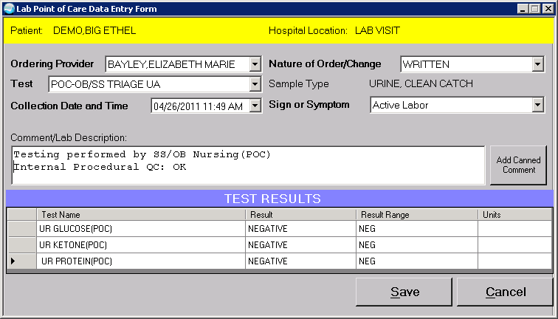

1. **NOTE:** For POC tests performed with devices containing an internal QC or performance area, the comment “QC” must also be added to the comment section. This includes the following tests: Rapid Strep, Pregnancy, Gastroccult and Fecal Occult Blood.

d. When documentation is complete, click on the **Save** button.

e. The result is now in RPMS lab and can be accessed as needed.

HOW TO REPORT “WRONG RESULT ENTERED”:

If the result was entered incorrectly in the RIGHT patient chart number:

* + - 1. When an error is discovered in that the wrong result was entered, but the result was saved, then the POC testing staff will re-enter the electronic chart and create a new visit but this time enter the correct test result and in the CANNED COMMENT field, type in “Previous Result is Incorrect. Please disregard. This result is correct.”
      2. Notify the Laboratory POC Coordinator, Laboratory Supervisor or designee to edit the wrong result and cancel/remove those results with documentation to the ordering medical provider the reason for the test cancellation in the comment field.

If the result was entered incorrectly in the WRONG patient chart number:

1. When an error is discovered in that the result was entered under the WRONG patient electronic chart, the POC testing staff will write down the name of the wrong patient name and chart number and the result that was entered.
2. The POC testing staff will pull up the RIGHT patient electronic chart, order and enter the test result correctly and save the information. No information is typed into the COMMENT section.
3. Take the paper with the wrong patient chart information and give to the Laboratory POC Coordinator, Laboratory Supervisor or designee to edit the wrong result and cancel/remove those results with documentation of reason for the test cancellation in the comment field.

THIS POLICY AND PROCEDURE REVIEWED AND APPROVED BY THE FOLLOWING:

______________________________________________________________________________

Kendrick Fritz, Laboratory Supervisor Date