UW Medicine - Pathology

6000-01-03-03

Weekend Specimen Accessioning Procedure

Adopted Date:7/23/2010
Review Date:
Revision Date:04/13/11

PURPOSE
Residents will use this shortened specimen accessioning procedure over the weekend to facilitate grossing in cases.

PROCEDURE
Materials:
- Gloves
- Lab Coat or Vinyl apron and sleeve protectors
- Eye protection
- Specimen
- PCR Requisition
- Power Path Application
- Scanner

Procedure:
Personal Protective Equipment must be worn at all times when handling specimen samples!

1. Type su under Accession no, then tab, tab.
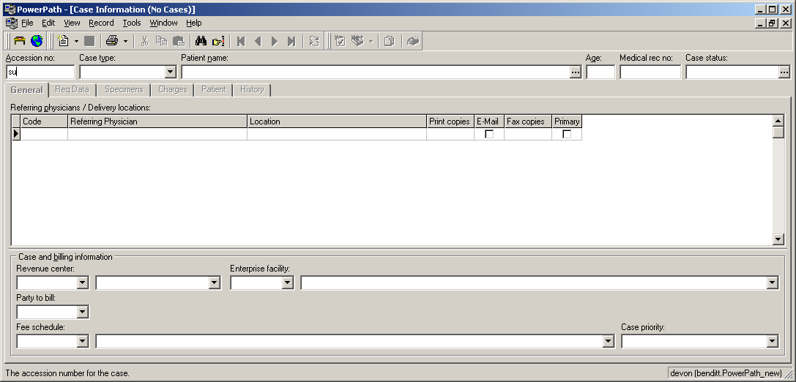

2. Type in the Patient’s U# under medical record no. Then Enter, Enter, Enter.
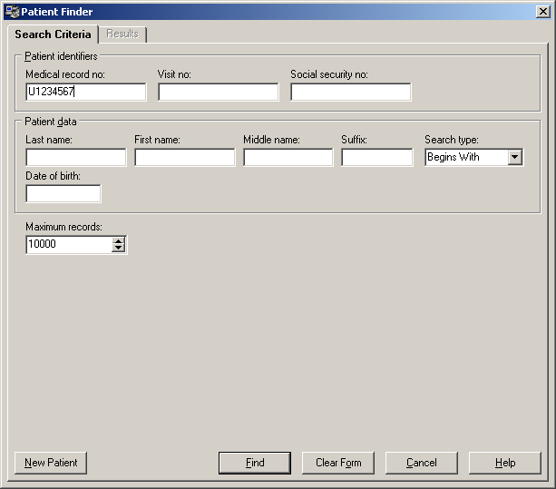

Concurrent case notification might pop up. If it does verify that the case does not already have a number. Otherwise ignore and hit OK.
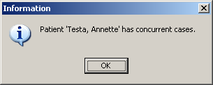

3. *Verify the Patient’s name in PowerPath matches specimen labels and paperwork*
Under General Tab: Enter Referring physician Code 009000, then tab.
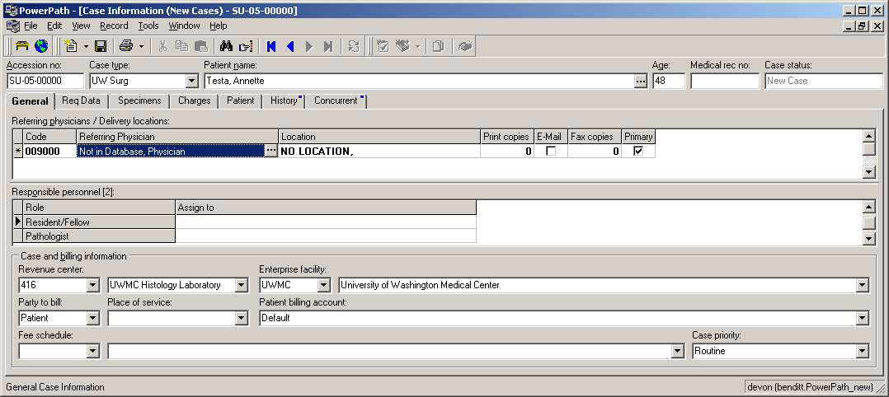

4. Under Specimens Tab: Enter in specimen code spec, then tab.
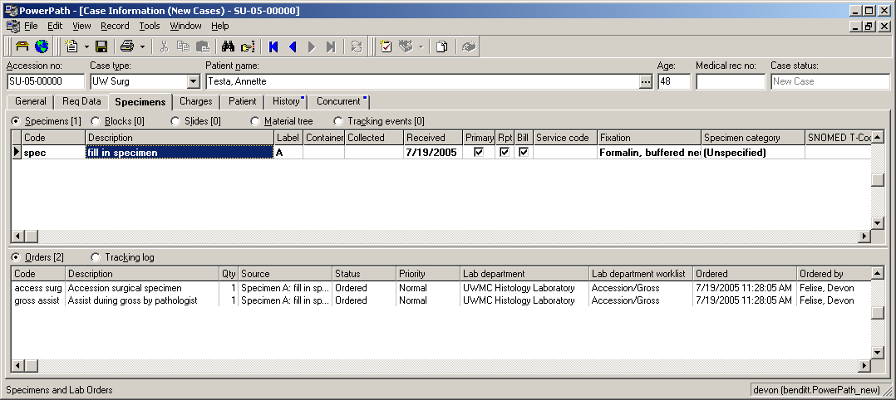

5. **SAVE CASE: Hit F10 to save case and generate number**
- Write case number on Paperwork
- Leave specimens, paper work and empty containers on desk with unaccessioned cases.
- Place a note on the specimen alerting the support staff that the case was accessioned by a resident.

Written By: Director Approval:
(Signature and Date) (Signature and Date)

_______________________ ___________________________

