UW Medicine - Pathology

6000-01-03-09
Accessioning UWMC Research Cases Procedure

Adopted Date: 10/23/08
Review Date: 06/22/09
Revision Date: 04/05/11

PURPOSE
This procedure provides instructions for accessioning research cases when needed to obtain an accession number for UWMC. Research cases are most often accessioned by the Research Coordinator and orders are entered before bringing into Histology. In the absence of the Research Coordinator, cases can be accessioned by Histology staff as needed.

SCOPE
Histology staff working on cases for research purposes

PROCEDURE
- Open PowerPath and click on the “cases” icon. A blank “Case Information” screen will open.
- In the Accession Number box, enter “RU” accession prefix and press tab.
- The “Case Type” window will now have the default “UW Research” in it., Press tab.
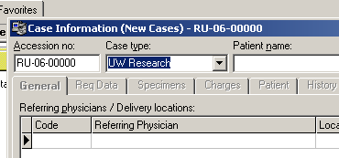

- The “Patient Finder” window will open and the cursor will be in Medical Record Number box. Enter the Registration Number (ex: R123) from the research Work Order and Click on "Find" at the bottom of the screen. If the number is accepted the next window to open will be a list of prior cases by that researcher. Choose the one most current, with the same contact person, and with a "Y" in the last column (if possible), but any choice will do. If the pop-up box indicates that there is no "patient" by this name, enter YES to create a "New Patient". 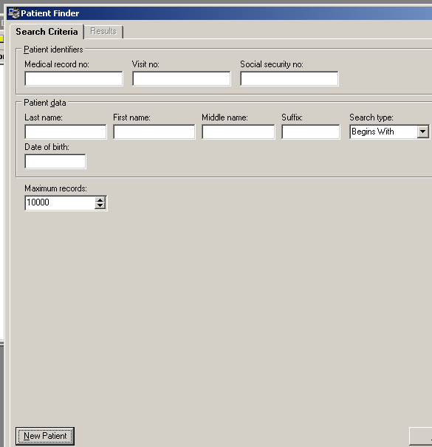
- In the Patient Information screen, the required fields are patient name, DOB and sex. Under last name, enter the principle investigator’s name. Under first name, enter the name of the person who submitted the request or the research coordinator’s name. Under sex, choose unspecified. Under date, enter today’s date. The number in the Medical Record box after the Registration number should always be RESEARCH 1 with "RES 1" appearing after it. Click on "OK" at the bottom of the screen.
- If a message appears stating that this number is not valid for this facility, go to the Medical Record Number box, click on you will have to change from the default “University of Washington Medical Center” to “RESEARCH 1" with "RES 1" after it.
- Click “OK” and the next screen to appear will be the “Case Information” screen.
- Press tab to move to the “Referring Physician” box. If there is no Anatomic Pathology Pathologist listed on the requisition associated with the request, click in the box to the left “code” and enter 009000 and you will get “physician not in database.
- The “responsible personnel, assigned to” box will be filled in with “ZZ Research Case, LS”.
- Press Alt B” to move to the billing section. The field “Party to Bill” should be “client”.
- In the box “client billing account” enter the Budget Number (if provided).
- In the box “Fee Schedule” choose “U Research”.
- Press Ctrl Tab to move to the Req Data screen. There are 3 mandatory fileds to be filled” “Type of Case’, “Accessioned At” and Order Station #.
Type of Case = Research
Accessioned At = UWMC
Order Station # = 799 OHP; this puts the patient name field on the bill as an identifier
- Press “Ctrl Tab” to move to the “Specimen” screen. Tab down to the “specimen code” field. For most research specimens, you will use the generic code “Histo Res #”. The "#" should be the number of parts in the Work Order. Press F10 to save the information and generate a case number. You can then enter the researcher’s case number onto “description” field.
- If there are multiple samples on the same patient, arrow down and repeat step 16.
- Use “Ctrl O” to order any lab procedures.
- Press F10 to save the record.

REFERENCES
Weekend Specimen Accessioning procedure, 6000-01-03-03

Written By: Director Approval:
(Signature and Date) (Signature and Date)

_______________________ ________________________
Supervisor / Manager

