UW Medicine - Pathology

100-02-01-09

Correcting Erroneously Accessioned Cases Procedure

Adopted Date: 06/07/02
Revision Date:

PURPOSE
To standardize the process of correcting erroneously accessioned cases in PowerPath.

SCOPE
For all department personnel involved in any step of accessioning, ordering or reporting in PowerPath.

PROCEDURE
- If the case is not finalized:
  - And was accessioned in error due to double accessioning, no specimen received, should not have been accessioned (e.g. verbal pathologist review, research cases), etc., submit a Clinical Admin Request System (CARS) request that the case was accessioned in error giving the reason for the error.

  - The responsible party for claiming the request will sign out the case with the comment on the Results tab:
***************************************************************
This case was accessioned in error in Pathology. Please ignore this report.
****************************************************************

  - In all other circumstances (e.g. wrong patient name, middle initial, MRN, date of birth, referring physician's name or information, specimen collection or received date) , correct as needed.

- If the case has been finalized (signed out):
  - Refer to the Addendum and Amendment Reports in PowerPath Procedure 100-02-01-07, and submit a CARS request.

For non-CG cases, the following comment should be entered on the report:
***************************************************************
Patient demographic information (list what was changed, e.g. Medical Record Number, patient name, etc.) was corrected. There is no change to the diagnosis or the original report.
****************************************************************

For CG cases, select the category "COMMENTS" in the dictionary tab of the resulting screen, open the "Amendment/Addendum Comments" folder and choose the following finding:
***************************************************************
CORRECTION:
Patient demographic information (list what was changed, e.g. Medical Record Number, patient name, etc.) was corrected. There is no change to the diagnosis or the original report.
****************************************************************

- To ensure the proper patient is billed, contact the coding supervisor if the case has been billed before the correction is made.

- For questions regarding this process, contact Pathology Computer Support by submitting a tech request through the Tech Request Database in InQ.

UWMC Pathology Chief of Service: HMC Pathology Chief of Service:
(Signature and Date) (Signature and Date)
5/22/13 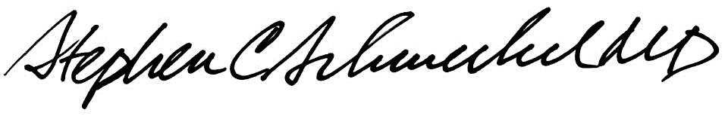5/22/13
____________________________ ___________________________
Suzanne Dintzis, MD, PhD Stephen Schmechel, MD, PhD

Written by: Revised by:
(Signature and Date) (Signature and Date)

_________________________ _________________________

