UW Medicine - Pathology

100-02-01-19

Reporting and Tracking of Mislabeling Events Procedure

Adopted Date: 01/23/12
Revised Date:

PURPOSE
To ensure that proper tracking and reporting occurs for all mislabeled blocks and slides.

SCOPE
QA Manager

PROCEDURE
- Reporting and Tracking of Mislabeling Events:
The QA Manager will run the specimen adequacy report, listed as Internal Lab Mislabeling, from PowerPath on a monthly basis and will report out the number of slides and blocks mislabeling events at the monthly QA meeting(s). Additionally, the final A3 document is to be saved in the S:Drive/QA Event Folder/Block and Slide Mislabeling. This location will act as the central location for future reference and/or CAP inspection requests.

- Root Cause Analysis of Block and Slide Mislabeling with Feedback Process:
All submitted A3's are to be reviewed with the Histology Supervisor to identify mislabeling trends or needs for additional countermeasures.

RELATED DOCUMENT
Correcting Block and Slide Mislabeling Procedure; 600-09-01-02 / 6000-02-07-13

UWMC Pathology Chief of Service: HMC Pathology Chief of Service:
(Signature and Date) (Signature and Date)
5/22/13 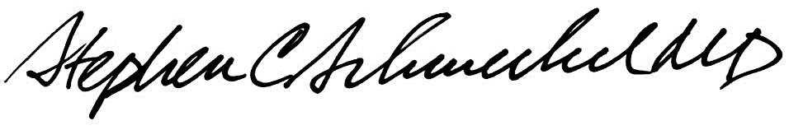5/22/13
____________________________ ___________________________
Suzanne Dintzis, MD, PhD Stephen Schmechel, MD, PhD

Written by: Revised by:
(Signature and Date) (Signature and Date)

Kim Simmons________________

