UW Medicine – Pathology

100-02-01-22

Specimen Rejection Procedure

Adopted Date: 05/06/11
Revision Date:

PURPOSE
To ensure that all unlabeled and/or mislabeled specimens are handled in accordance with the UWMC and HMC Administrative policies and procedures on Labeling Requirements and Handling of Mislabeled Specimens.

DEFINITIONS
Unlabeled Specimen:
- Specimen with no patient identifiers (i.e. patient name, patient medical record number) / specimen that has not been labeled.
Mislabeled Specimen:
- Specimen that has not been labeled with two patient identifiers.
- Specimen labeled with a patient name and/or medical record number that differ from those on the accompanying laboratory request form.
- Specimen labeled with a wrong name and/or medical record number / date of birth.

PROCEDURE
  - Notify supervisor of mislabeled / unlabeled specimen immediately.
  - Supervisor is to ensure that the procedure for relabeling specimens outlined in UWMC APOP Policy 65-4 / HMC APOP 65.1 (depending on originating institution) is followed for specimens deemed as impossible for repeat collection.

REFERENCE
- UWMC APOP Policy 65-4: Labeling Requirements for Laboratory Specimens and Handling of Mislabeled Specimens
https://uwmc.uwmedicine.org/sites/PoliciesProcedures/apop/Pages/65-4.aspx

- HMC APOP 65.1: Laboratory Specimens, Mislabeling
https://hmc.uwmedicine.org/PolicyProcedure/Pages/LABORATORYSPECIMENS,MISLABELED651.aspx

UWMC Pathology Chief of Service: HMC Pathology Chief of Service:
(Signature and Date) (Signature and Date)
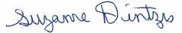6/4/13 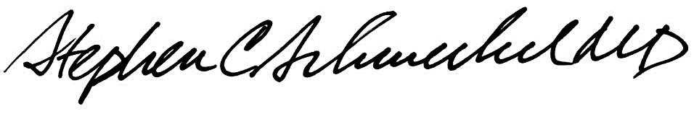6/4/13
____________________________ ___________________________
Suzanne Dintzis, MD, PhD Stephen Schmechel, MD, PhD

Written by: Revised by:
(Signature and Date) (Signature and Date)

Kim Simmons 05/06/2011_______ _________________________

