UW Medicine - Pathology

100-03-01-04

Annual Required Training Policy

Adopted Date: 05/23/11
Revision Date:

PURPOSE
To comply with the UW Medicine and UW Medicine Pathology's required training.

SCOPE
All department personnel

POLICY
All Pathology personnel will complete annual required training within the timeline set by Pathology Administration.

UWMC Pathology Chief of Service: HMC Pathology Chief of Service:
(Signature and Date) (Signature and Date)

5/23/13 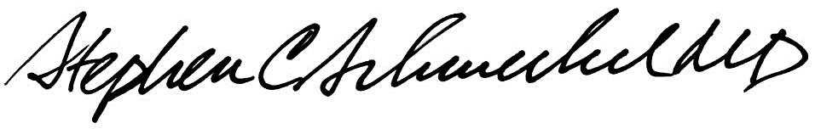5/23/13
____________________________ ___________________________
Suzanne Dintzis, MD, PhD Stephen Schmechel, MD, PhD

Written by: Revised by:
(Signature and Date) (Signature and Date)

_________________________ _________________________

