UW Medicine - Pathology

100-03-01-06
Laboratory Water QC Procedure

Adopted Date: 08/09/11
Revision Date:

PURPOSE
To ensure that CLWR standards for water quality and frequency of testing are being adhered to by all laboratories. And that in the event of quality issues corrective action will be taken by laboratory personnel.

SCOPE
All laboratories that utilize water in their testing protocols.

PROCEDURE
Water quality testing will take place once per month, either by the specific laboratory or by the property management company. Testing is to measure resistivity and microbiology cultures, and at the discretion of the laboratory can include pH, endotoxin/pyrogens, silicates and organic contaminates.

The CLWR Standards are:
Maximum Mircobial Content (CFU/ml) | 10
Minimum Resistivity (megohm-cm) | 10 (in-line)
Particulate Matter | 0.22 um filter

If the quality does not meet the standards listed above, another test must be done immediately. If the second test fails, laboratory supervisors are to contact Operations and Maintenance (UWMC) / Property Management (HMC) to have the filters changed. In the interim, laboratory personnel are to make arrangements to aquire water that meets the CLWR standards.

For UWMC, all water testing is completed in Microbiology. All laboratory personnel should follow the guidelines stated by Microbiology for the collection of the water to be tested.

For HMC, all water testing is completed by the property management company. Laboratory personnel are responsible for ensuring that reports are received monthly and that standards are being met.

UWMC Pathology Chief of Service: HMC Pathology Chief of Service:
(Signature and Date) (Signature and Date)

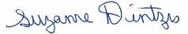5/23/13 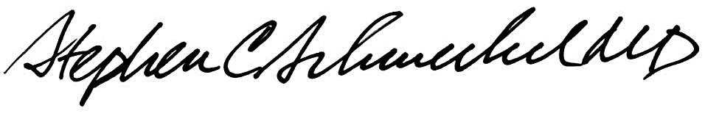5/23/13
____________________________ ___________________________
Suzanne Dintzis, MD, PhD Stephen Schmechel, MD, PhD

Written by: Revised by:
(Signature and Date) (Signature and Date)

_________________________ _________________________

