UW Medicine - Pathology

100-03-01-07
Laboratory Water QC Policy

Adopted Date: 08/09/11
Revision Date: 05/20/13

PURPOSE
To ensure that CLWR standards for water quality and frequency of testing are being adhered to by all laboratories. And that in the event of quality issues corrective action will be taken by laboratory personnel.

SCOPE
All laboratories that utilize water in their testing protocols.

POLICY
All laboratories will monitor their water quality on an annual basis (at the very least) with the minimum monitoring to include resistivity and microbiology cultures. pH, endotoxin/pyrogens, silcates, and organic contaminates are at the discretion of the testing laboratories and should be checked if the laboratory supervisor and director deem it necessary for the quality of testing.

The CLWR Standards are:
Maximum Mircobial Content (CFU/ml) | 10
Minimum Resistivity (megohm-cm) | 10 (in-line)
Particulate Matter | 0.22 um filter

Corrective action will be taken, including but not limited to, filter changes in the event of poor quality water tests. In the event of corrective action processes, viable water options will be arranged for the laboratory.

UWMC Pathology Chief of Service: HMC Pathology Chief of Service:
(Signature and Date) (Signature and Date)

5/23/13 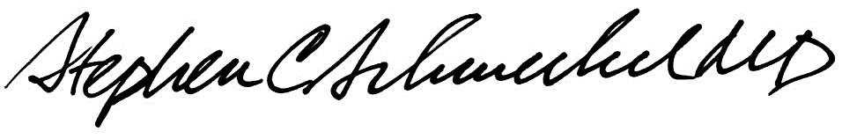5/23/13
____________________________ ___________________________
Suzanne Dintzis, MD, PhD Stephen Schmechel, MD, PhD

Written by: Revised by:
(Signature and Date) (Signature and Date)

_________________________ _________________________

