UW Medicine - Pathology

100-03-01-10
CAP Proficiency Test Receiving and Resulting Procedure

Created Date: 11/30/2012
Review Date:
Revision Date:

PURPOSE
The purpose of this procedure it to ensure CAP Proficiency Testing is delivered in a timely manner to the appropriate Pathologist or Laboratory Supervisor. This procedure also describes how to track CAP surveys from received date through test reporting due date.

Procedure

I. CAP testing chart:

CAP surveys are mailed to UW Pathology multiple times per year. The chart below located in the CAP folder on the “S” drive (S:\CAP\Proficiency Testing) details UWMC Pathology CAP proficiency tests and the month in which they are shipped.

II. CAP survey receipt:

1. Upon arrival of CAP survey in BB220, place package in the designated CAP mailbox
2. Call or email the CAP intake coordinator, contact information located on the CAP mailbox
3. CAP survey is picked up by the CAP intake coordinator and logged in to the CAP test tracking spreadsheet on the “S” drive
4. The person picking up the survey will fill out CAP survey intake form and deliver to the appropriate lab supervisor or pathologist (see CAP intake form on the “S” drive) within one day of receipt
5. The individual laboratory supervisor is responsible for submitting results by the appropriate due date via the CAP website or by fax
6. Faculty support staff members are responsible for ensuring the PIP and NGC PT are submitted to CAP on time
7. CAP requires the attestation statement is signed by the Medical Director or designee. This also must be signed by technologists performing the work
8. Results response forms are returned to UWMC Pathology by CAP several months after result submission. These should be kept by the individual laboratory supervisor in a binder labeled CAP surveys. Any unacceptable or unsatisfactory (defined by CAP) results need to be shared with the Laboratory’s Medical Director and appropriate documentation needs to accompany the results. CAP will ask to see responses to unsatisfactory results during the CAP inspection. The CAP intake form can be used to record discrepant results and responses.
9. Unsatisfactory results and responses should be recorded on the CAP intake form that accompanies each CAP survey. This form will be kept in the CAP binder for each laboratory

III. CAP intake form:
S:\CAP\Proficiency Testing

UWMC Pathology Chief of Service: HMC Pathology Chief of Service:
(Signature and Date) (Signature and Date)

5/23/13 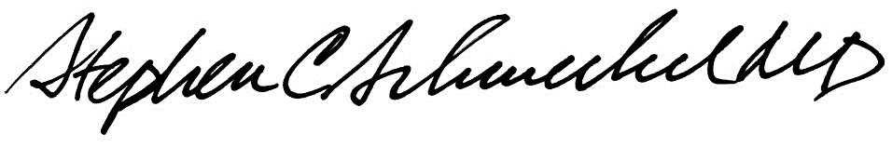5/23/13
____________________________ ___________________________
Suzanne Dintzis, MD, PhD Stephen Schmechel, MD, PhD

Written by: Revised by:
(Signature and Date) (Signature and Date)

_________________________ _________________________

