UW Medicine - Pathology

100-05-01-06

Chemical Spill Management Procedure

Adopted Date: 08/21/95
Revision Date: 05/26/11

PURPOSE
To establish guiedelines for management of hazardous chemical spills (i.e. carcinogenic, teratogenic / mutagenic, flammable, corrosive). For formaldehyde spills, see the Formaldehyde Management Plan (UWMC / HMC) and the Formalin (10% Formaldehyde) Small Spill procedure.

SCOPE
All laboratories and persons who work within the laboratories at any time

PROCEDURE
In the event of a chemical spill, notify supervisor of that laboratory immediately. The supervisor and personnel will access if it is safe to clean the spill based on the classification of minor vs. major spill, the department procedures and the Environmental Health & Safety guidelines.

Minor Spills:
- Minor spills are defined spills that may be easily and safely cleaned by lab staff, and are generally less than or equal to 1 cup.
- If staff is able to clean the spill safely, staff is to automatically respond to the spill as outlined below.
  - Evacuate staff from immediate area of the spill.
  - If concerned about fumes circulating through the ventilation system contact Environmental Health and Safety (UWMC @ 543-0467) or Wright Runstadt property management (HMC @ x4-6526).
  - Put proper safety equipment on before cleaning up the spill (e.g. gloves, eye shield, and shoe protectors - if desired).
  - Refer to MSDS in MyChem - in the Inventory List, for specific chemical instructions.
  - Apply appropriate pads / neutralizing agent to the spill. Spill kits are located in all laboratories.
  - Wait approximately 15 minutes or until fumes have cleared.
  - Remove pads / neutralizing agent and discard in appropriate manner. Contact EH&S for disposal.
  - If appropriate, clean remainder of spill using a mop.
  - Complete an incident report using Patient Safety Net (PSN).

Major Spills:
- Major spills are defined as spills too large or hazardous to clean up safely, and are generally greater or equal to 1 cup.
- In the event of a major spill, staff are to automatically respond to the spill as outlined below:
  - Evacuate all personnel from the immediate area of the spill.
  - Contact the following to report the spill:
    - HMC
      - 911
      - Wright Runstadt property management at x4-6526
      - HMC Safety Office at x4-7244
      - Laboratory Supervisor / Manager
    - UWMC
      - 222 (report a code Orange - internal)
      - Environmental Health & Safety (543-0467)
      - Laboratory Supervisor / Manager
  - Designate a point person to communicate with emergency personnel and property management.
  - Remain on the floor and wait for further instructions from supervisor / manager and/or emergency responders.
  - Emergency wardens / available staff need to check all laboratory rooms and ensure all staff in lab suites is safe and aware of the situation.

Spill Preparedness:
All laboratories / areas that receive or process specimens are expected to have spill kits and any other necessary safety supplies for spill response stocked at all times.

REFERENCE
Formaldehyde Management Plan - UWMC, 100-05-01-07
Formaldehyde Management Plan - HMC, 100-05-01-08
Formalin (10% Formaldehyde) Small Spill procedure,

UWMC Pathology Chief of Service: HMC Pathology Chief of Service:
(Signature and Date) (Signature and Date)
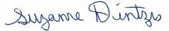5/24/13 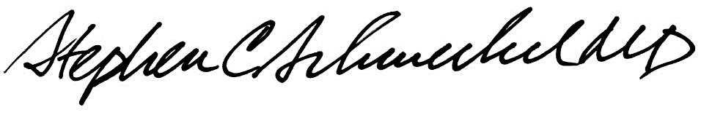5/24/13
____________________________ ___________________________
Suzanne Dintzis, MD, PhD Stephen Schmechel, MD, PhD

Written by: Revised by:
(Signature and Date) (Signature and Date)

_________________________ _________________________

