UW Medicine - Pathology

100-05-01-10

Prion / CJD Control Plan Procedure

Adopted Date: 09/16/02
Review Date: 06/19/09
Revision Date: 05/20/11

PURPOSE
To ensure that proper handling of specimens suspected of prion/CJD is followed by all pathology personnel responsible for handling specimens.

SCOPE
All staff, faculty and residents/fellows responsible for handling specimen that are suspected of prion/CJD.

PROCEDURE
For Specimen Handling and Protocols:
UWMC (Gross Room): refer to the Creutzfeldt-Jakob Disease Specimen Handling and Transport procedure.

UWMC (Autopsy): refer to the Handling of Neuropathology Research and Suspected CJD Cases policy

HMC (Cytology): refer to the Handling of Specimen Suspected of Contamination with CJD procedure

HMC (Autopsy): refer to the CJD Specific Autopsy procedure

Specimen Handling:
HMC (Neuropathology):
- The Cirulator will notify Neuropathology to come to the room for the specimen.
- A sterile specimen cup and Telfa will be given to the Scrub, who will in turn put the specimen in it from the sterile field.
- The specimen will be safely transferred into a specimen biohazard bag.
- The specimen will be given to the pathologist in the room, fresh. There will be no frozen section. The specimen will be carried to Pathology.

Specimen Protocol:
HMC (Neuropathology): refer to the Suspected CJD Specimen Handling procedure
Decontamination / Waste Disposal:
- All tissue and other waste (including disposable instruments used on specimens suspected of contamination) will be collected in biohazard bags to be disposed of by incineration.
- All glassware and containers must be decontaminated with 5% sodium hypochlorite (household bleach) or other approved disinfectant for CJD for 1 hour before washing.
- All instruments and microtome knives must be decontaminated by soaking in 5% sodium hypochlorite or other approved disinfectant for CJD for 1 hour. (Note: This may cause corrosion to metal instruments / equipment).
- All surface areas must be decontaminated by using 5% sodium hypochlorite or other approved disinfectant for CJD. All suspected contaminated areas must be wiped down. (Note: this may cause correction on certain surfaces)
- All solutions used for processing and staining contaminated tissue will be decontaminated with 5% sodium hypochlorite or other approved disinfectant for CJD for 1 hour before discarding.

Exposure Care & Follow Up:
In the case of employee exposure to CJD:
- Non-percutaneous:
  - Wash area with soap and water.
  - Report exposure to supervisor / manager
  - Report exposure to Employee Health
  - Complete an incident report using Patient Safety Net (PSN)
- Percutaneous:

REFERENCE
- Creutzfeldt-Jakob Disease Specimen Handling and Transport procedure, 6000-01-05-09
- Handling of Specimen Suspected of Contamination with CJD procedure, 4000-05-01-09
- Handling of Neuropathology Research and Suspected CJD Cases policy, 5000-13-01-16
- CJD Specific Autopsy procedure, 500-01-01-12
- Suspected CJD Specimen Handling procedure, 600-01-05-08

UWMC Pathology Chief of Service: HMC Pathology Chief of Service:
(Signature and Date) (Signature and Date)

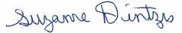5/24/13 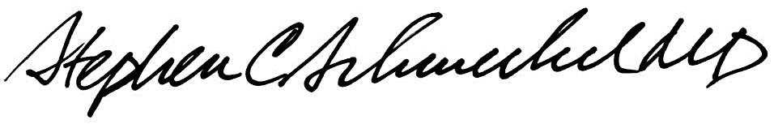5/24/13
____________________________ ___________________________
Suzanne Dintzis, MD, PhD Stephen Schmechel, MD, PhD

Written by: Revised by:
(Signature and Date) (Signature and Date)

_________________________ _________________________

