UW Medicine - Pathology

100-05-01-15
Incident Reporting Policy

Adopted Date: 10/18/07
Revision Date: 5/20/13

PURPOSE
To ensure that all adverse and/or potential incidents/events that may occur to either patient material or personnel are reported using the UW Medicine incident reporting system (PSN) or The Lab Information System (PowerPath).

SCOPE
For all staff, residents/fellows, and faculty.

POLICY
Incident/accident Reporting:
Incident/accident reports or quality assurance reports are used to document any unusual incident of injury/accident involving an employee or a patient. It is our opportunity to report to our department and/or to the appropriate risk management, situations that could be potentially harmful to good patient care. All Pathology faculty, residents/fellows, and staff are expected to promptly report adverse events/incidents and potential events/incidents. All Pathology faculty, residents/fellows, and staff may also report issues and complaints to CAP if they have a concern not addressed by laboratory management. The department and/or organization is strictly prohibited from harassing or taking punitive action against an employee in response to a complaint or concern made to CAP or other regulatroy organization regarding laboratory quality or safety. (refer to Admin policy: http://www.washington.edu/admin/rules/policies/PO/EO31.html

All incidents may be reported within the UW Medicine PSN System. Users unfamiliar with accessing the PSN application should notify their supervisor or immediate direct report.
- Event indicators which require entry to Patient Safety Net may include but may not be limited to:
- Employee Injury
- Mislabeled specimens
- Security issues
- Hazardous substance spills
- Damage to hospital/lab property
- Safety issues
- Quality issues
- Other indicators may be reported using this form at the discretion of the individual division directors or supervisors
- Specimen integrity (contaminated, wrong collection container, etc.)
- Lost/delayed specimens
- Procedure not performed when requested on requisition
- Laboratory results reported in error
- Communication challenges
- Testing requested inappropriate (duplicate order, wrong test ordered, etc.)

- Event indicators which require entry into Powerpath under the Specimen Adequacy Recorded located in the Req Data Tab. include but may not be limited to:
- Specimens submitted with deficient request information
- Intra- laboratory errors

All incidents/accidents must be reported to the supervisor or direct report immediately. PSNs will be reviewed in a management meeting. Those needing further review will be presented to the Medical Director. Incidents defined as major (irreversible harm) are to immediately escalate to the Medical Director (by passing the management review).

UWMC Pathology Chief of Service: HMC Pathology Chief of Service:
(Signature and Date) (Signature and Date)

5/24/13 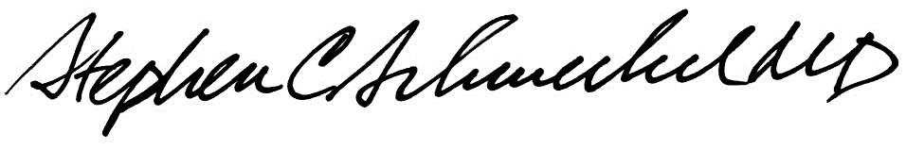5/24/13
____________________________ ___________________________
Suzanne Dintzis, MD, PhD Stephen Schmechel, MD, PhD

Written by: Revised by:
(Signature and Date) (Signature and Date)

_________________________ _________________________

