UW Medicine - Pathology

100-05-01-17

Xylene Control Procedure

Adopted Date: 07/15/11
Revision Date:

PURPOSE
To ensure that xylene vapor concentrations are maintained below the appropriate levels in all laboratories that use xylene and that monitoring of levels is done on an annual basis.

SCOPE
All staff working in laboratories that use xylene.

PROCEDURE
Survey Methods:
EH&S will collect samples to evaluate xylene levels next to staining and cover slip stations where levels would be at their highest. Samples are analyzed by the University of Washington Department of Environmental and Occupational Health Sciences Environmental Health Laboratory using OSHA Method 1002.

Xylene Exposure Limits:
Permissible Exposure Limit (PEL): 8 hour permissible exposure limit for xylene is 100 parts per million (ppm).
Short Term Exposure Limit (STEL): 15 minute short term exposure limit for xylene is 150 parts per million (ppm)

Monitoring Schedule:
Xylene will be monitored on an annual basis in all laboratories that use xylene. If exposure limits surpass the limits stated above, the area will be retested to determine if exposure levels changed.

Employee Notification of Results:
EH&S will notify the department of assessment / monitoring results within15 days after the laboratory analysis is received. The department is then responsible for providing the information to affected employees.

If monitoring results indicated personal exposure levels above the PEL and STEL, the department must develop a plan to reduce employee exposure. The plan should be submitted to the hospital safety officer and EH&S.

Work Practices:
- Do not eat or drink where xylene is handled, processed, or stored, since the chemical can be ingested.
- Always wash hands thoroughly after using xylene, even through gloves are worn.
- Minimize the amount of xylene used by using only the amount required to perform the required procedure
- Label xylene containers with the appropriate hazard warning label.
- Keep xylene stored in closed containers and only open when needed. Use in well ventilated areas.
- Spill cleanup material should be available in any area where xylene is used or stored. Follow the Chemical Spill Management Procedure for spills.

Exposure to Employees:
- For a splash to the eyes, flush eyes with water for at least 15 minutes and rinse/wash mouth and nose.
- Remove soiled clothing, wash skin, and replace with clean clothing.
- If swallowed, get medical aid immediately. Do not induce vomiting unless directed to do so by medical personnel.
- Notify Supervisor.
- If symptoms persist, report immediately to Employee Health (during day shift) or the Emergency Department (during evening, night and weekend shifts).
- Complete and submit an incident report.

REFERENCE
Chemical Spill Management Procedure, 100-05-01-06

UWMC Pathology Chief of Service: HMC Pathology Chief of Service:
(Signature and Date) (Signature and Date)

5/24/13 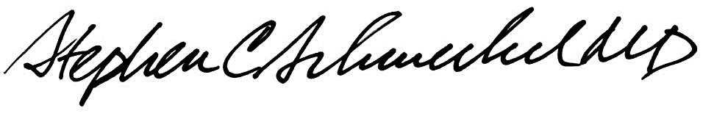5/24/13
____________________________ ___________________________
Suzanne Dintzis, MD, PhD Stephen Schmechel, MD, PhD

Written by: Revised by:
(Signature and Date) (Signature and Date)

_________________________ _________________________

