UW Medicine - Pathology

100-05-01-18

Handling of Blood and Other Spilled Fluids Procedure

Adopted Date: 08/10/11
Revision Date:

PURPOSE
To ensure that spills including bodily fluids are handled safely and appropriately.

SCOPE
All pathology personnel

PROCEDURE
All bodily fluid spills 50ml or less can be contained and cleaned by laboratory personnel following universal precautions guidelines. Surfaces should be decontaminated after the clean up of an accidental spill.

Spills over 50ml that are not contained are to be cleaned up immediately by contacting Environmental Services.

UWMC Pathology Chief of Service: HMC Pathology Chief of Service:
(Signature and Date) (Signature and Date)

5/24/13 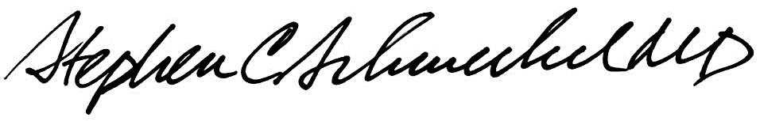5/24/13
____________________________ ___________________________
Suzanne Dintzis, MD, PhD Stephen Schmechel, MD, PhD

Written by: Revised by:
(Signature and Date) (Signature and Date)

_________________________ _________________________

