UW Medicine - Pathology

100-05-01-20

Annual Fire Exit Drill Policy

Adopted Date: 09/28/11
Revision Date:

PURPOSE
To ensure annual fire exit drill participation by all pathology personnel.

SCOPE
All department personnel, including staff, fellows, residents, and faculty.

POLICY
All Pathology personnel are required to participate in an annual fire exit drill. Participation is to be recorded on the department Fire Exit Drill Participation Sign In Sheet associated with the persons work area.

UWMC Pathology Chief of Service: HMC Pathology Chief of Service:
(Signature and Date) (Signature and Date)

5/24/13 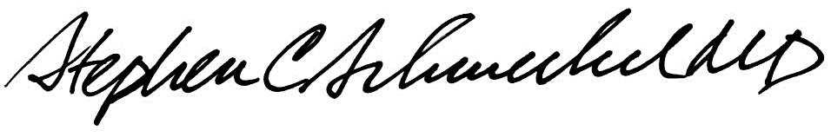5/24/13
____________________________ ___________________________
Suzanne Dintzis, MD, PhD Stephen Schmechel, MD, PhD

Written by: Revised by:
(Signature and Date) (Signature and Date)

_________________________ _________________________

