UW Medicine - Pathology

100-05-01-24

Chemical Receiving Instructions Procedure

Adopted Date: 06/13/09
Revision Date: 05/26/11

PURPOSE
To provide a systematic way to receive and document new chemicals in all laboratories.

SCOPE
All laboratories.

PROCEDURE
- The date received must be recorded on the container and the packing slip.

- A diamond shaped hazard label, if not already on the bottle, must be attached to the container. The appropriate numerical rating for each category is on the chemicals MSDS.

- All new chemicals must be added to the laboratories chemical inventory list in MyChem.

- For further information, refer to the departments Reagent Management procedure

REFERENCE
Reagent Management procedure, 100-02-01-25

UWMC Pathology Chief of Service: HMC Pathology Chief of Service:
(Signature and Date) (Signature and Date)

5/22/13 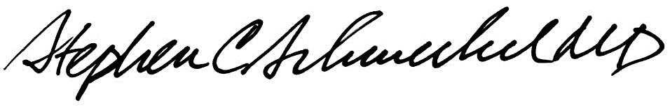5/22/13
____________________________ ___________________________
Suzanne Dintzis, MD, PhD Stephen Schmechel, MD, PhD

Written by: Revised by:
(Signature and Date) (Signature and Date)

_________________________ _________________________

