[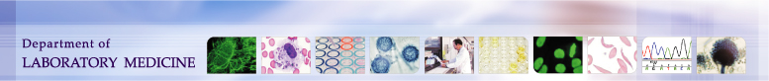](http://depts.washington.edu/labweb/index.h)

|  |  |  |
| --- | --- | --- |
| **University of Washington,**  **Harborview Medical Center**  **325 9th Ave. Seattle, WA, 98104**  **Transfusion Services Laboratory**  **Policies and Procedures Manual** | **Original Effective Date:**  September 2nd 2013 | **Number:**  **C5003-1** |
| **Revision Effective Date:** | **Pages:** 1 |
| **TITLE: Maintaining Autologous Cranial Bone Tissue for Re-implantation** | | |

**Purpose**

To provide instructions for maintaining autologous cranial bone tissue for potential re-implantation.

**Procedure**

|  |  |  |
| --- | --- | --- |
| **Step** | **Action** | **Related Documents** |
| Chain of Custody | * Transfusion Service Laboratory (TSL) staff signs for and receives autologous cranial bone tissue for storage after patient identification verification with OR designee. * TSL maintains a log and database of autologous cranial bone tissue inventory storage location. * TSL documents release of autologous cranial bone tissue for implantation to OR designee only after verification of patient identification. * TSL discards and documents permission to discard autologous cranial bone tissue according to policy. | * Tissue Tracking Process |
| Storage | * Autologous Cranial Bone Tissue is stored in the Autologous Tissue Freezer (F Ultra Low 2) at >-65°C in TSL * Freezer F2 is equipped with continuous temperature monitoring and alarm. * Daily documentation of temperatures * Weekly replacement of chart reader graphs * 24/7 alarm response. * Maintenance of Back-up freezer in OR in case of equipment failure of F Ultra Low 2 freezer. | * Refrigerator and Freezer QC and Maintenance |

**References:**

Standards for Tissue Banking, Current edition, American Association for Tissue Banks. AATB,

Bethesda, MD.