**UW Medicine - Pathology**

400-02-01-02

Chorionic Villi Cultures

|  |
| --- |
| Adopted Date: 08/05/91  Review Date: 06/12/09  Revision Date: 01/25/12 |

PURPOSE

This procedure allows for prenatal diagnosis of cytogenetic disorders during the first trimester of pregnancy, yielding a preliminary diagnosis as early as 24 hr following the procedure if needed (e.g., for sexing). See major indications under Amniotic Fluid Cultures. A final diagnosis will be provided within 10-14 days after setting up the case.

PROCEDURE

### Specimen Requirements / Sample Collection

* + - 1. Using sonographically guided catheters, villi samples are obtained at 7-12 wk gestation and placed into medium provided by the Cytogenetics Laboratory.
      2. The medium containing the villi is transported to the laboratory, where it is-transferred under sterile conditions to a 60-mm sterile Petri dish and evaluated under dissecting microscope for quality and quantity. The presence of villi is required for cytogenetic analysis. (WEAR GLOVES)

***Note***: Chorionic villi should be cleaned immediately and put into culture the following day (if not possible, keep it in a tissue culture incubator at 37°C).

### Materials and Equipment

1. 35-mm Petri dishes (Falcon #3001)
2. 60-mm Petri dishes (Falcon #3002)
3. Flask (T12.5 cm2)(Falcon #35-3107)
4. Pasteur pipettes
5. Clean glass microscope slides
6. 0.22-µm Millipore filter
7. Sterile 1-ml, 5-ml, 10-ml pipettes
8. Sterile 15-cc centrifuge tubes with caps (Falcon #35-2095)
9. Standard centrifuge
10. Syringes, 10-ml and 1-ml
11. Dissecting microscope
12. Inverted microscope
13. Laminar flow hood [Biosafety Hood (BioGard)]
14. 5% C02 wet and dry incubator at 37°C.
15. Sterile watchmaker forceps
16. Coverslip Kits (MatTek #CSGK/F)
17. Sterile H2O (Baxter #2F7114)

### Reagents and Solutions

* + 1. Alpha MEM Earle's Salts with Nucleosides (Irvine Scientific, catalog #9144)
    2. Amniomax C-100 (from Gibco, Cat #17001-082) + Amniomax supplement (Cat-#17002-080)
    3. Fetal bovine serum
    4. Penicillin-streptomycin-glutamine (Gibco Cat # 10378-016)
    5. Normocin (Invivogen Cat. #ant-nr-0)
    6. Trypsin 0.25% (Gibco Cat. #15050-065) (Obtain from Biochemistry Stores in Health Sciences)
    7. Dulbecco's phosphate buffered saline (D-PBS) (Gibco Cat. #14190-136)
    8. Collagenase Type 2 (Worthington)
    9. Colcemid (Gibco Cat. #15210-140)
    10. Sodium citrate (0.8%)
    11. Carnoy’s fixative (3 parts absolute methanol: 1 part glacial acetic acid), made fresh and kept at room temperature.
    12. Versene (Gibco Cat. #15040-066)
    13. Trypsin stock: Trypsin – 0.5% EDTA 10X (Invitrogen/GIBCO Cat. # 15400054) aliquotted and frozen in 10 ml aliquots. Working solution 10 ml stock + 90 ml sterile PBS.
    14. Media: Prepare two different lots at a time, labeled A and B to use in different vessels for each case.
        1. 100 m1 Alpha MEM (Earle's salts and nucleosides) (Irvine Scientific Cat #9144)
           1. +20 ml fetal bovine serum
           2. +90 m1 Amniomax C-100 (1 bottle)
           3. +Amniomax supplement
           4. +l ml penicillin-streptomycin-glutamine
           5. 0.4 ml Normocin

One small aliquot of each bottle must be incubated at 37°C for at least 24 hr before using the media to make sure the media is not contaminated. Whenever possible, overlap new media lots between different cultures in a case to verify that a new lot can support growth. Record media lot in case log book. Media shelf life is about two weeks when stored at 4°C.

Collagenase Type 2

1. Reconstitute 100mg of collagenase with 100 m1 alpha MEM
2. Use Nalgene 50mm filter unit to sterilize the collagenase
3. Aliquot 4-5ml in a 15ml tube
4. Write expiration date of +6 mo. Store at -20°C
   1. BrdU/Colcemid
5. 0.03 g BrdU (Sigma #B5002) in 10 ml HBSS (Gibco #14170-120).
6. Aliquot in 1 ml lots and store in dark at –20°C for up to one year.
7. Thaw just before use.
8. Add 0.8 ml of 10% colcemid (mixed with sterile H2O; Baxter) to 1 ml aliquot of BrdU.

### Procedure

***Note:*** No mouth pipetting. Adhere to sterile techniques. Use tissue culture hood [Biosafety Hood (BioGard)]. Use gloves. Use more than one incubator. Every effort should be made to avoid mislabeling of samples including ensuring that only one specimen is set up at a time (**ONE SAMPLE IN THE BIOSAFETY HOOD (BioGard) AT A TIME**).

1. Log in: When a sample is received, it is logged in GCS and in the Chorionic Villi log book and an accession number is attributed: CV/last two digits of year/ consecutive number, 4-digit accession number, e.g., **CV04-0052**. All vessels are labeled with this number and the patient’s first initial and first three letters of last name (e.g., Jane Smith = **JSMI**) using a VWR alcohol-proof marking pen. Log the case on the board. Look for indication. If previous cytogenetic studies were done on the patient or family, obtain previous reports or files. Record the quality and quantity (see Figure 1) of the villi sample on the lab set up sheet.
2. Chorionic villi are dissected carefully from maternal decidual tissues, clots, membranes and other unknown floating material. Note quantity and quality of cleaned villi for entry into GCS (see Figure 1).
3. The cleaned villi are transferred to another Petri dish containing medium and are rinsed. This step is repeated until the villi are free from decidua and maternal blood.
4. Villi are evaluated and divided for direct preparation and long-term cultures. One or 2 large, or 3 to 4 smaller, budded or branched pieces of villi (about 10 mg) is placed in a 35-mm Petri dish containing 2.5 ml medium and cultured for direct preparation, which can be harvested at 24 or 48 hr as needed. (See Direct Preparation Methods, below.)
5. The other pieces of villi, fragments and non-branched villi remain in the same container until they are set up for long-term cultures. Tissue can remain in 37°C incubator overnight. (See Long Term Culture Method, below.)

Figure 1.

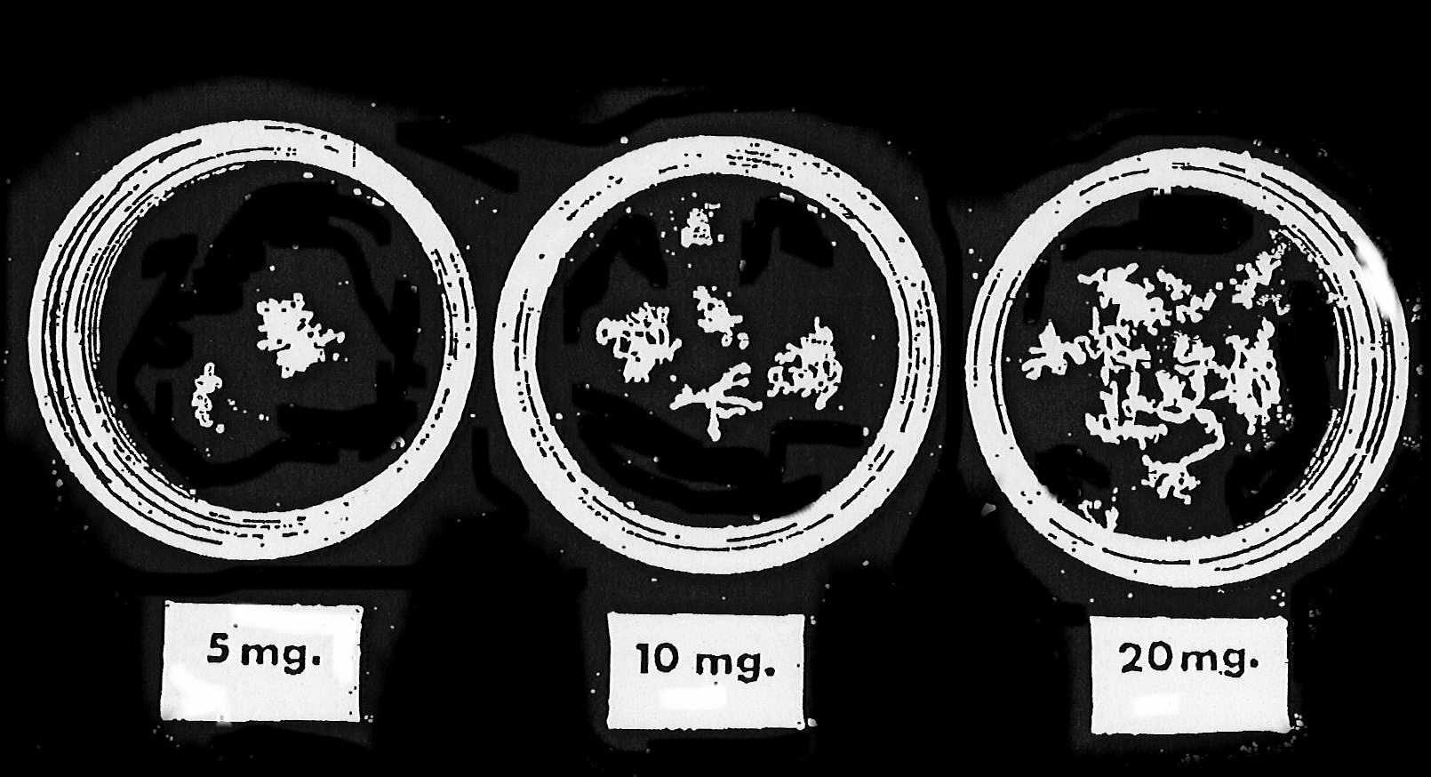

### Direct Preparation Method

* + 1. Incubate villi in a 35-mm Petri dish containing 2.5 ml medium for 24 to 48 hr at 37°C.
    2. When ready to harvest, add 50μl of full strength colcemid for 1 hr.
    3. With a transfer pipette, remove medium and replace with 2.5 ml of 10X trypsin-EDTA, and add 50μl of undiluted colcemid. Incubate for 20-30 min and begin checking for dissociated cells under inverted microscope. The edges of the villi should no longer look intact, and cells should be floating in the trypsin.
    4. Aspirate with sterile pipette up and down vigorously to break up villi. Let solid pieces settle somewhat; aspirate suspension into 15 ml centrifuge tube with approximately 4 ml media.
    5. Take solid villi that settled and put into collagenase with media. Leave villi in collagenase for approximately 1 hr then set up 3 coverslips and a flask
    6. Rinse empty dish twice with 2-3 ml of medium each time, and add to centrifuge tube with dissociated cells.
    7. Harvest cells in the centrifuge tube using the same method as for amniotic fluid flasks, eliminating the addition of colcemid.

### Interphase Fish

1. If there is too little tissue for a direct prep, or if there are too few analyzable metaphase cells in the direct prep, a slide should be prepared for IFISH from the cell suspension made in Long-Term Culture Method, step G (see below). Procedures for harvest, slide-making, hybridization, and viewing are the same as for interphase FISH on amniocytes.
2. Score as for AF IFISH.

### Long-Term Culture Method

***Note***: If there is more than one vessel, each should be harvested independently.

* + 1. When you are ready to set up the long term culture, take the material left aside after cleaning it and proceed as follows: transfer to a sterile centrifuge tube containing 5 ml of 0.25% trypsin.
    2. Incubate for 30 minutes at 37°C in CO2 incubator. Add 1 ml media to stop the trysin action. (media has alpha 1 anti-trypsin)
    3. Centrifuge for 8 min at 1000 rpm.
    4. Remove the trypsin and add 0.5 ml of 100 µg/ml collagenase solution in 4 ml complete medium at room temperature and place in CO2 incubator at 37°C for 2 hr.
    5. Remove tube from the incubator and centrifuge at 1000 rpm for 8 min.
    6. Remove supernatant (under sterile conditions), leaving 1 ml with the pellet.
    7. Add 2 ml complete fresh room temperature medium to cell suspension to be used for culturing and mix well.
    8. Divide 1 ml of suspension among 3 coverslip kits and incubate at 37°C overnight. The next day, flood each with 2.5 ml of room temperature media.
    9. Place the remaining suspension in a T12.5-cm2 flask. If direct harvest cell analysis indicates a normal female karyotype, one T-12.5 cm2 vented flask is set up in addition for maternal cell contamination studies (MCC). If there is insufficient material for both flasks, just set up one T-12.5.
    10. Incubate at 37°C and feed with fresh medium. Check for growth after 2 days.
    11. The afternoon before each coverslip is ready for harvest, 50µl BrdU/colcemid to each coverslip. Next morning, harvest as for amniotic fluid coverslip.

12. For Flask Harvesting (same as Amniotic Fluid flask harvest)

A. Add 100ul of colcemid (stock 10 µg/ml) to the flask for 30 min at 37°C.

* 1. Collect the media in a 15 ml conical centrifuge tube. Rinse flask 2 times with versene at 37°C (3 ml each) and collect the rinses in the same centrifuge tube. Add 1 ml of trypsin-EDTA at 37°C to the flask. When cells are detached (check in microscope and tap/smack bottom of flask on counter), transfer cells in trypsin to the same centrifuge tube. Make sure to leave a small amount of cells in the flask incase more cells needed. Spin tube at approximately 1000 rpm 8 min. Put 5 ml media back into flask and maintain until two weeks after case number is erased from board.
  2. Remove supernatant and flick tube to re-suspend the pellet. Add 8 ml of hypotonic (at 37°C) for 22 min. Add a few drops of fixative (methanol:acetic acid, 3:1) to the tube and mix. Spin 8 min at 1000 rpm.
  3. Remove the supernatant and flick the tube gently to re-suspend the pellet. Slowly add 6 ml of fixative and let it sit at room temperature for a minimum of 10 min.
  4. Centrifuge cells. Remove supernatant as close to the cell pellet as possible and add fresh fixative drop by drop until appropriate cell concentration is reached. Gently pipette to re-suspend and make slides.
  5. Bake slides for 60 min in 95°C oven before banding.

### Microscope Analysis

### Preliminary results, if needed, may be given following analysis of direct preparation, or interphase FISH. If the quality of the direct preparation is poor, results should not be given out until final analysis of long-term culture has been completed.

### If a normal female karyotype is indicated after direct analysis, the genetic counselor should be notified. After one of the two flasks is confluent, call Genetics at 8-6429 to pick up the flask for maternal cell contamination testing. Remember to always keep a backup!

### Count and sex 15 cells (5 cells from direct if available) fully analyze 5 cells

### For direct preparation, use 25 sec trypsin + 30 sec 4:1 Wright's stain.

### For long-term cultures, use 30 sec trypsin + 40 sec 4:1 Wright's stain.

***Note***: All vessels that come in contact with specimens or cultures from specimens are biohazardous and should be discarded in appropriate containers following the guidelines for disposal**.**

### Quality Assurance

1. If the diagnosis of a female fetus occurs in the direct preparation or in the absence of cytogenetic analysis of the direct preparation, the following procedures will be recommended to the patient’s physician or genetic counselor:
   1. follow-up amniocentesis
   2. heterozygosity testing from cultured chorionic villi cells and parental blood lymphocytes. The Cytogenetics lab will contact The Genetics Lab, Lab Medicine at 8-6429 to pick up the confluent T-12.5 flask. (see Ref. 7)

REFERENCES

1. Simoni G, et a1. Efficient direct chromosome analyses and enzyme determinations from chorionic villi samples in the first trimester of pregnancy. *Hum Genet* 1983; 63:349-357.
2. Niazi M, Coleman DV, Loeffler FE. Trophoblast sampling in early pregnancy. Culture of rapidly dividing cells from immature placental villi. *Brit J Obstet Gynaecol* 1981; 88:1081-1085.
3. Jackson LG. First-trimester diagnosis of fetal genetic disorders. *Hosp Pract* 1985; 39-48.
4. On-site training at Jefferson Medical College, Philadelphia
5. On-site training at Swedish Hospital (currently DynaGene), Seattle
6. Barch MT, Knutsen T, Spurbeck JL. Protocol for trypsin direct harvest of CVS. The AGT Cytogenetics Laboratory Manual. Raven Press, 3rd edition, pp. 236-237, 1997
7. Stojilkovic-Mikic, T., Mann, K., Docherty, Z., and Ogilvie, C.M. Maternal cell contaminiation of prenatal samples assessed by QF-PCR genotyping. *Prenat. Diagn*. 25:79-83, 2005.

Written By: Director Approval:

(Signature and Date) (Signature and Date)

­­­­­­­­­­­­­­­­­_______________________ ________________________

Cytogenetics Supervisor