**UW Medicine - Pathology**

400-11-01-07

Reporting Array Results Procedure

|  |
| --- |
| Adopted Date: 10/12/09  Review Date: 10/19/09  Revision Date: 02/2010 |

PURPOSE

After microarray analysis and related studies such as FISH confirmation and G-banding confirmation are complete, ISCN diagnosis and a report can be generated using Genoglyphix software and loaded in Genetic Computer System (GCS) with the findings of the analysis and other relevant information.

PROCEDURE

### Equipment

* + - 1. Genoglyphix software from Signature Genomic Laboratories
      2. Genetic Computer System (GCS)

### Procedures

1. **Primary analysis:** The primary technologist's responsibility is to make sure that a case is analyzed completely and accurately in a timely fashion. After analyzing the oligo array data completely, go through the Array CGH Quality Assurance Checklist in the patient folder, initial and date all check marks under Primary Tech for the following list (see the procedure of Oligo Array Data Analysis using Genoglyphix Software for detail).
   1. Print PDF file for the plots and flagged regions, Karyogram, and Analysis Summary
   2. Initial "Case Reviewed" in Genoglyphix
   3. Label all pages by putting patient label on every piece of paper/stapled papers in the case folder.
   4. Note related studies. Check if any previous or concurrent cytogenetic studies have been performed under Login on the QA checklist
   5. Check all data analysis completed (including karyotype if concurrent)
   6. Give folder to second technologist if normal
   7. If abnormal, determine if G-banding or FISH confirmation is warranted. Do G-banding confirmation when the region of gain or loss is larger than 5 Mb. For smaller gain (> 300Kb) or loss using FISH confirmation. Order BAC FISH probe from Signature Genomic Laboratories and determine the locator FISH probe. For small suspected non-CNV gain and loss or any uncertainty, check with directors to determine if FISH or array confirmation is appropriate.
   8. If FISH test done, supporting FISH documentation must complete and accurate including a copy of packing slip from SGL BAC probe.
   9. Abnormal marked on folder as red **A**
   10. After related studies are done, click on the **Final Review & Report**, enter ISCN diagnosis for array result and FISH result, make sure all annotation for the gains and losses are complete and accurate, and click on save report.
   11. Open Genetic Computer System (GCS), load ISCN diagnosis for array result, FISH result, and/or G-banding result, and load correct report template.
   12. Print the GCS report
2. **Secondary analysis:** The second technologist reviews all work completed for any errors or interpretative differences for QA purpose.
   1. GGX analysis reviewed
   2. Mark "Case Completed" in Genoglyphix
   3. Related studies such as FISH results reviewed
   4. Interpretation and recommendations are adequate
   5. Click on the **Final Review & Report**, check ISCN diagnosis for array result and FISH result, make sure all annotation for the gains and losses are complete and accurate, click on save report
   6. Check if correct templates, ISCN nomenclature, and report are accurate and loaded in GCS.
   7. Sign out case on the board.

APPENDIXES

**Cytogenetics Laboratory**

**University of Washington Medical Center**



**Seattle, Washington**

**Appendix A: aCGH Sample Processing/Report Form**

**Sample Setup: PB___ AF___ CVS___ POC___**

Date Set-up: ____ / ____ / ______ Initial: _____ Cytogenetics Study #__________________________

Case #: ___________ Patient Name: ____________________ Patient ID: ________ Gender: ___

Date Rec’d: ____ / ____ / ______ Draw Date: ____ / ____ / ______

Blood Sample Quality: Good, Hemolyzed, Clotted, Thick, Diluted, Dark

Tubes kept (number and type) Coagulation Type: Na heparin (green top)_______Volume ___________

EDTA (purple top)__________Volume___________

Other ____________________Volume___________

No. of cultures set-up: routine A1 (5ml)______ A2(5ml)______ 72 hr/37°C w/ complete RPMI+PHA

Set up (for each culture, record the letter, culture time, and any mitogens):___________________________

Notes: ________________________________________________________________________________

______________________________________________________________________________________

**Sample Login in GCS & Genoglyphix (office staff)** Date: ____ / ____ / ______ Initial: ___

____Computer login GCS

____check if any **previous or concurrent cytogenetic studies** have been performed.

* Case Accession # _______________________________________
* copies of past cytogenetic studies are placed in the patient folder

____Print out multiple labels for files

____Login Genoglyphix to add subject and full description of indications for testing

**Sample Harvest and Cytogenetics Confirmation Study: FISH____ G-banding_____**

**Date harvested**: ____ / ____ / ______ Initial: ______

**G-banding confirmation**: Date: ____ / ____ / ______ Initial: ______

**FISH confirmation**: FISH probe ordered (probe name, color, date)____________________________

Date FISH setup: ____ / ____ / ______ Initial: ______

FISH probe__________________ Control probe _________________

FISH analysis Date ________________ Initial_______________

metaphases_______ nuclei_______

**Cytogenetics Laboratory** Case #: Patient ID:

**University of Washington Medical Center** Patient Name:



**Seattle, Washington** Gender:

**Appendix B: Oligo Array CGH Patient Work Form**

**DNA Isolation/QC**

Date Rec’d: ____ / ____ / ______ DNA extraction: Date____ / ____ / ______ Initial: _____

EDTA (purple top) #__________Volume________ Amount of sample used for extraction: _________

NanoDrop readings: [DNA] ng/ul__________A260/280_________A260/A230_­­­­­________­­­­ Initial: ______

**DNA Labeling**

Labeling reaction set-up: Date: ____ / ____ / ______ Initial: _____

Patient DNA(cy3):____________ng per reaction

Control DNA(cy5): ___________ng per reaction (gender matched)

Post-labeling: Patient DNA(cy3): NanoDrop: [DNA] ng/ul________ x ­­­­_______ul = ug

Control DNA(cy5): NanoDrop: [DNA] ng/ul________ x ­­­­_______ul = ug

**DNA Hybridization**

Hybridization set-up: Date: ____ / ____ / ______ Initial: _____

Tracking Control: ________ Bay #: ______

*Set-up check:*

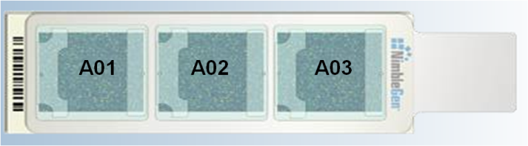

1. _____ Patient name correct on sample
2. _____ Accession number correct on sample
3. _____ Slide barcode number correct
4. _____ Hybridization solution added to correct fill port

Post-hybridization wash: Date: ____ / ____ / ______ Initial: ______

Experiment file name: ____________________________________________________________________

**Scanning and Data Processing** Date: ____ / ____ / ______ Initial: ______

Scan Image File names (barcodeA0x_532/635.tif)_________________532.tif ________________635.tif

Image quality: good, average, poor (bright, uneven, dim, blank, bubbles, missing array features, wash artifact, dust, scratches, fingerprints, others _____________________)

Alignment score (<0.2): 532 _______________ 635______________ STC match_________

Data QC on Genoglyphix: SD_______good, average, poor (noisy, telomere chatter, others____________)

Data reviewed on Genoglyphix (& inform techs for case review): Date: ______________ Initial: ______

**Cytogenetics Laboratory** Case #:

**University of Washington Medical Center** Patient Name:



**Seattle, Washington** Gender:

**Appendix C: aCGH Case Review Work Form**

**Primary Tech:** Date: ____ / ____ / ______ Initial: _______

1. _____ PDF, Karyogram, and Analysis Summary are printed
2. _____ Initial “Case Reviewed” in Genoglyphix
3. _____ Labels on all pages
4. _____ Related studies noted (ie. Karyotype study AF10-19)
5. _____ All analysis completed (including karyotype if concurrent)
6. _____ Give folder to second checker if normal
7. _____ If abnormal, determine if FISH confirmation or G-banding confirmation is warranted
   * _____ G-banding confirmation
   * _____ FISH probes: locator __________, BAC probe __________ order by date ____ / ____ / ______
   * _____ FISH confirmation (Vysis/BAC FISH test)
8. _____ Abnormal marked on folder as **A**

**Secondary Tech:** Date: ____ / ____ / ______ Initial: _______

1. _____ GGX analysis reviewed
2. _____ Mark “Case Completed” in Genoglyphix
3. _____ FISH results reviewed if necessary
4. _____ Interpretation and recommendations
5. _____ Print out the GGX final report
6. _____ Correct templates, ISCN nomenclature, and report are accurate and load in GCS

**Interpretation**

1. Normal __________________________ microarray analysis.
2. Genetic counseling is warranted.
3. Note: Results were discussed with ___________________________________________ on ____ / ____ / ______
4. Parental chromosome analyses are warranted to determine if this was inherited from a parental rearrangement or a *de novo* event.

_____ Family follow up by G-banding

_____ Family follow up by FISH

_____ Family follow up by array

Abnormal/Atypical report:

**Cytogenetics Laboratory**

**University of Washington Medical Center**  Run Date________ Tech______



**Seattle, Washington**

**Appendix D: aCGH Patient DNA Labeling Worksheet**

|  |  |  |  |  |  |  |  |
| --- | --- | --- | --- | --- | --- | --- | --- |
|  | **case number** |  | **Nanodrop** | **total volume 20 ul** | | **total volume 40 ul** | |
|  | **Patient ID** | **Gender** | **DNA [ng/ul]** | **ul DNA** | **ul H2O** | **ul DNA** | **ul H2O** |
| **1** |  |  |  |  |  |  |  |
| **2** |  |  |  |  |  |  |  |
| **3** |  |  |  |  |  |  |  |
| **4** |  |  |  |  |  |  |  |
| **5** |  |  |  |  |  |  |  |
| **6** |  |  |  |  |  |  |  |
| **7** |  |  |  |  |  |  |  |
| **8** |  |  |  |  |  |  |  |
| **9** |  |  |  |  |  |  |  |
| **10** |  |  |  |  |  |  |  |
| **11** |  |  |  |  |  |  |  |
| **12** |  |  |  |  |  |  |  |
|  | **female control** | x |  |  |  |  |  |
|  | **male control** | x |  |  |  |  |  |

**Cytogenetics Laboratory**

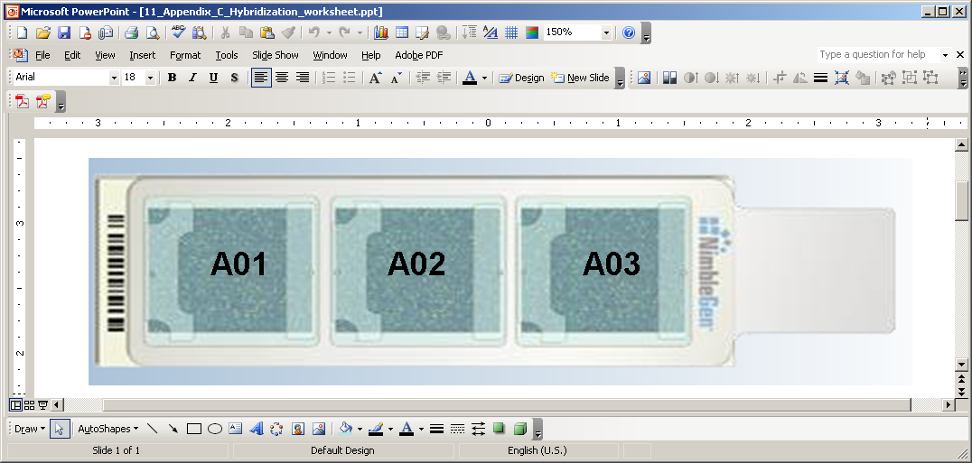

**University of Washington Medical Center**



**Seattle, Washington**

**Appendix E: aCGH Patient Hybridization Sheet** (Nimblegen 3-plex array template)

Date:___________ Tech:______ Hyb in___________ Hyb out____________

**Bay1.** **Barcode:___________**

A01: case#__________Patient ID________ Gender____Control______Tracking#____

A02: case#__________Patient ID________ Gender____Control______Tracking#____

A03: case#__________Patient ID________ Gender____Control______Tracking#____

**Bay2.** **Barcode:___________**

A01: case#__________Patient ID________ Gender____Control______Tracking#____

A02: case#__________Patient ID________ Gender____Control______Tracking#____

A03: case#__________Patient ID________ Gender____Control______Tracking#____

**Bay3.** **Barcode:___________**

A01: case#__________Patient ID________ Gender____Control______Tracking#____

A02: case#__________Patient ID________ Gender____Control______Tracking#____

A03: case#__________Patient ID________ Gender____Control______Tracking#____

**Bay4.** **Barcode:___________**

A01: case#__________Patient ID________ Gender____Control______Tracking#____

A02: case#__________Patient ID________ Gender____Control______Tracking#____

A03: case#__________Patient ID________ Gender____Control______Tracking#____

Written By: Director Approval:

(Signature and Date) (Signature and Date)

­­­­­­­­­­­­­­­­­_______________________ ________________________

Cytogenetic Supervisor

**UW Medicine - Pathology**

**Cytogenetics - UWMC**

**SIGNATURE PAGE FOR POLICIES AND PROCEDURES**

Procedure / Policy Title: Reporting Array Results Procedure

Procedure / Policy Number: 400-11-01-06

|  |  |  |
| --- | --- | --- |
| **STAFF NAME**: (printed) | **STAFF SIGNATURE** | **DATE REVIEWED** |
| Chen, Xiaoqin |  |  |
| Darrin, Delores |  |  |
| DeHoogh-Grigsby, Debi |  |  |
| Donovan, Chris |  |  |
| Kraus, Jean |  |  |
| Liu, Yuhua |  |  |
| McInnis, Donna |  |  |
| Mohapatra, Itu |  |  |
| Morgan, Catherine |  |  |
| Pilger, Carrie |  |  |
| Staley, Rong |  |  |
| Stampalia, Ann |  |  |
| Villiers, Catherine |  |  |
| Vogel, Jared |  |  |
| Wang, Sharon |  |  |
| Waychoff, Emma |  |  |
| Whalen, Sara |  |  |
| Zhou, Yang |  |  |