UW Medicine - Pathology

400-11-01-21
Forms and Worksheets of Microarray CGH+SNP Analysis

Adopted Date: 01/01/2011
Review Date: 03/01/2012, 11/02/2012
Revision Date: 04/03/2013

PURPOSE

The forms and worksheets are constructed to record the experimental data during the microarray CGH+SNP analysis

PROCEDURE
Forms and worksheets:

- Microarray Sample Processing/Report Form
- Microarray CGH Patient Work Form
- Microarray Case Review Work Form
- Microarray CGH+SNP Patient DNA Digestion Worksheet
- Microarray CGH+SNP Patient Post-labeling Worksheet
- Microarray Patient Hybridization sheet
- Feature Extraction QC report

Written By: Director Approval:
(Signature and Date) (Signature and Date)

__________________________________ ________________________
Technologist: Yuhua Liu and Yang Zhou Yajuan Liu PhD, FACMG

Cytogenetics and Genomics Laboratory

University of Washington Pathology
Seattle, Washington

A: Microarray CGH+SNP Sample Processing/Report Form

Sample Setup: MN___ NE___ NF___ TR___

Date Set-up: ____ / ____ / ______ Initial: _____ Cytogenetics Study #__________________________
Case #: ___________ Patient Name: ____________________ Patient ID: ________ Gender: ___
Date Rec’d: ____ / ____ / ______ Draw Date: ____ / ____ / ______
Sample Quality: Good, Hemolyzed, Clotted, Thick, Diluted, Dark
Tubes kept (number and type) Coagulation Type: Na heparin (green top)_______Volume ___________
EDTA (purple top)__________Volume___________
Other ____________________Volume___________
No. of cultures set-up: routine A1 (5ml)______ A2(5ml)______ following NE or TR culture setup
Set up (for each culture, record the letter, culture time, and any mitogens):___________________________
Notes: ________________________________________________________________________________
______________________________________________________________________________________

Sample Login in GCS & Genoglyphix (office staff) Date: ____ / ____ / ______ Initial: ___

____Computer login GCS
____check if any previous or concurrent cytogenetic studies have been performed.
- Case Accession # _MN______________________________________
- copies of past cytogenetic studies are placed in the patient folder
____Print out multiple labels for files
____Login Genoglyphix to add subject and full description of indications for testing

Sample Harvest and Cytogenetics Confirmation Study: FISH____ G-banding_____

Date harvested: ____ / ____ / ______ Initial: ______
G-banding confirmation: Date: ____ / ____ / ______ Initial: ______
FISH confirmation: FISH probe ordered (probe name, color, date)____________________________
Date FISH setup: ____ / ____ / ______ Initial: ______
FISH probe__________________ Control probe _________________
FISH analysis Date ________________ Initial_______________
metaphases_______ nuclei_______

Cytogenetics and Genomics Laboratory Case #: Patient ID:
University of Washington Pathology Patient Name:
Seattle, Washington Gender:
DOB:

B: Microarray CGH+SNP Patient Work Form
DNA Isolation/QC
Date Rec’d: ____ / ____ / ______ DNA extraction: Date____ / ____ / ______ Initial: _____
EDTA (purple top) #__________Volume________ Amount of sample used for extraction: _________
Other samples:__________________________________________________________________________
NanoDrop readings: [DNA] ng/ul__________A260/280_________A260/A230_________ Initial: ______
DNA Labeling
Labeling reaction set-up: Date: ____ / ____ / ______ Initial: _____
Patient DNA(cy3): ________ ul + ________ ul H₂O = ________ng per reaction
Control DNA(cy5): ________ ul + ________ ul H₂O = ________ng Control DNA used: _________
Post-labeling: Patient DNA(cy3): NanoDrop: [DNA] __________ ng/ul x ________ul = _______ug
Control DNA(cy5): NanoDrop: [DNA] __________ ng/ul x ________ul = _______ug
DNA Hybridization
Hybridization set-up: Date: ____ / ____ / ______ Initial: _____
Tracking Control: ________ Bay #: ______
Experiment file name: _______________________
A01
A02
A03
A04
Set-up check:
- _____ Patient name correct on sample
- _____ Accession number correct on sample
- _____ Slide barcode number correct
- _____ Hybridization solution added to correct fill port
Post-hybridization wash: Date: ____ / ____ / ______ Initial: ______
Scanning and Data Processing Date: ____ / ____ / ______ Initial: ______
Scan Image File names (barcodeA0x_532/635.tif)__________________532.tif _________________635.tif
Image quality: good, average, poor (bright, uneven, dim, blank, bubbles, missing array features, wash artifact, dust, scratches, fingerprints, others _____________________)
Alignment score (<0.2): 532 _______________ 635______________ STC match_________
Data QC on Genoglyphix: SD_________ good, average, poor (noisy, telomere chatter, others_________)
Data reviewed on Genoglyphix (& inform techs for case review): Date: ___ / ___ / _____ Initial: _____

Cytogenetics and Genomics Laboratory Case #: Patient ID:
University of Washington Pathology Patient Name:
Seattle, Washington Gender:
DOB:

C: Microarray Case Review Work Form

Primary Tech: Date: ____ / ____ / ______ Initial: _______

- _____FE QC report , Karyogram, and Analysis Summary are printed
- _____ Initial “Case Reviewed” in
- _____ Labels on all pages
- _____ Related studies noted (ie. Karyotype study AF10-19)
- _____ All analysis completed (including karyotype if concurrent)
- _____ Give folder to second checker if normal
- _____ If abnormal, determine if FISH confirmation or G-banding confirmation is warranted
  - _____ G-banding confirmation
  - _____ FISH probes: locator __________, BAC probe __________ order by date ____ / ____ / ______
  - _____ FISH confirmation (Vysis/BAC FISH test)
- _____ Abnormal marked on folder as A

Secondary Tech: Date: ____ / ____ / ______ Initial: _______

- _____ Cytogenomics analysis reviewed
- _____ Mark “Case Completed” in folder
- _____ FISH results reviewed if necessary
- _____ Interpretation and recommendations
- _____ Print out the Cytogenomics final report
- _____ Correct templates, ISCN nomenclature, and report are accurate and load in GCS
Interpretation
- Normal __________________________ microarray analysis.
- Genetic counseling is warranted.
- Note: Results were discussed with ___________________________________________ on ____ / ____ / ______
- Parental chromosome analyses are warranted to determine if this was inherited from a parental rearrangement or a de novo event.
_____ Family follow up by G-banding
_____ Family follow up by FISH
_____ Family follow up by array

Abnormal/Atypical report:

Cytogenetics and Genomics Laboratory
University of Washington Pathology Run Date________ Tech______
Seattle, Washington

D: Microarray CGH+SNP Patient DNA Digestion Worksheet
 |  |  | DNA (ng/ul) | 500 ng DNA in 10 μl |  | Notice
 | Sample # | Gender | DNA (ng/ul) | DNA (μl) | H₂O (μl) | Notice
1
2
3
4
5
6
7
8
9
10
11
12
13
14
15
16
 | Female: | Male:
II | Master Mix
 |  |  | 1 tube | 1 slide | 2 slide | III: 37C-2H-65
 |  |  | 1 run | 8 runs | 16 runs | 37˚C 2h
 | dH₂O |  | 1.1 | 9.9 | 20.35 | 65˚C 20 min
 | 10x buffer C |  | 1.3 | 11.7 | 24.05 | 4˚C forever
 | Acetyated BSA (10ug/ul) |  | 0.1 | 0.9 | 1.85
 | Alu (10u/ul) |  | 0.25 | 2.25 | 4.63 | machine #
 | RSA (10u/ul) |  | 0.25 | 2.25 | 4.63
 | Total |  | 3 ul | 27 ul | 74 ul
* final volume = 3+ 10 = 13 ul

Cytogenetics and Genomics Laboratory
University of Washington Pathology Run Date________ Tech______
Seattle, Washington

E: Microarray CGH+SNP Patient Post-labeling Worksheet

Labeling Reaction # | Case # | Nanodrop  [DNA] ng/ul | ul DNA
Cytogenetics and Genomics Laboratory
University of Washington Pathology
A01
A02
A03
A04
Seattle, Washington

Appendix F: Microarray Patient Hybridization Sheet (Agilent 4-pack array template)
Date:___________ Tech:______ Hyb in___________ Hyb out____________

Bay 1. Barcode:___________
A01: case#__________Patient ID________ Gender____Control______Tracking#____
A02: case#__________Patient ID________ Gender____Control______Tracking#____
A03: case#__________Patient ID________ Gender____Control______Tracking#____
A04: case#__________Patient ID________ Gender____Control______Tracking#____

Bay2. Barcode:___________
A01: case#__________Patient ID________ Gender____Control______Tracking#____
A02: case#__________Patient ID________ Gender____Control______Tracking#____
A03: case#__________Patient ID________ Gender____Control______Tracking#____
A04: case#__________Patient ID________ Gender____Control______Tracking#____

Bay3. Barcode:___________
A01: case#__________Patient ID________ Gender____Control______Tracking#____
A02: case#__________Patient ID________ Gender____Control______Tracking#____
A03: case#__________Patient ID________ Gender____Control______Tracking#____
A04: case#__________Patient ID________ Gender____Control______Tracking#____

G-1: Feature Extraction QC report

Print the Feature Extraction QC report

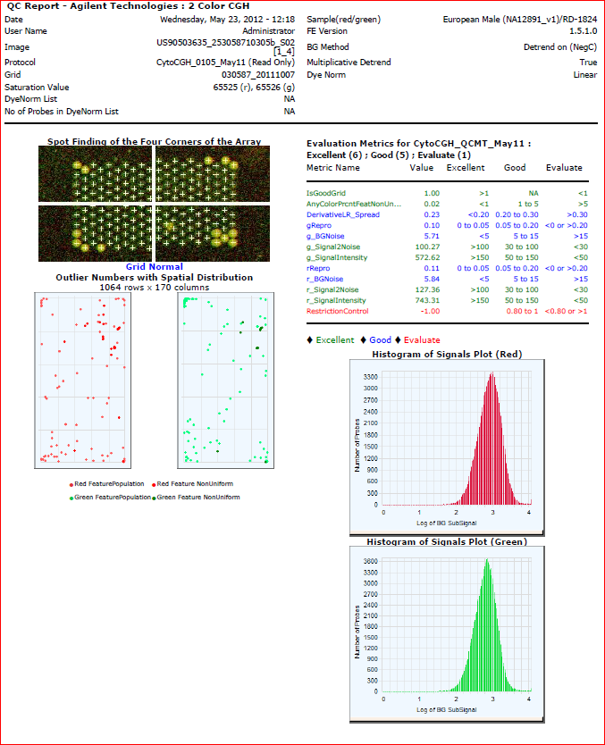

G-2: Feature Extraction QC report

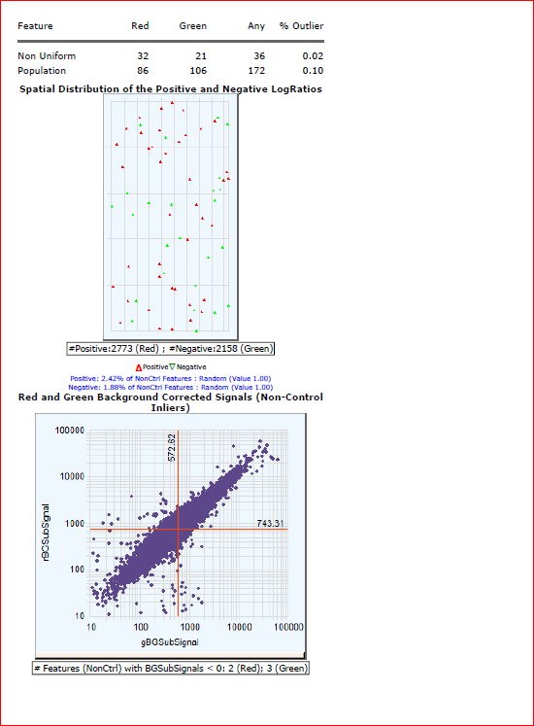

UW Medicine - Pathology

Cytogenetics and Genomics
SIGNATURE PAGE FOR POLICIES AND PROCEDURES

Procedure / Policy Title: Forms and Worksheets of Microarray CGH+SNP Analysis

Procedure / Policy Number: 400-11-01-21

STAFF NAME: (printed) | STAFF SIGNATURE | DATE REVIEWED
Chen, Xiaoqin
Darrin, Delores
DeHoogh-Grigsby, Debi
Donovan, Chris
Kraus, Jean
Liu, Yuhua
McInnis, Donna
Mohapatra, Itu
Morgan, Catherine
Pilger, Carrie
Staley, Rong
Stampalia, Ann
Villiers, Catherine

Vogel, Jared
Wang, Sharon
Waychoff, Emma
Whalen, Sara
Zhou, Yang

