**UW Medicine - Pathology**

400-11-01-24

**Microarray Data Extraction and Analysis using Agilent Cytogenomics**

|  |
| --- |
| Adopted Date: Nov. 12, 2011  Review Date: Nov. 21, 2011  Revision Date: Nov. 2011, Jan. 2012  Under Revision: November, 2012 |

PURPOSE

After scanned microarray data is processed and loaded the image to CytoGenomics, data analysis using CytoGenomics software allows for extracting the data from the images and evaluating the information of regions of copy number gain/loss using log2 ratio of signal intensity and SNP status using SNP plot of cut and uncut alleles in the genome.

PROCEDURE

### Material and Equipment

1. Computer
2. Agilent CytoGenomics software

### Procedures

1. Log in CytoGenomics
2. Set up Analysis Parameters under <**Config**> for 2-pack array and 4-pack array as below and name it as CGH+SNP Mosaic:

|  |  |  |  |  |  |  |  |  |  |  |  |  |  |  |  |  |  |
| --- | --- | --- | --- | --- | --- | --- | --- | --- | --- | --- | --- | --- | --- | --- | --- | --- | --- |
| Genome: hg19 | |  |  |  |  |  |  |  |  |  | |  |  |  |  |  |  |
| Aberration Algorithm: ADM-2 | | |  |  |  |  |  |  |  |  | |  |  |  |  |  |  |
| Threshold: 6.0 | |  |  |  |  |  |  |  |  |  | |  |  |  |  |  |  |
| Fuzzy Zero: OFF | |  |  |  |  |  |  |  |  |  | |  |  |  |  |  |  |
| Nesting Level: OFF | |  |  |  |  |  |  |  |  |  | |  |  |  |  |  |  |
| GC Correction: ON | |  |  |  |  |  |  |  |  |  | |  |  |  |  |  |  |
| Window Size: 2Kb | |  |  |  |  |  |  |  |  |  | |  |  |  |  |  |  |
|  | | |  |  |  |  |  |  |  |  | |  |  |  |  |  |  |
| Diploid Peak Centralization: ON | | | |  |  |  |  |  |  |  | |  |  |  |  |  |  |
| SNP Copy Number: ON | | |  |  |  |  |  |  |  |  | |  |  |  |  |  |  |
| SNP CN Confidence Level: 0.0 | | |  |  |  |  |  |  |  |  | |  |  |  |  |  |  |
| LOH: ON |  |  |  |  |  |  |  |  |  |  | |  |  |  |  |  |  |
| LOH Threshold: 6.0 | |  |  |  |  |  |  |  |  |  | |  |  |  |  |  |  |
| Combine Replicates (Intra Array): ON | | | |  |  |  |  |  |  |  | |  |  |  |  |  |  |
|  | | |  |  |  |  |  |  |  |  | |  |  |  |  |  |  |
|  | | |  |  |  |  |  |  |  |  | |  |  |  |  |  |  |
| **Aberration Filters**: minProbes = 5 AND minAvgAbsLogRatio = 0.15 AND maxAberrations = 10000  AND percentPenetrance = 0 | | | | | | | | | | | | |  |  |  |  |  |
| **Feature Level Filters**: gIsSaturated = true OR rIsSaturated = true OR gIsFeatNonUnifOL = true  OR rIsFeatNonUnifOL = true OR LogRatio = 0; Include matching values=false | | | | | | | | | | | | | | | | | |
| **Design Level Filters**: Homology = 0 OR IsPseudoautosomal = 1; Include matching values=true | | | | | | | | |  | |  |  |  |  |  |  |  |

1. Load array Image to **Agilent CytoGenomics** under < **Analysis>** from the top bar
2. Click **Analyze** icon on the left-up corner to set up analysis job
3. Select workflow as < CGH+SNP Mosaic -Image>, which have been set up before start analysis (see step **2**)
4. When mark <select is as default workflow to run this job>, both windows of Job Name and Description will show, for example, “CGH+SNP Mosaic - Image_24Oct2012_15.10.06”.
5. Click <**Add TIFF image**> on the right-low corner to add the array image from your file, then the window (Add image pack information for FE extraction) will pop up. Please check the file name (slide barcode and the number of pack (for 2x400k array should be 2 or 4x180K array should be 4).
6. Click <**Add image**> on the bottom of the screen, the window shows the impart image files name
7. Click <**Next**> on the bottom of screen
8. Add the sample name, control, double check the Sample name with slide position, and control
9. Click <**Save change**> on the bottom
10. Click <**Run**>. The data analysis using Agilent CytoGenomics will take about 30 minutes for a slide.
11. Review FE QC report and Array data under <**Analysis**>/<**Review**>
12. When the data analysis is completed, click <re**view**> to review the data for each sample (4 sample should be showed for one 4x180k slide)
13. Review the FE QC report and print out a QC report for each case. Check the DLRSD (DerivativeLR_Spread stander devition), the DLRSD threshold value is <0.2 for peripheral blood, bone marrow, and cultured cells, <0.3 for fresh/frozen tissue samples, and <0.4 for FFPE tissue samples (**Tables 15 and 16**).
14. Click <**View**> under the <**CGH&SNP Fit**> to check the CGH & SNP fit plot and CGH distribution, and print out the CGH & SNP Fit.
15. Click <**Analyzed**> under the <**Status**> for each sample. Then check through the whole genome and each individual chromosome CGH and SNP plots. Evaluate each flagged region to determine its significance following the procedure in section IV-VII below.

***Note***: These metrics are only appropriate for high-quality DNA samples analyzed with Agilent CGH microarrays by following the standard operational procedures provided in this user guide. These metrics are reported in the Feature Extraction QC report (in Feature Extraction 9.5, select **CGH_QCMT_Feb08** in Project Properties before extraction) and in Agilent CytoGenomics and Genomic Workbench. They can be used to assess the relative data quality from a set of microarrays in an experiment. In some cases, they can indicate potential processing errors that have occurred or suggest that the data from particular microarrays might be compromised. Many factors can influence the range of these metrics, including the microarray format (1-pack, 2-pack, 4-pack or 8-pack), biological sample source, quality of starting gDNA, experimental processing, scanner sensitivity, and image processing. The value guidelines presented below represent the thresholds that Agilent has observed when analyzing samples using this protocol.

**Table 15.** QC metric thresholds for enzymatic labeling for high DNA quality samples.

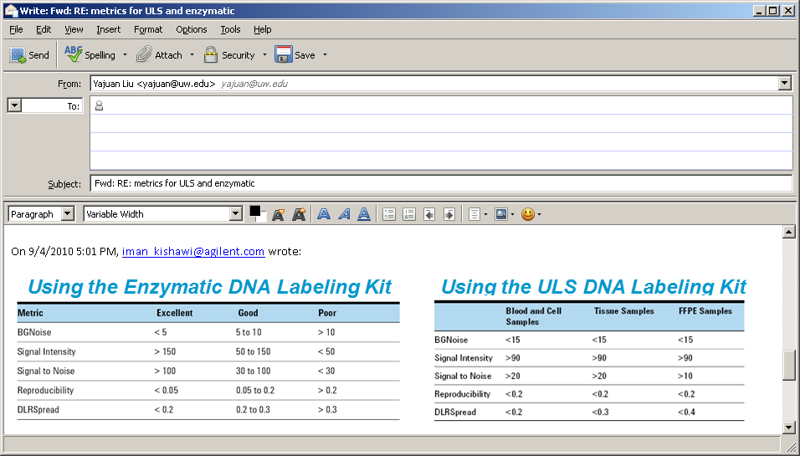

Table 16. QC metric thresholds for different sample types



* 1. **Reference**

1. Agilent Arrays-based CGH for genomic DNA analysis protocol version 7.1 p. 88-98.
2. Cytogenomics user manual

Written By: Director Approval:

(Signature and Date) (Signature and Date)

­­­­­­­­­­­­­­­­­_________________________________ ________________________

Technologist: Yuhua Liu and Yang Zhou Yajuan Liu PhD, FACMG

**UW Medicine - Pathology**

**Cytogenetics and Genomics**

**SIGNATURE PAGE FOR POLICIES AND PROCEDURES**

Procedure / Policy Title: **Microarray Data Extraction and Analysis using Agilent Cytogenomics**

Procedure / Policy Number: 400-11-01-24

|  |  |  |
| --- | --- | --- |
| **STAFF NAME**: (printed) | **STAFF SIGNATURE** | **DATE REVIEWED** |
| Chen, Xiaoqin |  |  |
| Darrin, Delores |  |  |
| DeHoogh-Grigsby, Debi |  |  |
| Donovan, Chris |  |  |
| Kraus, Jean |  |  |
| Liu, Yuhua |  |  |
| McInnis, Donna |  |  |
| Mohapatra, Itu |  |  |
| Morgan, Catherine |  |  |
| Pilger, Carrie |  |  |
| Staley, Rong |  |  |
| Stampalia, Ann |  |  |
| Villiers, Catherine |  |  |
| Vogel, Jared |  |  |
| Wang, Sharon |  |  |
| Waychoff, Emma |  |  |
| Whalen, Sara |  |  |
| Zhou, Yang |  |  |