Purpose
To provide instructions for calibration of NIST TempTrak sensors in the Transfusion Service Laboratory (TSL).
Policy
Cooper Atkins Intelli-ware v 4.5 software is licensed to UWMC/HMC and is accessed via the internet: https://temptrak.mcis.washington.edu/Intelli-ware/
All identified equipment in TSL will be fitted with electronic monitoring TempTrak which will record temperatures 24/7.
Monitored equipment includes:
- Refrigerators
- Freezers
- Platelet Incubators
- Portable refrigerators
- Room Temperature and Humidity

All TempTrak sensors will have calibration checked annually. Room Temperature/Humidity sensor does not need calibration. Acceptable limits across the 4 point temperature range will be ±1.5 °F (±0.8 °C).

Equipment
- TempTrak Prover box

Procedure
Step | Action | Related Documents
1 | Using Internet Explorer, log into the Cooper Atkins website.  https://temptrak.mcis.washington.edu/Intelli-ware/  Log on computer with user name and password  - To Access Cooper Atkins website:  - Open Internet Explorer  - Open “Remote Access” link in favorites  - Log in using your AMC account and password  - Under Web Bookmarks, Open “Temptrak”  Note: Require supervisor level login access
Step | Action | Related Documents
 | 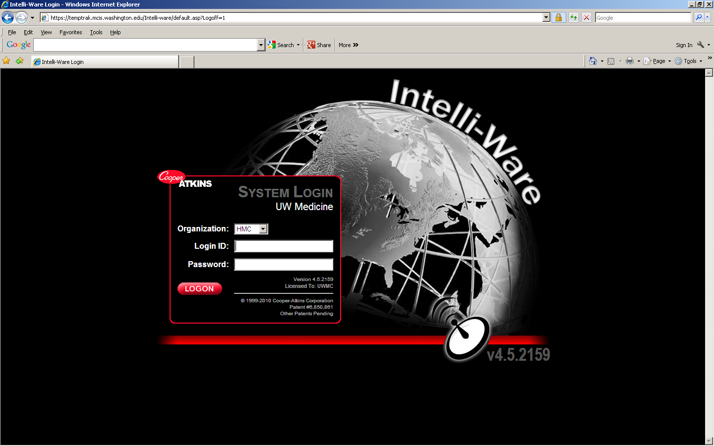
2 | Using pull down menu at top of screen, pull up NIST Validation:  - Configuration  - TempTrak  - NIST Validation  - Start Session  - The following screen comes up:  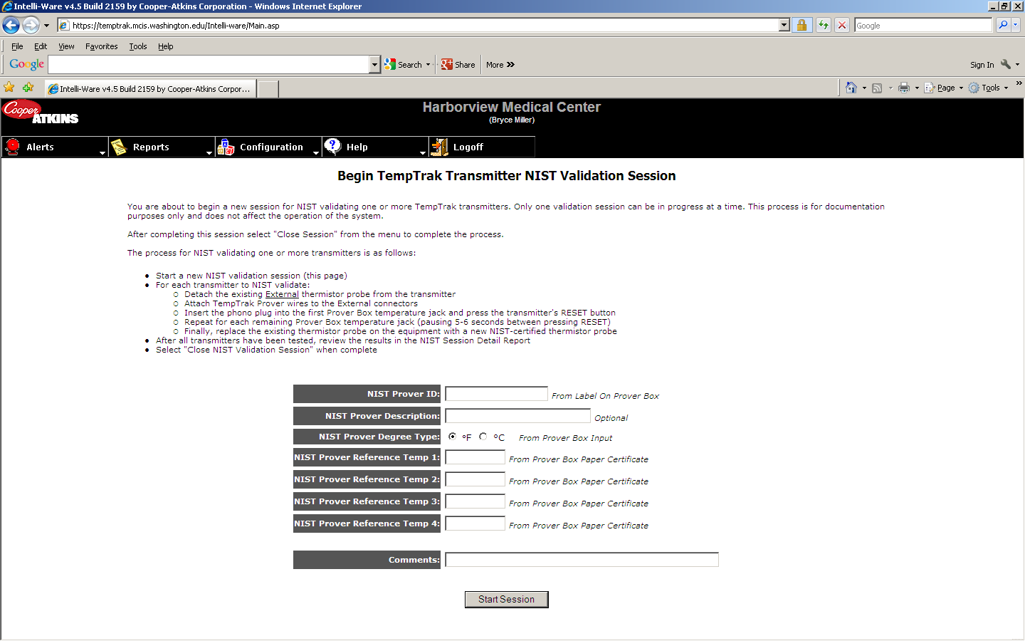
3 | Input the required information from the Certificate of Calibration and Report that came with the TempTrak Prover box  Note: Select ⁰F for the NIST Prover Degree Type
4 | Click on Start Session
5 | Locate the tan TempTrak sensor transmitter box that needs calibration
6 | Push the tab on the end of the housing and remove the housing cover from the TempTrak transmitter
Step | Action | Related Documents
7 | Remove one of the wires connecting the sensor to the Terminal Block by loosening the appropriate screw (Not necessary to remove both wires)
8 | Set switch to lower temperature on Prover box
9 | Press the 2 Prover box spring pins onto the Terminal Block and momentarily press the Reset button on the transmitter. (watch for the LED on transmitter board to flash)
10 | Switch to next temperature and repeat  - Repeat for each temperature. (leave the spring pins depressed as you move from one temperature to the other)  NOTE: By pressing the TempTrak transmitter Reset button, you are sending a temperature reading. This reading will be recorded in the TempTrak software. If the Reset button is held down for more than 5 seconds the transmitter will go into Sleep Mode. Hold Reset button again for 5 seconds to release transmitter from Sleep Mode.  - After 4 readings are sent to software, on the computer, press Refresh to see latest readings from transmitter.
11 | Verify the temperature readings on the computer are ±1.5 °F (±0.8 °C) of the selected temperatures on the Prover. If any temperatures are out of acceptable ranges, the software automatically highlights the failed readings in yellow.
12 | If any of the four readings are either out of range or missing, repeat the above process starting at step 8
13 | If the four readings are acceptable, reinstall the detached sensor wire(s) into Terminal Block and fully tighten the screw. Replace cover to transmitter box.
14 | If transmitter box is inside the refrigerator, you may need to reattach the sensor/transmitter with new cable ties.
15 | When complete, you can move on to the next transmitter. After sending new data to the computer, pressing Refresh will update the program with data from each transmitter.
16 | When finished checking all the transmitters, press Stop Session.
17 | For all freezers that use the Lab/Cryogenic RTD probe, (-80C and -30C Freezers), change the Temperature Probe Type to Standard for data to be transmitted to the software. Change probe type as follows:  - Configuration  - TempTrak  - Sensor Configuration  - Sensor Attributes  - Choose appliance
Step | Action | Related Documents
- At Temperature Probe Type, change Lab/Cryogenic RTD to Standard in pull down menu
- Save Changes
- Refresh Information
- Proceed with validation
After results are obtained and acceptable, remember to change probe type back to Lab/Cryogenic RTD to prevent Temperature error alarms
18 | Print out report as follows:  - Configuration  - TempTrak  - NIST Validation  - Session Report  - Click on appropriate session  - Print
19 | To print a Summary Report to include all sensors last validated in the laboratory:  - Configuration  - TempTrak  - NIST Validation  - Summary Report
20 | Create a Certificate of Calibration for each sensor calibrated.  - Update the TempTrak Prover Kit Calibration Information from current insert that came with the prover box.  - Sensor Validation Expiration will be 1 year from validation date  - All certificates and attached calibration must be reviewed and approved by manager or designee | Cooper-Atkins Corp Certificate of Calibration
21 | Troubleshooting questions can be directed to HMC Facilities Services or to Cooper Atkins directly. Link to Cooper Atkins is in one of the drop down menu boxes on Intelli-ware program.
22 | If a new or replacement sensor is needed,  - Obtain manager approval  - Request the item using HMC’s Clinical Support Services Centralized Work Request

Reference
TempTrak Service and hotline
Laboratory Equipment NIST Temperature Calibration Policy

