Purpose

To provide instructions for accessing patient history files using an encrypted USB drive when the Sunquest system is not operational. (SQ Downtime)

Method

Select the USB drive used for Daily Patient History Back-up
1 | Remove the flash drive from the Downtime Folder.
2 | Drives are labeled ODD and EVEN. Select the flash drive that has the most current capture:  - If the capture has not been done yet, select the drive for the previous day.  - If the capture has been done, select the drive for the current day.  Example: Downtime starts at 0200 on the 15th. Capture is scheduled for dayshift. Select the EVEN drive to access the capture of the 14th.
Prepare USB drive:
3 | Insert the encrypted flash drive into the USB port.  A Microsoft Pop-up scan/fix may appear, choose “continue without scanning”
4 | Found New Hardware may appear on lower desktop tool bar. A box opens with “Removable Disk (:E)”. Close this pop-up  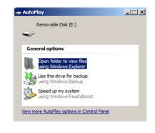
5 | Select the TrueCrypt program (blue icon) on the desktop of a blue computer or under the Start menu.  - Start, All programs, TrueCrypt, TrueCrypt  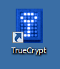
Step | Action
Prepare USB drive (continued)
6 | Click on “Select File…” button  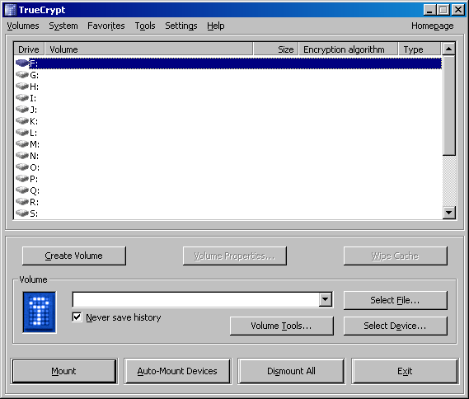
7 | In the “Select a TrueCrypt Volume” window:  - Select “My Computer” or “My Documents”  - Open “Removable Disk (E):”  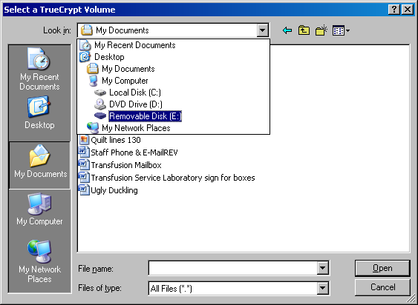
8 | Select BBCrypt and click “Open”.  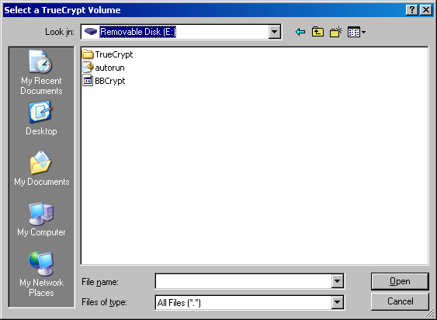
Step | Action
Prepare USB drive (continued)
9 | Note: In TrueCrypt, the volume box displays “E:\BBCrypt”.  Click “Mount”. Notice that the USB drive now displays a pulsing light.
10 | Password prompt: Enter bl00db@nk. (o’s are zeros, a is @ symbol). Do not check any of the boxes and click on OK.  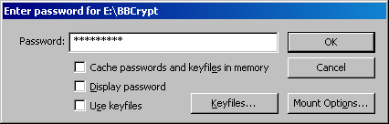  A pop-up may appear telling you the USB stick is corrupt, click on “no”
11 |     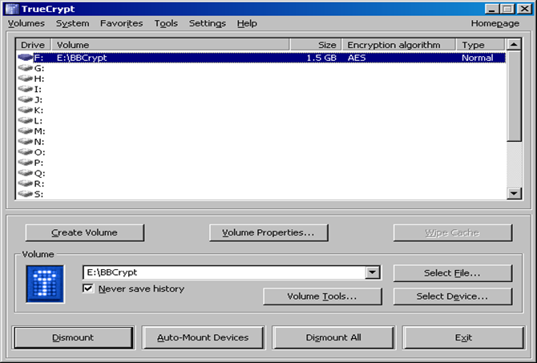  Minimize this pop-up screen
Access Captured Files
12 | Open local disk (F):  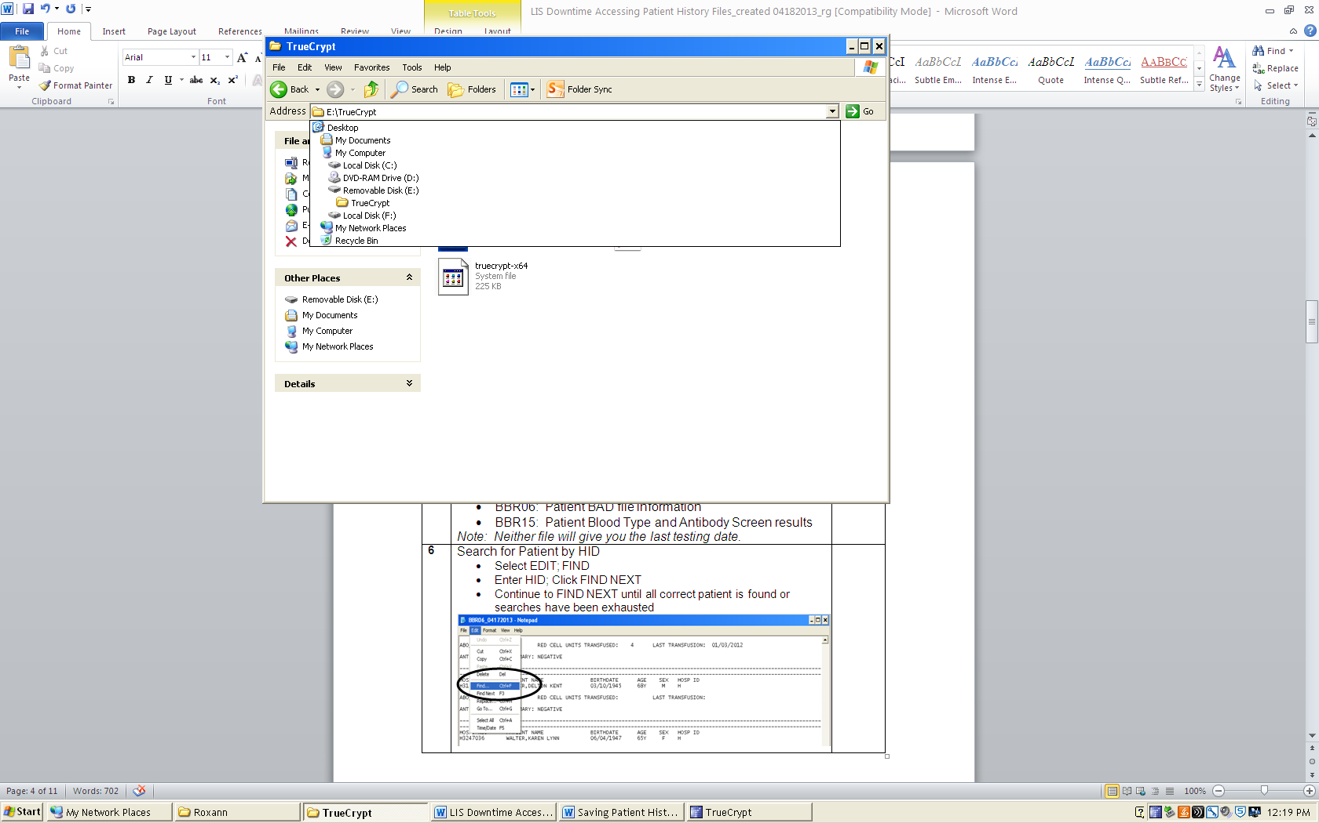
Step | Action
Access Captured Files (continued)
13 | Open folder “Transfusion Services Backup A or B”. Available files:  - BBR02: Product File List  - BBR06: Patient BAD file information  - BBR15: Patient Blood Type and Antibody Screen results  - BBR22: Test Result Review  BBR22 will tell you if the patient had a testing performed in the last three days. Patients not tested within that window will have results in BBR06 and BBR15 but those reports will not state the last testing date.
14 | Search for Patient by HID  - Select EDIT; FIND  - Enter HID; Click FIND NEXT  Note: HID can be scanned  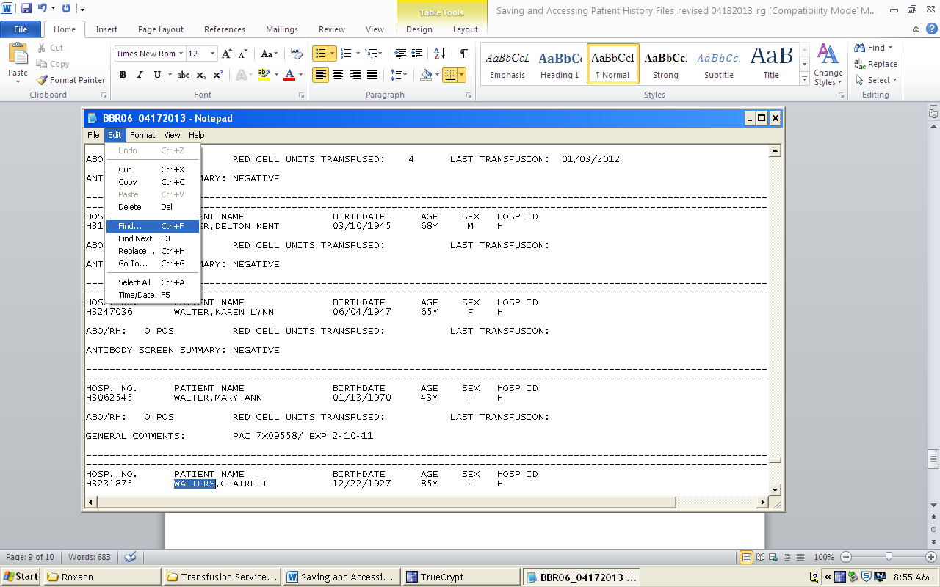
15 | 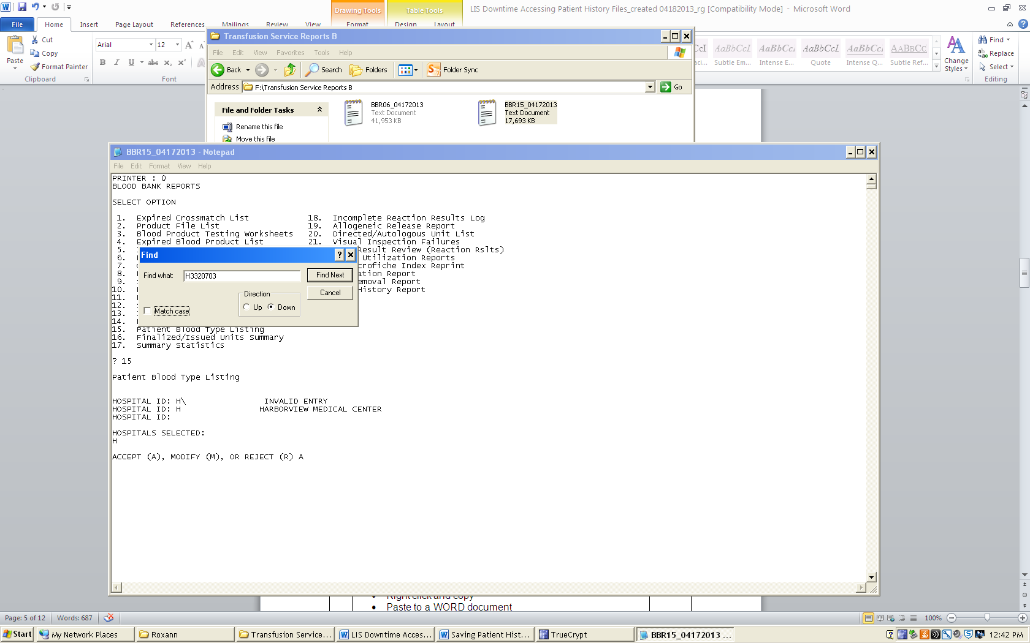
16 | Highlight selected patient data  - Right click and copy  - Paste to a WORD document  - Print data from both files, if applicable
17 | Staple to Blood Request
18 | Close BBR02, BBR06, BBR15, and BBR22 after each use in order to search for next patient.  Clear WORD document after each printing.
19 | Repeat steps 6 through 9 until Sunquest is available.
Step | Action
Removing USB drive
20 | To remove the encrypted drive without damage to the files, perform Dismount.  - Restore TrueCrypt session.  - Click DISMOUNT  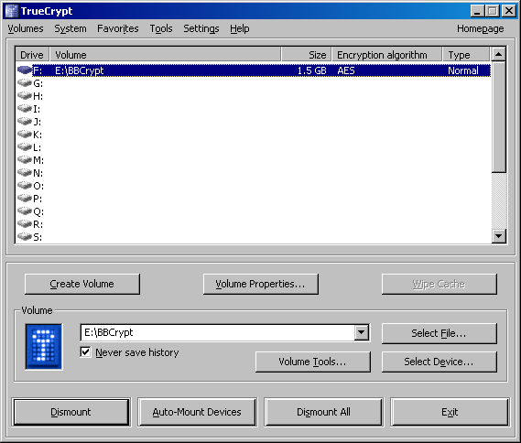
21 | Watch the pulsing light on the USB drive change from a steady, rapid pulse to a slow pulse.
22 | Remove the encrypted flash drive from the USB port on the computer hard drive.
23 | Store USB drive in the Downtime folder.
24 | Click Exit button.

References:

AABB Standards for Blood Banks and Transfusion Services, Current Edition

Blood Bank User Guide, Misys Laboratory

