Purpose:
To provide instructions for saving patient history files using an encrypted USB drive in order to provide patient history information in the event Sunquest system is not operational.

Method:
Step | Actions | Related documents
Perform Report Capture in Sunquest:
1 | Perform Function BEX in SmarTerm | Patient History Backup Reports in Sunquest
Prepare USB drive:
2 | Insert the encrypted flash drive into the USB port on the hard drive.  - Even days: “A”  - Odd days: “B”  NOTE: Alternate using the A and the B drives each day so that if one flash drive goes missing or becomes unusable the data is still recent on the other.  A Microsoft Pop-up scan/fix may appear, choose “continue without scanning”
3 | Found New Hardware may appear on lower desktop tool bar. Box opens with “Removable Disk (:E)”. Close this pop-up.  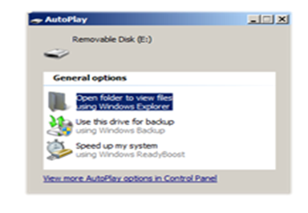
4 | Select the TrueCrypt program (blue icon) on the desktop of a blue computer or go to the start menu  - Start, All programs, TrueCrypt, TrueCrypt  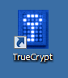
Step | Actions | Related documents
Prepare USB drive (continued):
5 | Click on “Select File…” button  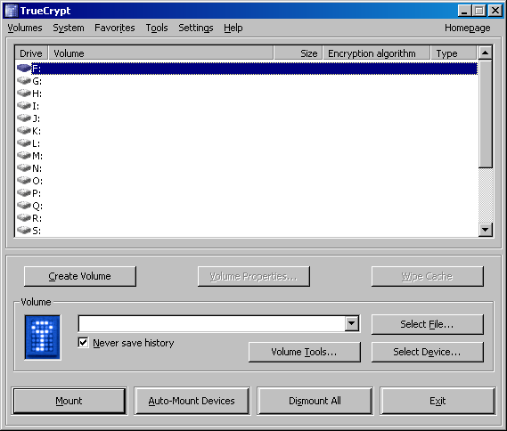
6 | In the “Select a TrueCrypt Volume” window:  - Select “My Computer” or “My Documents”  - Select “Removable Disk (E):”, click “open”  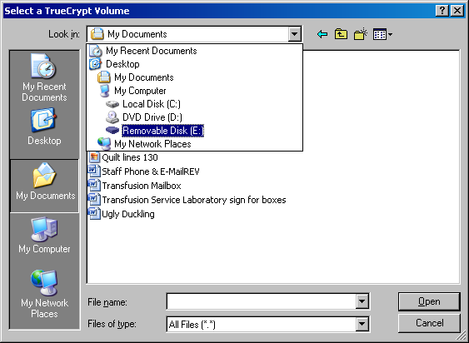
7 | Select BBCrypt and click “Open”. 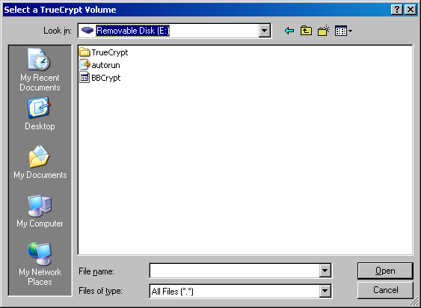
Step | Actions | Related documents
Prepare USB drive (continued):
8 | Note: In TrueCrypt, the volume box displays “E:\BBCrypt”.  Click “Mount”. Notice that the USB drive is now displays a pulsing light.
9 | Password prompt: Enter bl00db@nk. (o’s are zeros, a is @ symbol). Do not check any of the boxes and click on OK.  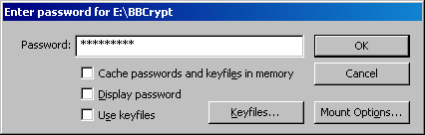  A pop-up may appear telling you the USB stick is corrupt, click on “no”
10 | 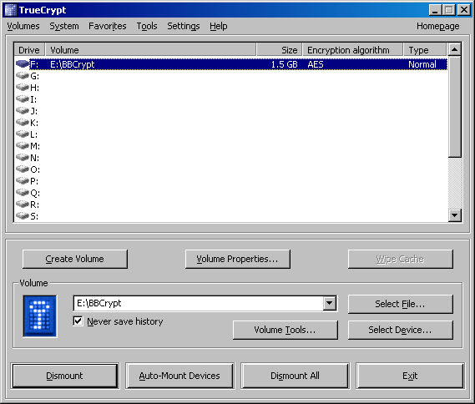  Minimize the pop-up screen.
11 | The F drive is the encrypted part of the E drive (like a subfolder). This drive must be used for patient information. If only the E drive is selected, the information will not be encrypted!

Step | Actions | Related documents
Capture Reports
1 | Open SmarTerm Roll N Scroll. Log on.
2 |   On the Menu bar, under “Tools”, choose “Start Capture”.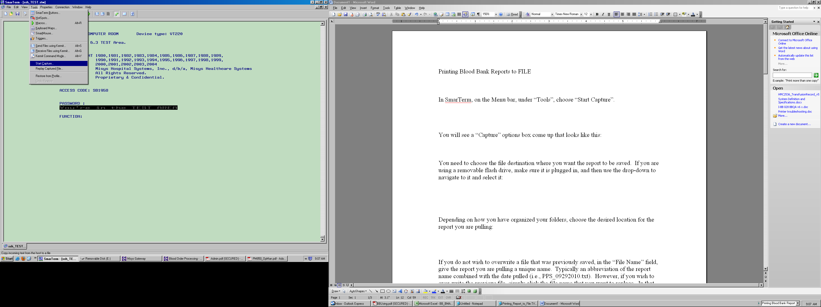
3 | “Capture” options box is displayed:  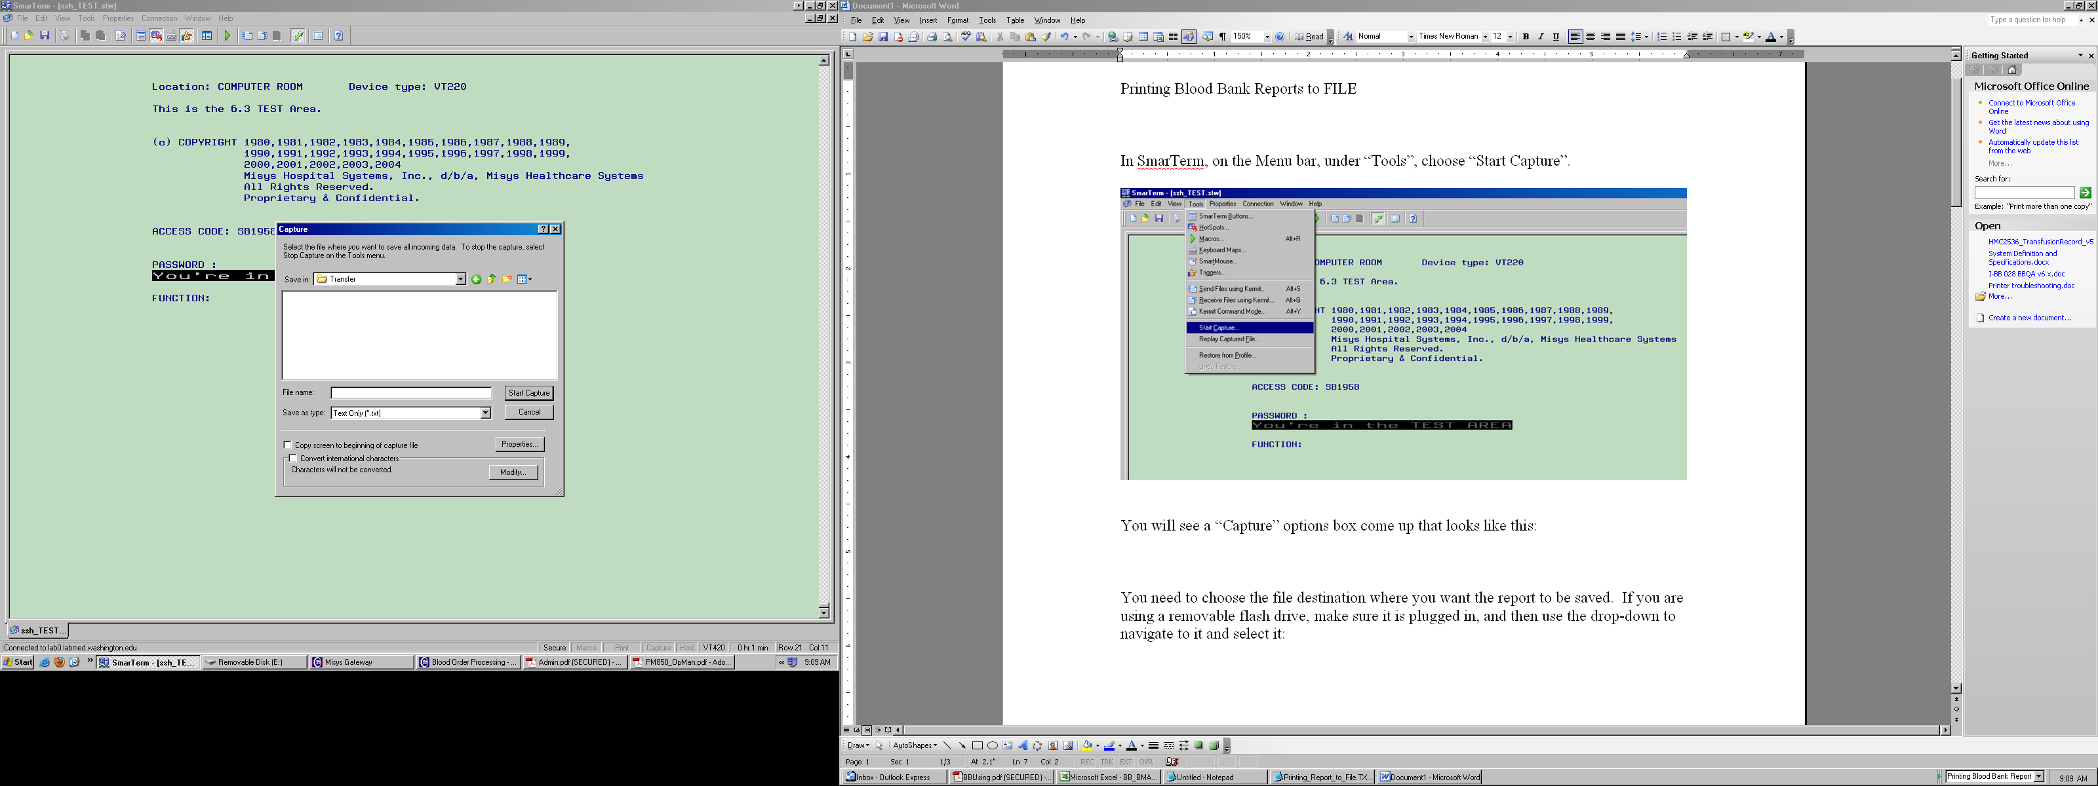
4 | Select “Local disk (F)” to identify the file destination where you want the report to be saved.  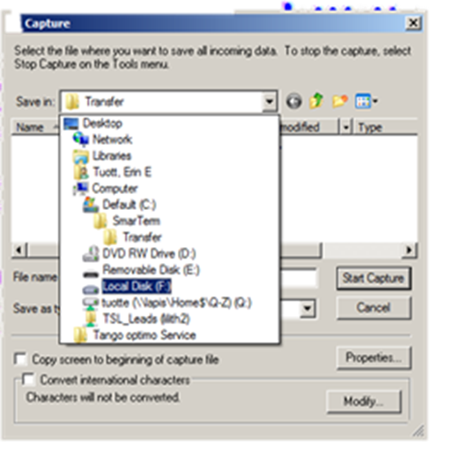
Step | Actions | Related documents
Capture Reports(continued)
5 | Select the Transfusion Service Reports folder  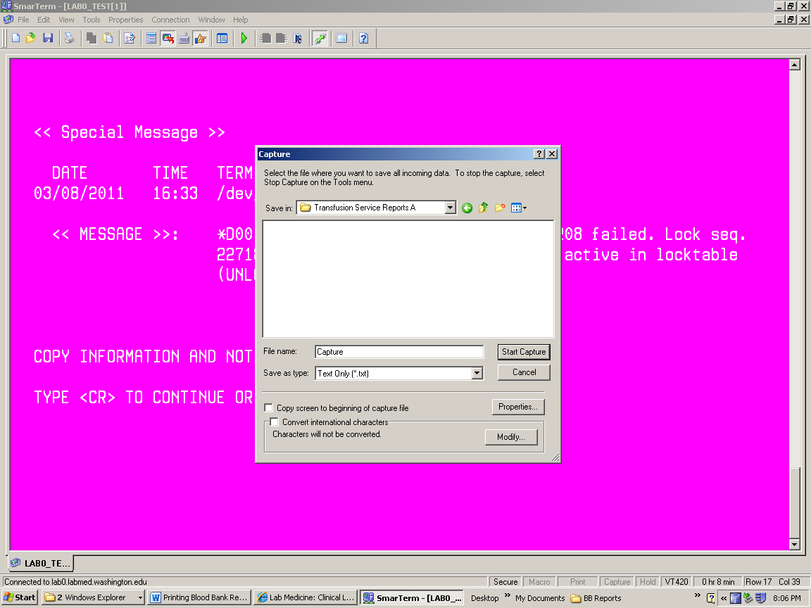
6 | Assign a file name, typically an abbreviation of the report name combined with the date compiled (i.e., BBR15_040511.txt).  - Click “Start Capture”.  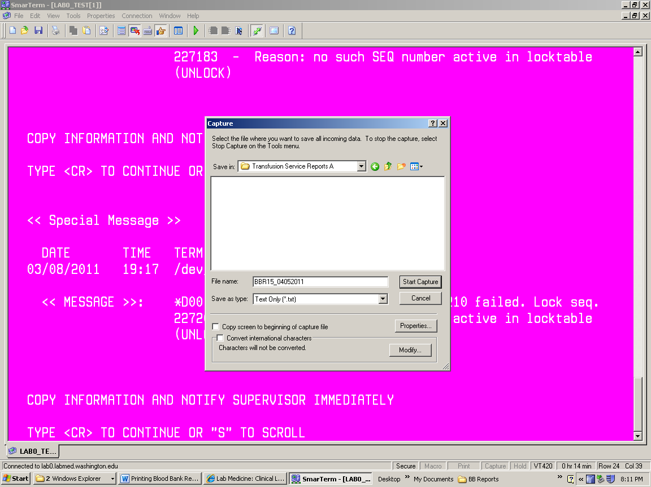
7 | Once complete, on the Menu bar under “Tools”, choose “Stop Capture”.
8 | Repeat steps 2-7 until all of the following reports have been extracted:  - BBR2  - BBR6  - BBR15  - BBR22 | Patient History Backup Reports in Sunquest
Cleaning Up
1 | Review to ensure reports have been properly saved. Delete previously saved reports.

Step | Actions | Related documents
Removing USB drive
1 | To properly remove the encrypted USB drive without damage to the files  - Restore TrueCrypt session.  - Click DISMOUNT
2 | Watch the pulsing light on the USB drive change from a steady, rapid pulse to a slow pulse.
3 | Remove the encrypted flash drive from the USB port.
4 | Store USB drive in the Down Time folder.
5 | Click Exit button.

References:
AABB Standards for Blood Banks and Transfusion Services, Current Edition
Blood Bank User Guide, Misys Laboratory

