**Purpose**

To provide instructions for the use of RC-AID (Red Cell Antibody Identification) web-based software. RC-AID is a tool for selecting antigen specific cells for antibody panels and electronic analysis.

**Background**

Antibody identification and resolution process must follow HMC Transfusion Services Laboratory Policies and Procedures.

RCAID provides the following:

* Database of antigen specific cells available in TSL for antibody identification purposes.
* A rule-out analysis based on the cells and criteria selected.
* ePanel technology for entering/saving results and analysis electronically.

**Support Information:**

* Any difficulties in display of RC-AID or the final worksheets are usually resolved by updating to the most current browser or Adobe Reader version.
* The RC-AID vendor can be contacted at [support@rcaid.net](mailto:support@rcaid.net) or 602-717-8888

**Procedure**:

1. **RC-AID users**

|  |  |  |
| --- | --- | --- |
| **Step** | **Action** | **Related Documents** |
|  | **Logging onto RCAID** |  |
| 1 | Go to [www.rcaid.net](http://www.rcaid.net)  Click on “Click Here to log into RC-AID” |  |
| 2 | Log onto system:  Email: *email address*  Password: *your chosen password* |  |
| 3 | The screen should appear as seen below with the following options in the menu bar   * Select Cells: cell selection for testing and/or e-panel * ePanel: test results and analysis * Process Selections: pre-testing analysis and pre-analysis worksheets |  |
|  | **Select Cells for Testing** |  |
| 4 | Click on Select Cells.  Note: Screen should show the inventory of panel cells and lot numbers that is in the Harborview Medical Center Inventory. |  |
| 5 | Perform Basic Search using any one of the following   * Lot# * Donor ID * Testing Medium field always defaults to All.   + Can be changed as needed. * Rh-hr field can be used if looking for a particular phenotype.   + Leave on default “O” setting if not needed. * The Extended Antigen Search tab shows all the special antigens. |  |
| 6 | Antigens are listed at the top.   * Use dropdown boxes to select desired phenotype * Blank boxes = no filter * “+” displays cells that are “+”, “W” (weak) or “S” (strong) for that antigen * “0” displays only cells negative for that antigen   Click Search to find cells matching the selected criteria  Click Reset to clear the selected antigens |  |
| 7 | Select cells for testing   * Ignore Analysis cells; these are used for validation only. * Click checkbox to select cells that fit search antigen profile.   + Bold lot # indicates cells that are in-date   + Cells with duplicate donor IDs are highlighted in pink. |  |
| 8 | The selected cells are highlighted in orange.  **Note:** The Clear Selections tab can be used deselect all selected cells. Click Reset if starting over; this will clear all phenotype criteria. |  |
| 9 | Once cell selections have been made, one or more of the following options can be selected:   * Pretesting Analysis from the Process Selections menu * Create a pre-analysis worksheet from the Process Selections menu * Generate an electronic panel from the ePanel menu |  |
|  | **Pretesting Analysis** |  |
| 10 | Pretesting Analysis   * Selected cells will show up on screen, only negative reacting cells must be used for analysis. * Check any antibodies that have been previously identified or suspected or is currently demonstrating (these will not be included in the rule-out analysis). * Click Run Analysis. | Example A |
| 11 | Pretesting Analysis  Color-coded rule-outs for each antigen are shown below the antigens.   * Homozygous rule outs are displayed in the first row – these include all homozygous rule-outs and rule-outs of antigen without alleles * Heterozygous rule outs are displayed on the second row. | Example A  Example C |
| 12 | Rule-out color codes:   * + Red no rule outs   + Yellow one (1) rule-out   + Green two (2) or more rule-outs   + Blue suspected or previously identified antibody | Example A |
|  | **Creating Worksheets** |  |
| 13 | Creating Worksheets for testing selected cells  Go to Process Selections, Create Pretesting Worksheets  Enter Patients name and HID, date of birth   * Click Standard Worksheet. * The Coversheet can be created as needed to record patient transfusion history and results. * The Extended Worksheet is available and it includes the extended antigen typing. * Print worksheet. | Example B |
|  | **Creating an ePanel** |  |
| 14 | ePanel  Used for entering/saving patient workup results/comments   * Go to Select Cells, select desired cells, select from dropdown box to add to an In-Progress ePanel or to a new ePanel, and click GO * Selected cells will be added to an ePanel; auto-analysis should be ON * Enter phase 1 results, patient ID, name and DOB, phase testing comments and testing conditions (conditions are selectable from dropdown boxes) * Patient auto-control results can also be entered * Click Save to save entered results, then click Next Phase to enter results for the next phase of testing. Repeat process for all remaining phases. Bear in mind auto-analysis can only be done on consecutive phases; CC results may need to be entered as phase comments to ensure accurate auto-analysis. * Continue until all phases of testing are entered * Click Save to save all the reactions and comments * Click Exit to keep the ePanel in “In Progress” status, this allows additions of more selected cells if needed or modification to the results * Click Close to close the ePanel and ready it for review; closed ePanel cannot be edited. * To reopen an in-progress ePanel go to ePanel, Status List, click on phase header to enter the workup.   *Note*: Only the creator of an ePanel can make changes to an in-progress ePanel; an ePanel will no longer be editable once it is closed. | Example C |
| 15 | ePanel   * Rule-outs for each antigen follows the same rules as the pretesting analysis * Analysis grids shading are color coded. Refer to RC-AID User Manual section 9.7.3 for color coding chart.   **Note:** When using enzyme treated cells, antigens denatured or depressed must be manually discounted. RCAID cannot distinguish enzyme treated panels from non-treated panels. | Example C  RC-AID User Manual  Antibody Panel by Tube IAT Method Using Enzyme Treated Cells. |
| 16 | Closely evaluate any antigens with no rule-outs.   * Remember to consider any antigens displaying no homozygous rule-outs to potentially have the corresponding antibody, since dosage would allow heterozygous rule outs to appear. |  |
| 17 | Compare worksheet to manual workup for discrepancies before attempting to resolve antibody ID. | Guidelines for Antibody Identification |
| 18 | Worksheet and coversheet will be generated in Adobe Reader format which can be printed or saved. |  |

**B. Updating Site Inventory (Inventory Managers only)**

|  |  |  |
| --- | --- | --- |
| **Step** | **Action** | **Related Documents** |
| 1 | Any corrections, deletions or additions are made by users with Inventory Management access. Log into [www.rcaid.net](http://www.rcaid.net) with an inventory manager account username and password.  The menu bar will display an “Inventory” option.   * Manage Inventory * Import Lots * Add new lot * Inventory reports |  |
| 2 | Select “Manage Inventory” to make changes to the site inventory.   * Changes can be made on the lot or cell level. * Lot information consists of lot number, supplier, test media and outdate. Deleting a lot removes all cells within the lot. * To update or delete an individual cell, expand the lot listing. |  |
| 3 | Select “Add New Lot” to manually add lots to the inventory |  |
| 4 | Lots can be imported from the RC-AID master inventory. From the “Inventory” menu, select “Import Lot”. |  |
| 5 | After importing cells to inventory, verify the added cells against the supplier product insert. This validation is essential to the integrity of the inventory and is saved in either printed or electronic format, along with the original manufacturer antigrams for 5 years. |  |

**C. ePanel Review (Reviewers only)**

|  |  |  |
| --- | --- | --- |
| **Step** | **Action** | **Related Documents** |
| 1 | Select ePanel, Status List and click on Review  ePanels with a status of “Closed” can be reviewed by designated reviewers  The following status can be seen under Status List:   * In Progress- remains editable by the initiating tech * Closed-ePanel is ready to be reviewed * Reviewed-Final Review has been done, no changes or review comments can be made to the ePanel |  |
| 2 | Review ePanel per SOP   * Add comments under “Review Comments” * Update rule outs if needed * Multiple reviews can be done before final review * Save | Guidelines for Antibody Identification |
| 3 | Click Final Review if all reviews are complete and no changes and additions are to be made. |  |

**Example A: Process selected cells and analysis run**

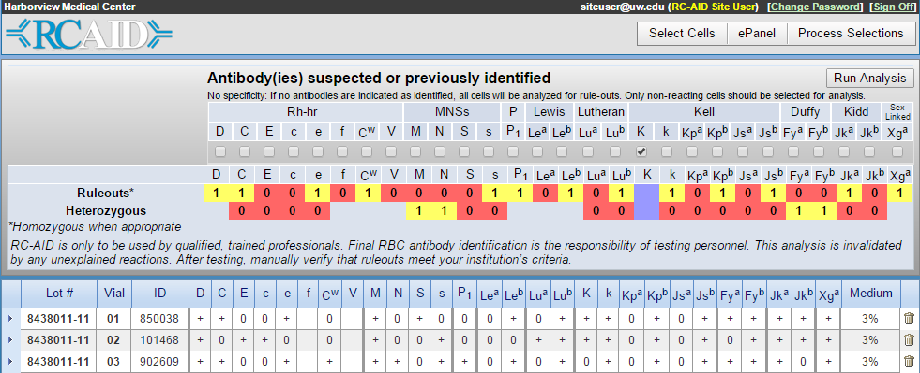

**Example B: Standard Worksheet**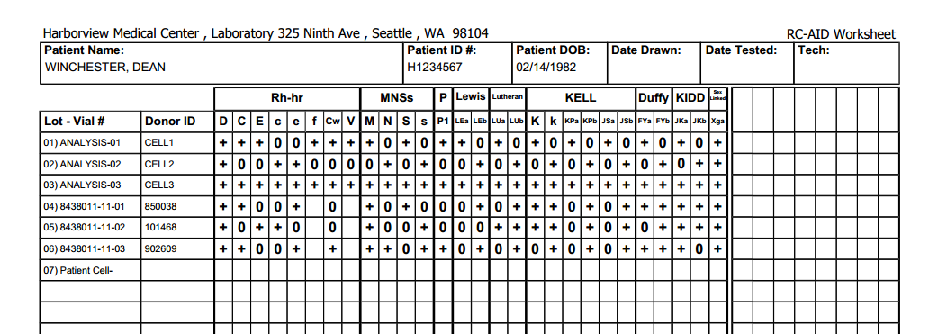

**Example C: ePanel Analysis**

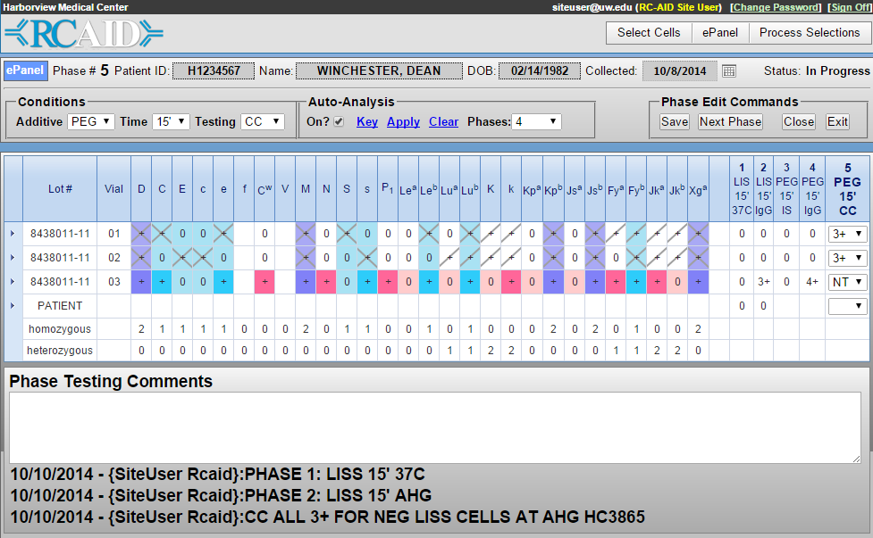

**References**: RCAID User Manual Version 2.2