Purpose:

To provide instructions for using the Blood Location function in Sunquest to transfer units between monitored blood storage locations.

Method

Step | Actions | Computer Processes
1 | Log into SQ.  Select Blood Location function, Single Unit tab | Opens Blood Location function.
2 | Scan unit number and component type | HID list opens list of locations
3 | Tab through TIME field. | If performing computer recovery, change date field.  New Comments now available: Click to open pop-up and enter comment code and free text. Example: Computer Down Recovery
4 | Select New location. | AREA updates.  H indicates HMC TSL.  Additional locations are added as applicable.  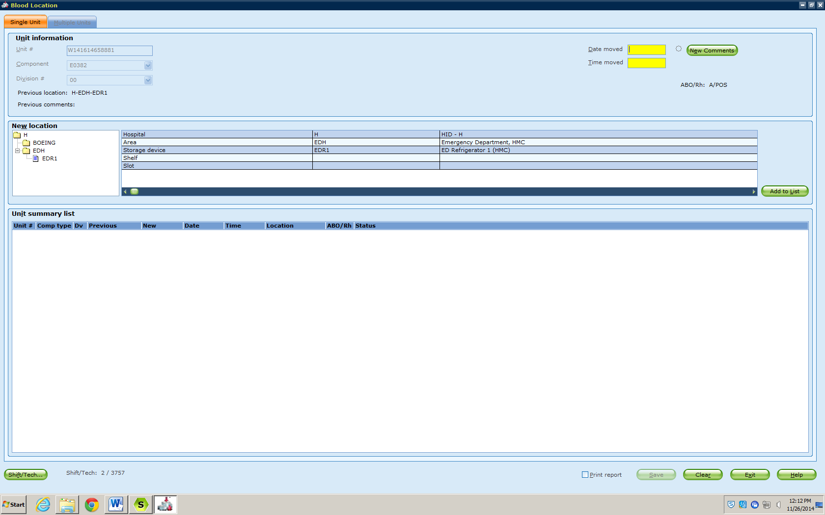
5 | Select storage device. | STORAGE DEVICE updates.
6 | Select ADD TO LIST. | Unit moves to bottom half of the screen
 | Actions | Computer Processes
7 | Repeat for additional products. | All units moved should display.
8 | Review entry and location assignment. | Units moved to the wrong location can be corrected by selecting CLEAR and rescanning the unit number.
9 | SAVE. | Pop-up states SAVE completed. Click OK.  Screen clears.  EXIT to close function.
Options
10 | Report | Print a report:  - Select print button at the bottom of the screen  - Following SAVE, a report will appear.  - Select PRINT.
 | Multiple Units Tab | - Displays a list of available units based on inventory search criteria.  - Not applicable to TSL application of the Blood Location function.
 | Shift/Tech | Select to change shift/tech.

References:

AABB Standards for Blood Banks and Transfusion Services, Current Edition
Blood Bank User’s Guide, Mysis Laboratory

