

COLORADO LABORATORY

**BLOOD BANK SPECIMENS, LABELING**

**(**For Exempla Saint Joseph Hospital or Good Samaritan Hospital)

**PRINCIPLE**

The first step in ensuring that oncology and surgical patients receive the correct blood type for transfusion occurs when the type and cross specimen is drawn and labeled.

**PROCEDURE**

RECIPIENT ID WRISTBAND (Refer to example at end of procedure)

1. The person obtaining the blood specimen MUST print the patient information on the Blood Recipient ID Wristband and on the requisition, use black indelible (non-smearing) ink and write legibly.

2. Print the following on the ID Wristband:

* + Last name, first name & middle initial (legal name), for accuracy ask the patient to spell their name
  + Date of Birth (month, day, year) (Do Not Use KP MRN)
  + Date & time of the phlebotomy (blood draw)
  + Your initials, (only the person performing the phlebotomy can fill out the ID Wristband)

3. ALL of the information must be verified by the patient.

4. Draw one 6 ml pink top tube

5. Detach the tail with the pre-numbered labels, at the perforation after the last hole on the ID

Wristband.

6. Remove the handwritten name label from the ID Wristband

7. Secure one end of the tail (with the pre-numbered labels), underneath the bottom portion of the

Hand written label (the end opposite the name).

8. Then attach the label to the vacutainer tube with the patient’s name under the stopper.

(Refer to example at end of procedure).

BLOOD BANK REQUISITION (printed from Reference Lab Requisitions under Forms)

Section: PATIENT INFORMATION (Top of requisition).

* Print the patient’s last name, first name and middle initial
* Print KP HRN on address line
* DOB and Gender

Section: CLIENT INFORMATION

* Print the KP Provider’s last name, first name
* KP Clinic Location, i.e. Arapahoe
* Lab contact phone #

Section: SPECIMEN COLLECTION & PROCESSING (Bottom right)

* Record: Date Collected (MM / DD / YYYY)
* Record: Time Collected (HH / MM)
* Record: Collected by – Initials of the person drawing the specimen
* Check one of the following: ROUTINE / TIMED / STAT

1. Section: Doctor’s Verbatim Order: (Bottom right)

* Include special instructions i.e. Call results to ______
* Indicate TYPE and SCREEN, TYPE and CROSS, Number of Units (If information is provided)

|  |
| --- |
| IMPORTANT - COMPLETE the EXEMPLA BLOOD BANK CHECKLIST before the  PATIENT LEAVES THE LABORATORY: (Refer to example at end of procedure) |

* ESJH / EGSH Blood Bank departments will reject the specimen if all of the information does not match, is not accurate or is not complete.
* The patient will have to be redrawn and the transfusion or surgery will be delayed.

NOTES, LIMITATIONS AND INTERFERENCES

1. The following can cause incorrect test result information being sent to providers and can cause serious consequences for the patient: misidentification of the patient, incorrect labeling – i.e. labeling tube(s) or specimen container(s) with another patient’s name, incorrect tube type for test ordered, QNS, clotted whole blood specimens, hemolyzed specimens.
2. Incorrect placement of the labels can result in the KP department performing the test reprinting and re-labeling tubes and/or specimen container(s) so that the barcode reader can read the barcode on the tubes/containers.

|  |
| --- |
| COMPLETE the EXEMPLA BLOOD BANK CHECKLIST “*BEFORE*” the PATIENT LEAVES THE LABORATORY |



**Place computer label here ******* FILE AND SAVE**

**▼▼▼▼**

|  |  |
| --- | --- |
|  | **Initial below** |
| ⁯ Verified Name matches **EXACTLY** on requisition and Blood Recipient  ID Wristband and is the correct, complete name of the patient. |  |
| ⁯ Verified DOB matches **EXACTLY** on requisition and Blood Recipient  ID Wristband. |  |
| ⁯ Verified surgery date is <72 hours |  |
| ⁯ Provider First AND Last name on requisition |  |
| ⁯ Ordering Location on requisition |  |
| ⁯ Lab contact phone number on requisition |  |
| ⁯ Specimen collection information on requisition and Blood Recipient ID  Wristband. |  |
| ⁯ Blood Recipient ID Wristband on the patient |  |
| ⁯ Blood Recipient ID Wristband label with attached pre-numbered labels  are on tube |  |
| ⁯ Is this an Oncology patient? If yes, is their transfusion at  ⁫ ESJH  ⁫ EGSM  ⁭ KP EN  Send to correct location.  ⁬ Is this a surgery patient? If yes, is their surgery at  ⁫ ESJH  ⁬ EGSM  ⁭ KP EN  Send to the correct location. |  |
| Phlebotomist name: Print |  |

**EXEMPLA BLOOD BANK CHECKLIST**

**Write correct information on label**

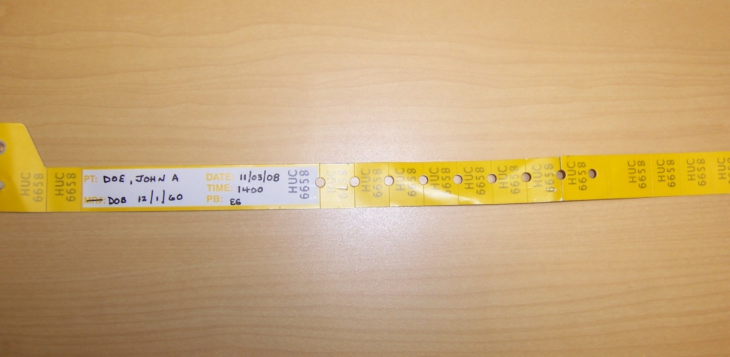

**Place label on tube by:**

**1. Removing labels below the circle cutouts**

**2. Slipping the end of the removed labels under the name label as it is applied to**

**the tube**

