HPV & Pap CoTest Processing Checklist for MOL staff

Pap and HPV Co-testing for women between ages 30 to 64 is being implemented in the Colorado Region.
- The Pap test will continue to be performed in the RRL Cytology dept.;
- the HPV test is performed in RRL Molecular dept.
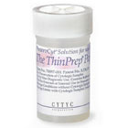
The new orderable name is “HPV Cotest (>29 YRS)”

Both tests will use the same Thin Prep vial but be ordered as two
separate tests in Healthconnect by the provider. The tests are in
Cerner as “PapTrack” and “HPV Cotest”.

The specimen will be collected in the clinics and received in
the medical office laboratories.

Dispatch the labels for both the “PapTrack” and “HPV Cotest (>29 YRS)”
from Cerner Millennium.

Label the vial with the small “HPV Cotest” barcode label by affixing label
on vial vertically.

Label the Pap requisition with the large “PapTrack” barcode label &
the large “HPV Cotest” barcode label on lower right hand side of
the requisition.

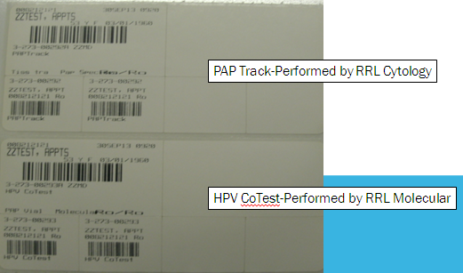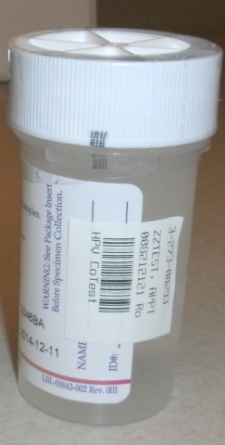

Log the specimen in as received (both “PapTrack” and “HPV Cotest”) and build a PapTrack/HPV Cotest Transfer List. Additional information: Procedure for Ordering & Tracking Histology, Cytology and NonGYN Specimens.

  Colorado Laboratory | WRITTEN BY: | POLICY NO.:
Mike Moyer
Becky Doughdrill
 | Mike Moyer  Becky Doughdrill | EFFECTIVE DATE:  10/1/2013
POLICY AND PROCEDURE  METHOD HISTORY | ISSUED BY:
POLICY AND PROCEDURE  METHOD HISTORY | Becky Doughdrill  Manager, Manager Cytology
Procedure Name:  HPV & PAP CoTest Processing Checklist for MOL Staff | Becky Doughdrill  Manager, Manager Cytology
 | APPROVED BY:
 | Medical Director

DATE | REVIEW | REVISION | COMMENTS | SIGNATURE
8/19/2015 |  | X | Renamed | B Doughdrill

