Title:
ALERE™ i Streptococcus Group A

Prepared By | Date Adopted/Replaces | Approved By
Trina Kimbrough, MT (ASCP) | 10-2017 | Edward H. Adelstein, Laboratory Director
 |  | Section Pathologist
ANNUAL REVIEW
Review or Revision Date | Comments (check all that apply) |  | Approved By
 | No changes Revision initiated – see below Available on-line
 | No changes Revision initiated – see below Available on-line
 | No changes Revision initiated – see below Available on-line
 | No changes Revision initiated – see below Available on-line
 | No changes Revision initiated – see below Available on-line
 | No changes Revision initiated – see below Available on-line
Date | Page # | Description of revision

Distribution

Clinical Lab Sections
Blood Bank | Chemistry | Morgue | Hematology | Immunology | Microbiology | Frozen Section
Lab Manager | Pulm. Function | Sharepoint

Retirement Date | Approved By | Archived Location

Alere i Streptococcus Group A
CLIA Waved

Principle

Alere™ i Strep A utilizes isothermal nucleic acid amplification technology for the qualitative detection of Group A Strep bacterial nucleic acids. It is comprised of a Sample Receiver, containing elution buffer, a Test Base, comprising two sealed reaction tubes, each containing a lyophilized pellet, a Transfer Cartridge for transfer of the eluted sample to the Test Base, and the Alere™ i Instrument.

The reaction tubes in the Test Base contain the reagents required for Group A Strep bacterial lysis and the subsequent amplification of the target nucleic acid and an internal control. Alere™ i Strep A utilizes templates (similar to primers) for the specific amplification of DNA from Group A Strep and a fluorescently-labelled molecular beacon designed to specifically identify the amplified nucleic acid target.

To perform the assay, the Sample Receiver and Test Base are inserted into the Alere™ i Instrument. The sample is added to the Sample Receiver and transferred via the Transfer Cartridge to the Test Base, initiating bacterial lysis and target amplification. Heating, mixing and detection are provided by the instrument, with results automatically reported.

Clinical Significance

Alere™ i Strep A is a rapid, instrument-based, molecular in vitro diagnostic test utilizing isothermal nucleic acid amplification technology for the qualitative detection of Streptococcus pyogenes, Group A Streptococcus bacterial nucleic acid in throat swab specimens obtained from patients with signs and symptoms of pharyngitis. It is intended to aid in the rapid diagnosis of Group A Streptococcus bacterial infections.

All negative test results should be confirmed by bacterial culture because negative results do not preclude infection with Group A Streptococcus and should not be used as the sole basis for treatment.

Specimen collection and Handling

A. Specimen: | Use freshly collected specimens for optimal test performance. Inadequate specimen collection or improper sample handling/storage/transport may yield erroneous results.  For optimal performance, use the swabs provided in the test kit. Alternatively, rayon, foam, flocked or polyester throat swabs can be used to collect throat swab samples.  Calcium alginate swabs are not suitable for use in this assay.  Collect patient specimen by swabbing the posterior pharynx, tonsils and other inflamed areas. Avoid touching the tongue, cheeks and teeth with the swab.
B. Specimen Transport: | The following transport media have been tested and are also acceptable:  • ESwab™ Collection Kit, Liquid Amies  • BBL™ CultureSwab™ Liquid Amies*  • BBL™ CultureSwab™ Liquid Stuart*  *These transport media systems preserve the sample on the swab tip via contact with a media-moistened sponge.
C. Specimen Storage: | Swab specimens should be tested as soon as possible after collection. If immediate testing is not possible, the throat swab can be held in a clean, dry plastic tube or sleeve at room temperature (approximately 20°C) for up to twenty-four (24) hours prior to testing. If the swab will be held longer than twenty-four (24) hours, it must be refrigerated at 2-8°C and tested within 5 days from the time of sample collection.  For specimens in transport media: If immediate testing is not possible, the throat swab can be held in transport media at room temperature (approximately 20°C) or refrigerated at 2-8°C for up to twenty-four (24) hours from the time of sample collection prior to testing.
D. Handling Precautions: | Patient samples, controls, and test pieces should be handled as though they could transmit disease. Observe established precautions against microbial hazards during use and disposal.

Use freshly collected specimens for optimal test performance. Inadequate specimen collection or improper sample handling/storage/ transport may yield erroneous results.

Reagents and Materials

- Materials provided

Component | Content | Quantity
Test Bases | Orange plastic components containing two reaction tubes of lyophilized reagents. One tube contains reagents for the targeted amplification of Group A Strep nucleic acid and the other tube contains the internal control. | 24
Sample Receivers | Blue plastic components containing 2.5 mL of elution buffer. | 24
Transfer Cartridges | White plastic components used to transfer 2 x 100 µL of sample extract from the Sample Receiver to the Test Base. | 24
Throat Swabs | Sterile swabs for use with the Alere™ i Strep A Test. | 24
Positive Control Swab | The positive control swab is coated with inactivated Group A Strep bacteria. | 1
Negative Control Swab | The negative control swab is coated with inactivated Group C Strep bacteria. | 1
Package Insert |  | 1
Quick Reference Guide |  | 1

- Materials needed but not provided
Alere™i instrument

- Storage and Stablility

Store kit at 2-30˚C. The Alere™ i Strep A kit is stable until the expiration date marked on the outer packaging and containers. Ensure all test components are at room temperature before use.

Quality Control

Alere™ i Strep A has built-in procedural controls. The result of the Procedural Control is displayed on the screen and is automatically stored in the instrument with each test result. This can be reviewed later by selecting Review Memory on the instrument.

Procedural Controls:
Alere™ i Strep A contains an internal control that has been designed to control for the functionality of the amplification/detection process and reagents. In positive samples where target amplification is strong, the internal control is ignored and the target amplification serves as the ‘control’ to confirm that the clinical sample was not inhibitory and that assay reagent performance was robust. At a low frequency, clinical samples can contain inhibitors that may generate invalid results.

Procedural Control Valid displayed on the instrument screen indicates that the assay reagents maintained their functional integrity and the sample did not significantly inhibit assay performance.

External Positive and Negative Controls:
Good laboratory practice suggests the use of positive and negative controls to ensure that test reagents are working and that the test is correctly performed. Alere™ i Strep A kits contain Positive and Negative Control Swabs. These swabs may be used to demonstrate the ability to generate appropriate positive and negative results by following the assay process. Test these swabs when the assay is run on an instrument for the first time, as well as once with each new shipment received and once for each untrained operator. Further controls may be tested in order to conform with local, state and/or federal regulations, accrediting groups, or your lab’s standard Quality Control procedures.

If the correct control results are not obtained, do not perform patient tests or report patient results. Refer to the Troubleshooting section in the System Manual. If the repeated QC is still outside the acceptable range, the analyzer may not be used until the problem is resolved. A corrective action form will be filled out documenting actions taken for the resolution of the problem. If the problem is not resolved, contact Alere i technical service.

CONTROL SWAB PROCEDURE
External Positive and Negative Control swabs are provided and should be tested following the Run QC Test instructions on the Alere™ i Instrument.

- Alere I Strep test kit contains Positive and Negative Control Swabs. These swabs will monitor the entire assay and verify the test kit is working properly. The Ancillary Testing Coordinator will test the kit before it is provided to the VA Outpatient Clinic for patient testing.
- Positive or negative control swabs are tested like patient samples. Follow patient testing procedures when running quality controls. The only exception is to select “Run QC Test” instead of “Run Test”.
- Record results on the appropriate log sheet.

If the External Control test results are not as expected, do not use the kit and contact the supplier of the problem and request a replacement kit.

Press located in the back corner on the right hand side of the instrument to turn on.
At the “Enter User ID or Scan” prompt: admin.
“Password” prompt: admin.

Shutdown

Press located in the back corner on the right hand side of the instrument to turn off
Test Procedure

Before testing with Alere™ i Strep A:
- Allow all samples to reach room temperature.
- Allow all test pieces to reach room temperature.
- Check that a reagent pellet is visible at the bottom of each of the reaction tubes prior to inserting the Test Base in the Alere™ i Instrument. Do not use the Test Base if a pellet is not visible at the bottom of each reaction tube.

To Perform Test:
Follow the step-by-step instructions shown on the instrument screen.
Note: If testing a swab transported in media, the collection swab is to be tested following the step-by-step instructions shown on the instrument screen.
Note: The optimum environmental operating conditions for Alere i Strep A are: 15-30°C and 10-80% relative humidity.

Step 1  Turn on the Alere™ i instrument – press the power button on the side of the instrument.  Note: If the unit is unattended for one hour, the instrument will go to a black screen power save mode. Touch the screen to return the unit to active display operation. | 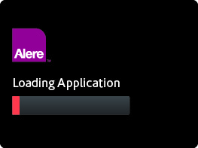
Enter User ID  Press √ after entry. | 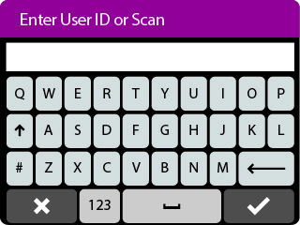
Touch ‘Run Test’  This will begin the test process. | 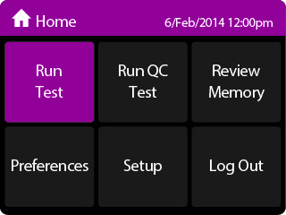
Touch ‘Strep A Test’  This starts a Strep A test. | 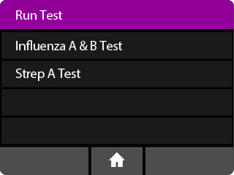
Enter Patient ID using on screen keyboard or barcode scanner.  Touch √  Verify that the ID was entered correctly, then touch √ to confirm entry. | 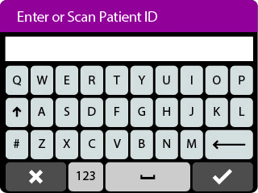
Step 2  Open the Lid and Insert Orange Test Base into the Orange Test Base holder  Caution: Do not apply excessive force. Excessive force could damage the instrument. | 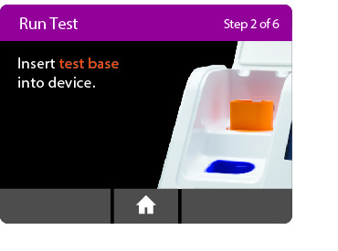
Confirm that the correct test is displayed on the screen.  Touch OK to continue. | 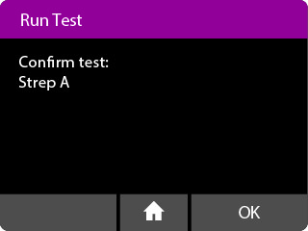
Caution: Once the Test Base has been placed in the holder, the user will have 10 minutes to confirm the test. If the test is not confirmed within 10 minutes, the instrument will time out and the Test Base must be removed and discarded.
If the incorrect Test Base has been inserted, remove and dispose of the incorrect Test Base. Close the lid. The instrument will then run a self-test before proceeding to the Home screen. Press Run Test and restart the test using the correct Test Base.
Step 3  Insert Blue Sample Receiver into the Blue Sample Receiver holder  Caution: Do not apply excessive force. Excessive force could damage the instrument.  Caution: Confirm that the foil seal on the Sample Receiver indicates that it is for use with the Alere™ i Strep A. If not, then remove the Sample Receiver and replace it with a new Sample Receiver for Alere™ i Strep A. | 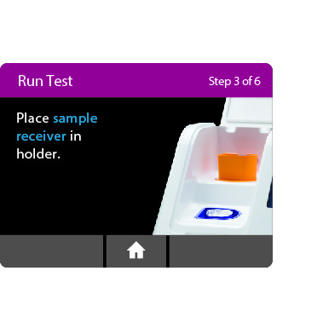
Caution: Once the Sample Receiver has been placed in the holder, the user will have 10 minutes to start the test (Steps 3 through 5). If the test is not started within 10 minutes, the instrument will time out and all test pieces (Test Base and Sample Receiver) must be removed and discarded. The instrument will proceed to the Home Screen. Press Run Test and restart the test using a new Test Base and Sample Receiver.
Wait for the Sample Receiver to Warm Up.  Caution: DO NOT REMOVE THE FOIL SEAL UNTIL PROMPTED BY THE INSTRUMENT. DO NOT close the lid or insert the swab sample until prompted by the instrument. | 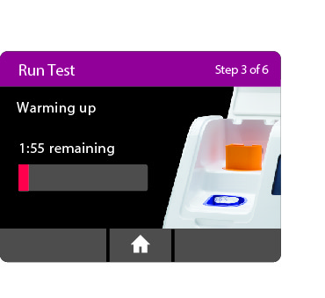
Step 4  When prompted, remove the foil seal and place the patient swab to be tested into the Sample Receiver.  Vigorously mix the swab in the liquid for 10 seconds. Press the swab head against the side of the Sample Receiver as you mix it. This helps remove the sample from the swab. Once the swab is removed, touch OK to proceed.  Caution: To ensure the Sample Receiver remains in the instrument while removing the foil seal, place two fingers along the outer edge of the Sample Receiver to hold it in place. If the Sample Receiver spills after warm up, cancel the test by pressing the Home button. Remove and discard the test pieces (Sample Receiver and Test Base) and clean the instrument. Press Run Test to start a new test using a new Test Base and Sample Receiver.  Discard the swab. | 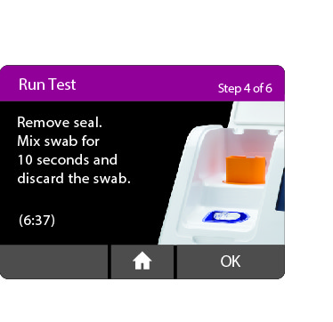
Step 5a  Press the White Transfer Cartridge into the Blue Sample Receiver.  Listen for a click.  When the Transfer Cartridge is properly attached to the Sample Receiver, the orange indicator on the Transfer Cartridge will rise. If the orange indicator does not rise, continue pushing onto the Sample Receiver until it does.  Caution: The orange indicator should be observed closely. If the orange indicator does not fully rise, the Transfer Cartridge may not collect enough sample and may lead to false negative or invalid results. | 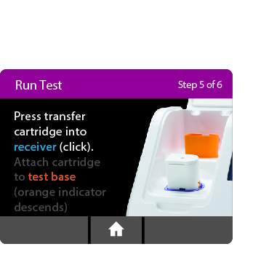  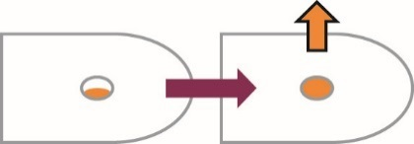
Step 5b  Lift and then connect the Transfer Cartridge to the Test Base  When the Transfer Cartridge is properly attached to the Test Base, the orange indicator on the Transfer Cartridge will descend. If the orange indicator does not descend, continue pushing onto the Test Base until it does.  Caution: If the orange indicator does not fully descend, not enough sample will be dispensed. This may potentially result in invalid or false negative results. | 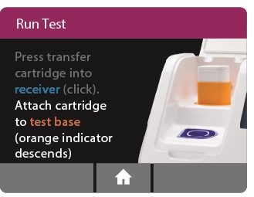  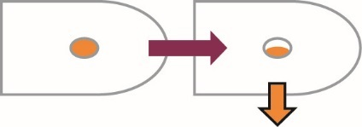
Step 6  Close the Lid.  DO NOT OPEN THE LID until the Test Complete message appears on the screen.  Note: The test will be cancelled if the lid is opened.  Caution: This screen will be displayed for up to 30 seconds once the Transfer Cartridge is detected. If the instrument does not detect that the lid has been closed by then, it will time out and all test pieces (Sample Receiver, Test Base, and Transfer Cartridge) must be removed and discarded. The instrument will proceed to the Home screen. Collect a new sample from the patient. Press Run Test and restart the test using a new Test Base and Sample Receiver. | 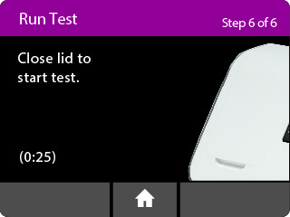
Caution: DO NOT OPEN THE LID. The test will be cancelled and all test pieces (Sample Receiver, Test Base, and Transfer Cartridge) must be removed and discarded. A test result will not be reported or saved in the instrument memory. | 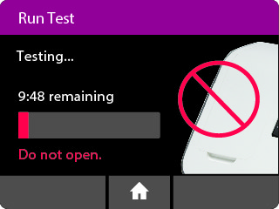
When amplification and detection is complete, the instrument will automatically save the data before advancing to the results screen.  Caution: The test is not saved until the completed result is displayed. Do not open the lid until the results are displayed. | 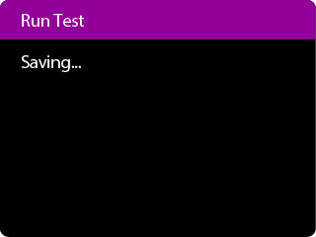
The Test Results screen displays either a Negative or Positive result for a successfully completed test. If a test error occurs, the display will read ‘Invalid’. Refer to the Result Interpretation Section for the Interpretation of Results.  Press Print to print test results, press New Test to run another test, Press Home to return to the Home screen. | 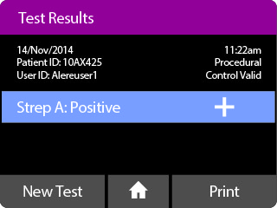
After printing, or if New Test or Home are selected, the instrument will prompt to open the lid and discard the used test pieces. | 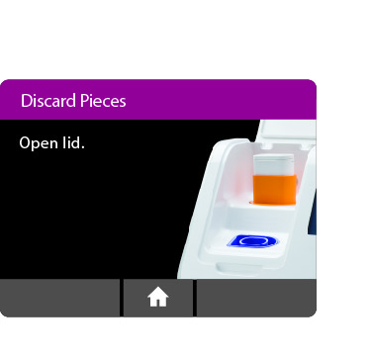
Remove test pieces by lifting the Transfer Cartridge attached to the Test Base, and clicking it into the Sample Receiver, by pressing into the Sample Receiver.  Caution: Do not try to remove the Sample Receiver by any other method as there is a risk of spilling the patient sample.  All test pieces will be connected and can now be removed from the instrument and disposed of according to federal, state and local regulations.  Caution: DO NOT disassemble the Transfer Cartridge and the Test Base before disposal. | 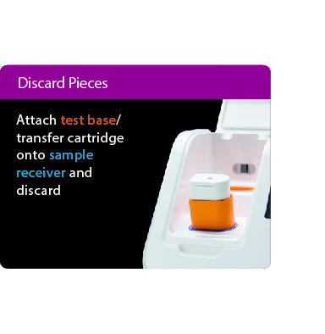
Close the lid. The instrument will then run a Self-Test before showing the Home screen or Enter Patient Data screen, depending on the previous selection.
For QC testing, select Run QC Test on the Home screen, and follow the displayed instructions. Refer to Running a QC Test in the Alere™ i Instrument User Manual for further details.
- Touch ‘Run QC Test’ | 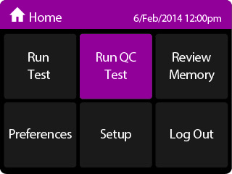
- Touch ‘Strep A Test’ | 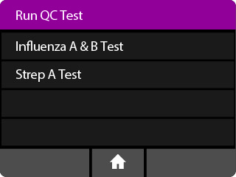
- Select the QC Test to be Run | 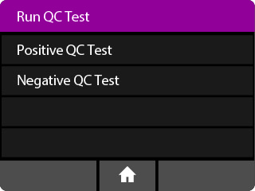
- Confirm Test  Confirm the test type to match the QC sample intended for testing by touching ‘OK’ and following the on screen prompts to complete testing.  Note: The QC test is run in the same manner as a Patient Test. See the To Perform a Test section above for step by step instructions. | 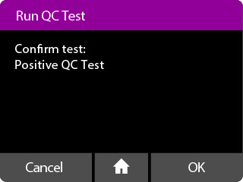

RESULT INTERPRETATION
When the test is complete, the results are clearly displayed on the instrument screen.

Instrument Display | Suggested Report
 | Positive for Strep A nucleic acid.
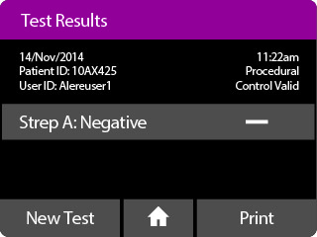 | Negative for Strep A nucleic acid.
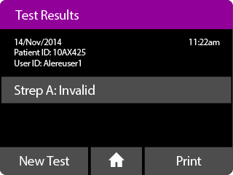 | Invalid.  Immediately repeat testing of the sample using new test components. If repeated Invalid results are obtained, repeat test with a new patient sample and new test components.

If an Invalid result is received, one additional test may be run using the same Sample Receiver. The instructions below should be followed:
- Remove the connected Test Base and Transfer Cartridge from the instrument and connect the Test Base portion to an UNUSED Sample Receiver. The connected Test Base and Transfer Cartridge MUST be attached to a Sample Receiver prior to disposal. The Sample Receiver from a new Transfer Cartridge package may be used for this.
- Remove the blue Sample Receiver separately and carefully from the instrument. The Sample Receiver should be retained and kept upright, to avoid spilling the liquid contents.
- From the Home Screen, start a new test. Follow the screen prompts, however when asked to insert the Sample Receiver, reuse the Sample Receiver and DO NOT re-elute the swab.

REPORTING OF RESULTS

Results of Group A Strep will be reported as POSITIVE or NEGATIVE. All results are to be recorded on the patient log sheet and reported directly to the requesting provider upon completion of the test. The patient log sheet will be submitted each day of patient testing to the Ancillary Testing Coordinator along with the regular shipment of patient specimens. The Ancillary Testing Coordinator will enter the results into the hospital computer system after reviewing the log sheet for proper recording of patient information and procedural controls has taken place.

Normal Value: Streptococcus A – Negative

Critical Value: N/A. All results are immediately reported to provider and notification is recorded on the patient testing result form.

.
MAINTENANCE

Routine maintenance other than cleaning is not required for the Alere i System. Clean and/or decontaminate as needed.
- Make sure the analyzer stays dry. If liquids enter the electronics compartment, the battery compartment, or the cartridge port, the analyzer may be damaged.
- Clean the display screen with lintless tissue or alcohol pad when dirty. Before use, squeeze the excess liquid from the pad.
- To decontaminate the i-STAT System, wipe the surface with Super Sani-Cloth disposable wipes or 10% bleach solution.
- Inspect and clean the cuvette opening as required. Remove residual dried blood or other foreign matter using an alcohol wipe or a swab moistened with 10% bleach. Wipe instrument with a water dampened cloth to remove bleach from the plastic surfaces. Use Super Sani-Cloth disposable wipes to clean and disinfect areas contaminated with blood. DO NOT use solvents or strong cleaning solutions as they may damage the instrument's plastic components.
- Exercise universal safety precautions at all times when handling the analyzer, cartridges, and peripherals to prevent exposure to blood-borne pathogens.
- The analyzer is NOT designed to be sterilized or autoclaved by any method.
- Dispose of cuvettes in biohazard trash.

Calibration

No calibration needed

CALIBRATION VERIFICATION

VERIFICATION/CORRELATION OF INSTRUMENT/METHOD ASSESSMENT

- When more than one instrument/method is used to test a given analyte, correlation will be performed against each instrument/method twice a year.
- CAP surveys, QC materials, or patient samples will be used for comparison.
- Instrument verifications are performed twice a year using matrix appropriate materials.
- When results fail, a corrective action form is filled out. Affected lot numbers cannot be used for patient testing until errors are resolved.
- If repeat calibration/verification fails, contact technical support.

Calibration verification is a procedure intended to validate instrument performance according to manufacturer expectations. Run a positive and negative control for the following conditions:

- Before any new Alere i system is placed into use.
- To verify that results have not been affected by major maintenance or repair.
- To troubleshoot when control values are out-of-range or reflect an unusual trend or shift.
- As recommended by manufacturer
- With each untrained operator
- At least every six months

TROUBLESHOOTING

When the analyzer detects a potential or real problem before the test cycle is initiated or at any time during the test cycle, an “invalid” result will be displayed.

Contact the Ancillary Testing Office at extension 53026 or 53034 for assistance. If the error cannot be resolved, a loaner Alere i will be available for use.

Alternative Procedure
Should the Alere i System become inoperable for any reason, specimens should be collected and submitted to the laboratory for testing. Keep specimens refrigerated until testing.

Precautions

- PRECAUTIONS
- For in vitro diagnostic use.
- For US Customers Only: Federal Law restricts this device to sale by or on the order of a licensed practitioner.
- To be used in conjunction with the Alere™ i Instrument.
- Leave test pieces sealed in their foil pouches until just before use.
- Do not tamper with test pieces prior to use.
- Do not use kit past its expiration date.
- Do not mix components from different kit lots.
- Solutions used to make the control swabs are inactivated using standard methods. However, patient samples, controls, and test pieces should be handled as though they could transmit disease. Observe established precautions against microbial hazards during use and disposal.
- If any assay components are dropped, cracked, found to be damaged or opened when received, DO NOT USE and discard. Do not use scissors or sharp objects to open foil pouches as damage to test pieces can occur. Do not touch the test tubes contained within the Test Base.
- Do not use a Transfer Cartridge if it is dropped after aspiration of the sample. If the Transfer Cartridge is dropped, discard the component and continue the test by transferring the sample with a new Transfer Cartridge.
- Do not open the Sample Receiver before placing in the instrument. It will prohibit the Elution Buffer from reaching temperature and may impact test performance.
- If the Sample Receiver is spilled while opening, clean the instrument per instructions provided in the instrument User Manual and cancel test. Repeat test with a new Sample Receiver.
- All test pieces must be removed from the instrument according to removal instructions displayed on the instrument, and disposed of according to country and local requirements. Pieces must not be separated once they are assembled.
- All test pieces are single use items. Do not use with multiple specimens.
- Once reacted, the Test Base contains large amounts of amplified target (Amplicon). Do not disassemble the Test Base and Transfer Cartridge. In the case of a positive sample, this could lead to amplicon leakage and potential Alere™ i Strep A false positive test results.
- At a low frequency, clinical samples can contain inhibitors that may generate invalid results.
- Due to the high sensitivity of the assays run on the instrument, contamination of the work area with previous positive samples may cause false positive results. Handle samples according to standard laboratory practices. Clean instruments and surrounding surfaces according to instructions provided in the cleaning section of the instrument User Manual. Refer to Section 1.6, Maintenance & Cleaning, for further information.
- Do not touch the heads of the Control Swabs. Cross contamination with the Positive Control Swabs may occur due to their high target level and the sensitivity of the assays run on the instrument.
- Test results should be interpreted in conjunction with other laboratory and clinical data.
- The performance of Alere™ i Strep A was evaluated using the procedures provided in this package insert only. Modifications to these procedures may alter the performance of the test.
- False negative results may occur if a specimen is improperly collected, transported or handled; or if inadequate quantities of target DNA are present in the system.
- To avoid contamination, do not move the Alere™ i Instrument during a run or until all assay components have been removed from the instrument.
- The orange indicator should rise when the Transfer Cartridge is pressed into the Sample Receiver until a click is heard. The indicator should descend fully when correctly connected to the Test Base. Failure to follow this procedure may lead to false negative or invalid results.

LIMITATIONS
- Alere™ i Strep A does not distinguish between viable and nonviable organisms.
- Performance of Alere™ i Strep A has not been established for monitoring treatment of pharyngitis caused by Group A Strep.
- Alere™ i Strep A will not differentiate asymptomatic carriers of Group A Strep from those exhibiting streptococcal infection.
- False-negative results may occur in the presence of assay inhibitors when levels of S. pyogenes DNA are close to the limit of detection of the assay.
- False-negative results may occur if a Sample Receiver for an assay other than Alere™ i Strep A is used.

INTERFERING SUBSTANCES
The following substances, naturally present in throat swab specimens or that may be artificially introduced into the throat, were evaluated with Alere™ i Strep A at the concentrations listed below and were found not to affect test performance.
Substance | Concentration
Whole Blood | 5.0% (v/v)
Mucin | 0.016% (w/v)
Human Saliva | 10% (v/v)
Ibuprofen | 15.4 mg/mL
Acetaminophen | 19.4 mg/mL
Acetylsalicylic acid | 12.4 mg/mL
Albuterol | 0.5 mg/mL
Diphenhydramine HCL | 2.7 mg/mL
Cepacol® Sore Throat Lozenges - cherry | 20% (w/v)
Sucrets® Sore Throat & Cough - cherry | 20% (w/v)
Halls Plus® – Honey Lemon | 20% (w/v)
ACT® Total Care – Fresh Mint | 20% (v/v)
Cepacol® Mouthwash | 20% (v/v)
Listerine® Antiseptic Mouthwash - Original | 20% (v/v)
Crest® Complete Multi-Benefit Whitening + Deep Clean Toothpaste | 0.16% (w/v)
Zicam® Oral Mist – arctic mint | 20% (v/v)
Chloraseptic® Max Sore Throat Relief + Coating Action – wild berry | 20% (v/v)
Contact Cold & Flu Tablets - Night | 20% (w/v)
Robitussin® Maximum Strength Nighttime Cough DM | 20% (v/v)
Tylenol® Cold Multi-Symptom Liquid | 20% (v/v)
Children’s Dimetapp® Cough & Cold | 20% (v/v)
When Mucin was tested at a concentration of 2%, 0.4%, and 0.08%, false negative results were observed.

When Crest® Complete Multi-Benefit Whitening + Deep Clean Toothpaste was tested at 20% and 4% invalid results were observed. Additionally, false negative results were observed when tested at a concentration of 0.8%.

REFERENCES
- Wannamaker, L.E. (1979) Reviews of Inf. Dis. 1:967-973.
- Manual of Clinical Microbiology, 6th Edition, ASM. (1995) pg. 301.
- American Academy of Pediatrics. Red Book: 2012 Report of the Committee on Infectious Diseases. Pickering LK, ed. 29th ed. Elk Grove Village, IL: American Academy of Pediatrics; 2012.US Department of Health and Human Services PHS/CDC/NIH. Biosafety in microbiology and biomedical laboratories, Washington DC: US Government Printing Office, 2007.
- Shea, Y.R., Specimen Collection and Transport, in Clinical Microbiology Procedures Handbook, Isenberg, H.D., American Society of Microbiology, Washington, D.C., 1.1.1-1.1.30, 1992.

