Precision Dx Quick Cup Urine Drug Screen CLIA Waived
- PRINCIPLE
  - The Precision Quick Cup M2000 tests are competitive binding, lateral flow, immunochromatographic assays for qualitative and simultaneous detection of Amphetamine (AMP), Barbiturates (BAR), Benzodiazepines (BZO/BZD), Buprenorphine (BUP), Cocaine (COC), Marijuana (THC), Methamphetamine (MET), Methadone (MTD), Morphine (Opiates) (OPI) and Oxycodone (OXY).

  - Intended Use: The test may yield positive results for the prescription drugs Buprenorphine, Oxazepam (Benzodiazepine), Secobarbital (Barbiturate) and Oxycodone when taken at or above prescribed doses. It is not intended to distinguish between prescription use or abuse of these drugs. Clinical consideration and professional judgement should be exercised with any drug of abuse test result, particularly when the preliminary is positive. The test only provides preliminary results. A more specific alternative chemical method must be used in order to confirm positive results. GC/MS or LC/MS is the preferred confirmatory method.

- SPECIMEN COLLECTION
  - Directly observe collection of urine sample at request of ordering provider and/or if sample adulteration or questionable results are suspected.
  - Have patient collect at least 30 cc of urine in a clean catch urine cup (BD Vacutainer Urine Complete Cup Kit REF# 364957)
  - Fill three yellow-top, no additive urinalysis evacuated tubes (BD Vacutainer UA No Additive REF#3649790) using the needle adapter on the lid of the cup.

- REAGENT, SUPPLIES, AND EQUIPMENT
  - 1 -BD Vacutainer Urine Complete Cup Kit REF# 364957
  - 3 - BD Vacutainer UA No Additive REF#3649790
  - 1 – American Screening Corporation Precision Dx Multi-Panel Drug Test Cup REF# PREDX-CUP5104N
  - Do not use kits or collection equipment beyond their expiration date. Store drug test cups and all collection supplies at room temperature (18-25 C) .

- QUALITY CONTROL
  - Each new shipment or new lot number of drug screen kit must be tested with a known positive and a known negative quality control sample that yields the appropriate intended result for each test analyte prior to patient testing. Quality control testing must be repeated every 30 days or when a new kit or shipment arrives, whichever comes first. Quality control results must be acceptable, recorded and records stored according to laboratory requirements.
  - Each individual drug analyte also has its own internal control within each test cup. The internal control must be valid per the manufacturers instructions in order to report patient results for that analyte.
  - Test personnel must be properly trained by the Ancillary Testing Coordinator initially and competency maintained in order to perform and report patient results.

- PROCEDURE
  - After completion of specimen collection in 2.0 above, open a new Precision DX Multip-Panel Drug Test Cup. Ensure that the cup is within acceptable expiration date.
  - Pour the contents of two yellow top BD UA No Additive tubes into the cup and screw on the lid until it clicks shut. NOTE: To ensure that the temperature strip registers within the acceptable temperature range (90 – 100 F), add sample to the cup within 2 to 4 minutes after patient has voided.
  - Label the cup with patient name, ID number and date and time of collection.
  - Place the cup on a flat surface. Using a calibrated timer, such that provided by a smart phone, set a timer for 5 minutes.
  - After 5 minutes, read the results according to illustration on the test cup package, package insert or in 6.0 below.

- RESULTS AND INTERPRETATION
  - Negative Result: Two colored bands appear on the strip. One appears in the control region
(C) and another band appears in the test region (T).
Preliminary Positive Result: Only one colored band appears in the control region of the strip (C). No apparent colored band appears in the test region (T).
Invalid: If NO line appears in the control region (C), of the strip, then results are invalid and cannot be interpreted for the test region (T) of the strip, regardless of whether or not a line appears in the (T) region.

  - Interpretation Diagram:
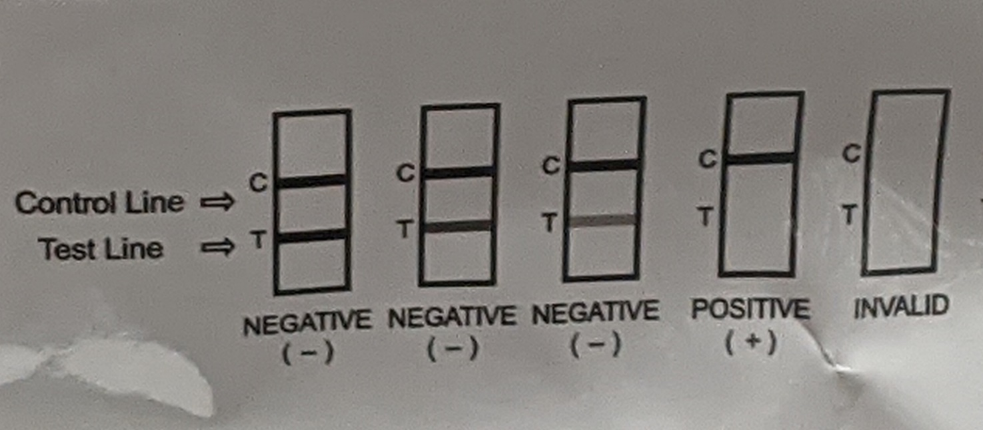

- LIMITATIONS OF THE PROCEDURE
  - Test is for urine only. Do not use whole blood, plasma, serum or other body fluids
  - Results may be adversely affected by additives or sample adulteration. If results are suspect, repeat testing with a fresh sample and kit cup.
  - A false positive test may occur with certain drugs in similar or same drug classes as those in the test cup. Certain foods and supplements may also yield false positive results. Consult the package insert for performance characteristics of each drug tested in this kit. Positive results should be confirmed using an alternate method of testing. Contact the main lab at CVVAMC for information on what confirmatory test should be ordered.
  - A false negative result may occur when samples are diluted or altered or if the drug in question is present at levels below the cut-off detection limit for the test kit. Consult the package insert of specific detectability cut-off levels and time to detection for each specific drug in the kit.

- REFERENCES AND ADDITIONAL RESOURCES
  - Precision Dx Quick Cup M2000 package insert
  - Tests Granted Waived Status Under CLIA, https://www.cms.gov/Regulations-and-Guidance/Legislation/CLIA/Downloads/waivetbl.pdf
  - CLIA Waived Urine Drug Screens, search engine. https://www.accessdata.fda.gov/scripts/cdrh/cfdocs/cfCLIA/Detail.cfm?ID=39943&NoClia=1

