The Correct Way To Use A Safety Shower In An Emergency

How to Use a Safety Shower
In the event of an emergency involving corrosive substances, it is crucial to know how safety showers are operated. The moment a corrosive chemical comes into contact with skin, it begins to cause tissue damage - and the damage becomes more serious with each passing second. That’s why it’s so important to make sure your staff know exactly when and how to use safety showers before the unthinkable happens.

When to use a safety shower
Safety showers are designed to mitigate the damage caused by exposure to corrosive, injurious substances. Corrosive chemicals include the following:

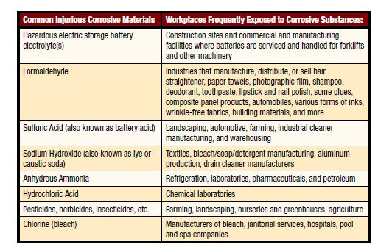

While this list is not exhaustive, it should give you a good idea of the sorts of chemicals involved. If you think you work with a corrosive chemical but don’t have access to safety showers, speak to your health and safety officer.
Once a corrosive chemical comes into contact with skin - no matter how small an amount - it is extremely important to use a safety shower as soon as possible. In accordance with the ANSI Z358.1 regulations, safety showers must be installed no more than a 10-second walk away from the hazardous area. See our guide to the ANSI regulations for more information.
Operating a safety shower can be very disruptive, and many people worry that using a safety shower will draw undue attention to themselves, or be seen as ‘making a fuss’ - but it really is better to be safe than sorry. Upon exposure to corrosive chemicals, tissue damage can occur surprisingly quickly, and once the damage is done, it’s irreversible. Even small amounts of these chemicals can cause permanent scarring and life changing injury, so it’s always better to err on the side of caution.

Before using a safety shower
Once exposure has occurred, don’t delay - make your way to the safety shower as quickly as possible. It bears repeating that the longer a corrosive chemical is in contact with flesh, the graver the injury will become.
Before entering the safety shower, it is important to remove all clothing and jewelry. Fabrics can become easily saturated with harmful chemicals and keep them in close contact with the skin, causing severe injuries.
Of course, most people feel uncomfortable about the idea of stripping naked in front of their work colleagues, but removing clothing is an essential part of the decontamination process - and besides, protecting yourself from injury is more important than saving face.

Operating a safety shower
Safety showers are designed to be simple to use. Most are operated by means of a pull lever. Once the lever has been pulled, the shower will discharge water at a specific rate and volume for at least 15 minutes, in line with the ANSI regulations.
You should stay under the stream of water for at least 15 minutes to ensure thorough decontamination. It is advisable to stay in the shower for as long as possible until medical help arrives.
When using the safety shower, be careful not to get the stream of water into your eyes, since the rate at which it is discharged is enough to cause damage. If your eyes have been contaminated with an injurious substance, you should thoroughly sluice them using an eyewash station. A combination safety shower and eye wash unit should be used in situations where both the skin and eyes have been contaminated.
In some cases, the water provided by an outdoor safety shower may be discolored by rust; however, this is no cause for concern, and you should enter the shower immediately, rather than waiting for the stream to run clear.

Safety Shower and Eye Wash Demonstration

