**How to Use an Eyewash Station**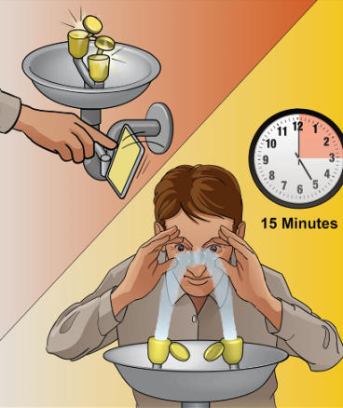

***"When a chemical or irritant enters your eyes, knowing how to properly flush them can save your sight."***

***Select Safety Sales***

**Go Immediately to the Eyewash Station – Don’t Waste A Second!**

If a chemical splashes in your eyes, time is of the essence.  GO immediately to the eyewash station which should be located within 10 seconds walking distance from you if you work with caustic chemicals.  
   
 **Push the Lever to Activate the Unit**  
Push the lever- An ANSI compliant unit will activate with one single motion.  The dust covers will pop off and the flushing fluid will begin to flow out from the faucet heads.  
  
 **Begin to Flush**  
Get your eyes directly in the stream of the flushing fluid- Immediately!  
  
  
**Hold Your Eyes Open with Your Fingers**  
An ANSI compliant unit will be hands free so that you do not have to hold the lever open.   Once activated, the unit will stay on.   Keep your eyes open by holding your eyelids apart with your fingers.  
   
  
**Roll Your Eyes**Gently roll your eyes from left to right and up and down to be sure that the fluid is flushing all of the areas of your eye.  
   
  
**Flush for a Full Fifteen Minutes**  
  
Continue Flushing your eyes for a full 15 minutes.  The temperature in an ANSI compliant eyewash will be between 60 and 100 degrees fahrenheit so that you will comfortably be able to continue flushing for the entire period of time.  This is important because you want to fully dilute the chemical and wash it out of your eyes.  Any time less than 15 minutes is NOT enough time to accomplish this.  
  
  
**Take Out Your Contacts**If you have contact lenses in your eyes, you can gently take them out while you are flushing. Don’t delay the flushing to take out your lenses but make sure that you take them out because they could trap the chemical in your eyes.  
  
  
**Seek Medical Help**After you have flushed, see a doctor to determine if anything more needs to be done for the preservation of your vision.

[Safety Shower and Eye Wash Demonstration](https://gcc02.safelinks.protection.outlook.com/?url=https%3A%2F%2Fwww.bing.com%2Fvideos%2Friverview%2Frelatedvideo%3Fq%3Dhow%2520to%2520use%2520an%2520eyewash%2520station%2520and%2520a%2520safety%2520shower%2520Power%2520Point%26mid%3DEBD4F92F322BD7B122FBEBD4F92F322BD7B122FB%26ajaxhist%3D0&data=05%7C02%7C%7Cfbda6291753a4badac5a08ddb7df112f%7Ce95f1b23abaf45ee821db7ab251ab3bf%7C0%7C0%7C638868890877247490%7CUnknown%7CTWFpbGZsb3d8eyJFbXB0eU1hcGkiOnRydWUsIlYiOiIwLjAuMDAwMCIsIlAiOiJXaW4zMiIsIkFOIjoiTWFpbCIsIldUIjoyfQ%3D%3D%7C0%7C%7C%7C&sdata=5tVUaqSZzZThjg4290wQNCs6lnaSWRJJAiyyS8Vmxyk%3D&reserved=0)