Refresher for Class of 2017-18

It is important to discuss what activities are planned for the day. Encourage the student to be an active learner, to tell you when they do understand and to ask questions. However, you may need to ask probing questions to test their understanding as well. Once the student gains confidence and becomes more comfortable with the clinical routine and you are comfortable with their performance, allow the student more independence to test their abilities. You must still watch over them as they perform their work and you may need to revise your expectations as the student progresses through their clinical experience.


Remember!
- We may want students to be able to reach performance levels of an experienced practitioner during their experience (proficiency). This is not really appropriate because they are just beginning their careers.
- Remember how you felt when you were a new graduate and how much training was required when you first started out.
- The focus of laboratory education is to develop competent individuals to enter the workforce.
- Yes, there are some skills where they should be competent – basic skills in each laboratory discipline. Full laboratory proficiency will come with time.
- Along with modeling professional behaviors, clinical preceptors are the student’s guide when corrective action is needed. Students need to be informed when behavior is unacceptable and given the opportunity to make adjustments. Point out what aspect needs improvement and what behaviors are desired. Often if you explain why it is important, they will see the value of changing. Your intervention could be all that’s needed for success.

The core exams and previous coursework evaluate the student’s knowledge, or cognitive skills. Our primary evaluations then are of psychomotor and affective objectives, so the manual or physical performance of procedures and professional attitudes and values that guide behaviors. Student performance in the clinical laboratory can readily be observed but it is not always easy to obtain objective information for evaluation (grading) purposes.
Checklists work best for psychomotor objectives, and rating scales are better for measuring affective objectives.

CLINICAL ROTATION COMPETENCIES

Scoring key and guide for 2017-18 revisions of competency checklists.

The goal of the revised checklists is to try to improve the format (got rid of all the little boxes) while aligning the checklist using statements that mimic or are like those that students may encounter as employees undergoing competency assessment. However, unlike competency assessment of an employee, we cannot expect students to be fully competent or proficient at the end of a clinical rotation. This requires assigning scores to checklist items.

Students will still be scored on achievement of the checklist items, but this will be recorded differently. First, the scoring has changed to scores of 1-4. These are like the previous minimum pass levels, and they are defined below:

1. Discussed: Reagents, sample and equipment discussed or principle explained.
Student is responsible for being able to explain the above in his/her
own words, demonstrating understanding.

2. Demonstrated: Test or procedure has been demonstrated by instructor. Student is
responsible for careful observation of demonstration and asking
questions about any phase not understood.

3. Practiced: Student has had procedure/theory discussed. Is responsible for
practicing performance of procedure or applying theory to work.
May not report out results because has not developed consistently
accurate results.

4. Minimum Student is responsible for correctly performing test or operating
supervision: instrument under direct supervision with minimum checking by instructor. Control values obtained are acceptable to standard laboratory protocol and patient results are reportable. Results are reviewed by instructor before being reported.

The next difference is that some items have expected score ranges. The idea here is that students are expected to achieve at least the lowest level listed, but if they achieve a higher score that is acceptable too. These ranges can help identify students who excel beyond the expected level while also taking into account that each student’s clinical experience will differ just due to the nature of the clinical practicum. An example of this could be a task that only gets performed periodically. Often the range of score for such a task might be 2-4; depending on the rotation a student may encounter and perform the task while the next student that rotates through might only see something demonstrated or practiced the task once.

Instructors will circle the score achieved and initial in the box next to the score. Finally, there is an area for instructors to make notes. This can be used in any way that instructors see fit. On the next pages you will see an example of portions of the new chemistry competency checklist.

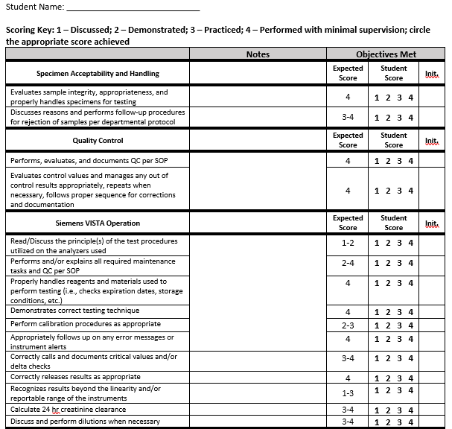
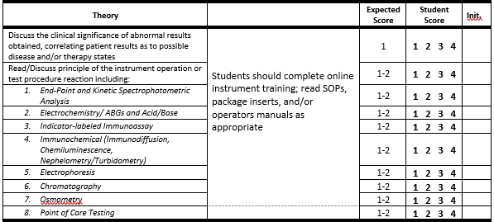
Finally, refresher on errors associated with evaluations:
Advantages: The results of the tool can yield specific, concrete feedback for the student when filled out thoughtfully and with specific comments to support evaluating decisions.
Disadvantages: Our tool often relies on instructor recall of student performance, which is unreliable and may be influenced by the students most recent performance. Also, while we use specific definitions for anchor points to help the objectivity of the tool, there are inherent subjective judgments that can be made by even the most well-meaning instructor/evaluator. These are as follows.

May also be described the “benefit of the doubt.”
These are things written by some of your peers who have received excellent and positive feedback from students.

I think it helps me to know what it was like years ago with “older” techs. Our relationship was different, we respected the techs because they were older vs now the students and the techs are similar in age and gaining respect in a teacher/student relationship may be more difficult (especially if personalities differ). Some of the things I see now, would never fly years ago, but it’s the age gap that changes the environment of the teacher/student. This is not the case with all young techs/students though. It may come down to the personality of the individuals, both teacher and student. Good teachers may want to teach and have a good attitude about it. Teaching is part of our job duty and it’s not going to change, so make the best of it.

