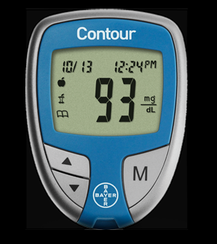

Contour Blood Glucose Monitor is used to monitor glucose concentration in:

* Whole blood
* Serum
* both

You need to code the meter to make sure you get accurate results:

* False
* True

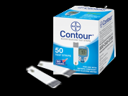

The expiration date on this test strip box is 12/01/12. The bottle was opened on 01/12/12. You should not use the strips after:

* The expiration day 12/01/12
* 04/12/12
* 07/12/12

Control should be stored at:

* Room temp
* 2°-8°
* Freezer

Quality control should be performed with Contour control solutions when:

* Opening a new lot of Contour test strips.
* Using a new meter
* Verifying the accuracy of a test result
* All of the above