 |  | FIRE TYPE
TYPE EXTINGUISHER | CLASS "A" | CLASS "B" | CLASS "C"
Carbon Dioxide (CO₂)  BC Fires Only  Operating rooms  C-Section Room  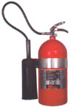 | NO  They don't work very well on class A fires because the material usually reignites. | YES  Excellent  Carbon dioxide leaves no residue, does not affect equipment or food | YES  Excellent  Carbon dioxide is a non-conductor, will not damage equipment and leaves no residue
Dry Chemical  ABC Rated  Throughout the hospital  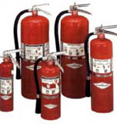 | YES  Excellent for ordinary materials like burning paper, lumber, cardboard, plastics etc. | YES  Excellent  Chemical absorbs heat and releases smothering gas on fire | YES  Excellent  Chemical is a non-conductor
MRI Center or nuclear magnetic resonance spectrometers (NMR's)  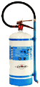 | YES  Provides safety from electric shock and reduces scattering of burning materials | NO | YES  Ideal for Class A fires where a potential Class C hazard exists.
  - Class A fires are ordinary materials like burning paper, lumber, cardboard, plastics etc.

  - Class B fires involve flammable or combustible liquids such as gasoline, kerosene, and common organic solvents used in the laboratory.

  - Class C fires involve energized electrical equipment, such as appliances, switches, panel boxes, power tools, hot plates and stirrers. Water can be a dangerous extinguishing medium for class C fires because of the risk of electrical shock unless a specialized water mist extinguisher is used.

