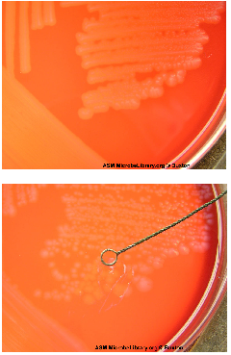
Top picture: Strep agalactiae
Bottom picture: Listeria monocytogenes

