[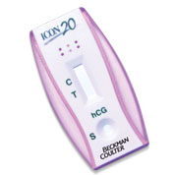](https://www.beckmancoulter.com/ucm/idc/groups/public/documents/webasset/glb_bci_052168.jpg)