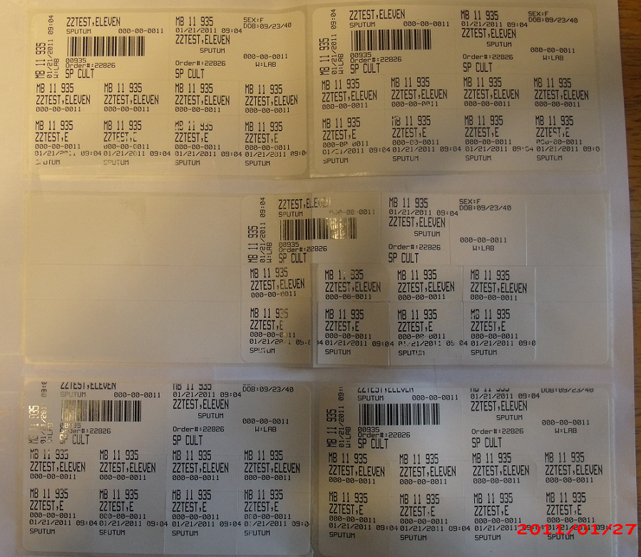

**DO NOT LABEL TUBES WITH THESE LABELS!!!**

**CALL THE BVAMC LAB @ EXT. 6519 OR 4160 FOR HELP IF THIS HAPPENS!!!**

**LABEL PRINTED CORRECTLY**

**LABELS PRINTED INCORRECTLY**

**LABELS PRINTED INCORRECTLY**

**Name cut off of the label. ☹**

**Accession number cut off of the label!!! ☹**

**DO NOT PRINT LABELS OVER THE SEAM!**

**SEAM**