[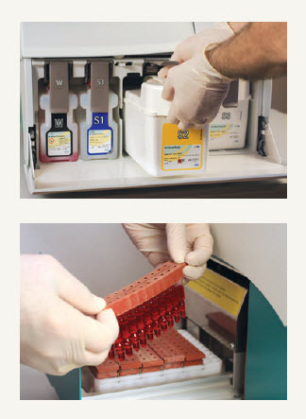](https://www.google.com/url?sa=i&rct=j&q=&esrc=s&frm=1&source=images&cd=&cad=rja&uact=8&ved=0CAcQjRw&url=https://usdiagnostics.roche.com/en/instrument/cobas-b-221-poc-blood-gas-system.html&ei=_F4IVeuFHpXloASanYKgBQ&bvm=bv.88528373,d.cGU&psig=AFQjCNGIvRlVOPwMkT4xc1FS0MEyyllizA&ust=1426698363225396)