**PRINCIPLE:**

Over 1 million species in the animal kingdom are found in the phylum Arthropods. These invertebrates are characterized by the possession of an exoskeleton, an internal hemocuele that is filled with hemolymph and internal organs, and a body that is usually divided into the head, thorax, and abdomen. Arthropods develop through a process called metamorphosis, often involving three or four stages: eggs, larva, nymph and adult.

The significance of this group is due to the morbidity, mortality and wide geographic distribution of the various diseases that they transmit. Transmission of the disease may occur through mechanical transmission, in which the arthropod vector is not part of the life cycle of the organism, or biological transmission, in which the arthropod vector multiplication or development is an integral part of the organism’s life cycle. Many bacterial, spirochetal, viral, rickettsial, helminthic, and protozoal diseases are transmitted to humans by arthropods vector.

**Lyme borreliosis** ( Lyme disease) is now the most common tick-borne disease in the United States. The illness is caused by a spirochete, Borrelia burgdorferi, which is transmitted by a bite from a tick, mainly of the Ixodes ricinus complex. The disease can involve a complex series of clinical disorders. These include a classic skin rash, erythema migrans, which occurs in the early stages usually accompanied by influenza and meningitis-like symptoms. Disease progression can result in extensive neurologic, cardiac, skin, and joint involvement. Fatalities are rare, but the disease can have serious debilitating effects.

Ticks that carry Borrelia burgdorferi:

1. Ixodes damnini- deer tick
2. Ixodes pacificus- deer tick
3. Amblyomma americanum- lone star tick
4. Dermacentor variabilis (dog tick) can harbor the spirochete, but has not been shown to transmit the disease.

**Tunga penetrans**, the chingoe or sand flea, is the only flea that invades the human epidermis and produces nodular swellings that are painful and eventually ulcerate. Fertilized fleas burrow into the skin and proceed to grow as they become engorged during their feeding process. The head end pf the flea lacerates and takes blood from the dermal blood vessels, while the posterior end remains exposed to the air through the small hole in the keratin. Eggs are extruded through this hole. Cutaneous lesions occur principally on the ankle, instep, between the toes, and under the nails. If a lesion is excised and sectioned, it is not difficult to make an appropriate diagnosis.

**Lice** infestations have been observed in virtually every inhabited area of the world. Persons from all social and economic backgrounds can become infested with head lice, and infestations can reach epidemic proportions in school children. Lice are transferred by close contact and the sharing of hats, combs, and brushes.

**Pediculosis corporis (**body lice) is seen primarily where there is overcrowding and poor sanitation. The body louse lays its eggs and resides in the seams of the clothing rather than on the skin of the host, the body louse leaves the clothing only to obtain a blood meal form the host. Nits that present in the clothing only are viable for up to 1 month. Besides causing significant cutaneous disease, the human body louse is a vector for epidemic typhus, trench fever, and louse-borne relapsing fever. Patients complain of pruritus and develop small erythematous macules, papules, and excoriations that are located primarily on the trunk. Persons with long-standing untreated pediculosis corporis may develop generalized hyperpigmentation and thickening of the skin with evidence of numerous healed excoriations, and entity known as “**Vagabonds disease”.**

**Pediculosis capitis,** adult head lice and nits, localize in the temporal and occipital areas of the scalp: however the entire scalp as well as the beard area may be involved. Adult lice may be difficult to see, but the nits are found at the base of the hair shaft **.** The major complaint of persons afflicted with head lice is pruritus of the scalp. Scratching leads to excoriations and secondary bacterial infection that is manifested by weeping and crusting of the scalp as well as tender occipital and cervical adenopathy. A pruritic, symmetric, morbilliform eruption may develop on the body, especially on the upper part of the trunk and arms.

**Phthirus pubis,** public lice infestation is transmitted by sexualor close body contactand less often from the sharing of clothing and bedding. The pubic louse resides primarily on pubic hair, but can also be seen in the eyebrows, eyelashes, axillary hair, and coarse hair on the back and chest of males. The primary complaint of persons infested with Phthirus pubis is marked pruritus of all affected areas, which may include axillary and coarse truncal hairs and eyelashes as well as pubic hair. One may or may not see erythematous macules and papules with excoriations and secondary infection. The nits and occasionally the adult pubic lice can be seen attached to the base of the hair. Small gray to bluish macules measuring less than 1 cm may be seen on the trunk, thighs, and upper parts of the arms. The lesions known as maculae cerulae, are felt to be caused by the anticoagulant that is injected into the skin by biting louse. Infestations can cause crusting, in which the louse will be seen at the base of the hair.

**Scabies is** a disease of great antiquity and possibly the cause of the ‘7 year itch” known to humanity for centuries. Scabies are transmitted by intimate personal contact, often sexual in nature, but casual contact, including that of nursing attendants may be adequate for transmission and institutional epidemics can occur. Most individuals infested with the scabies mite complain of intense itching that is usually more severe at night. Erythematous papules and excoriations are noted in areas of predilection such as the interdigital web spaces, wrists, elbows, anterior axillary folds, periumbilical skin, pelvic girdle, buttocks, penis, knees, and sides of feet. The scabies mite is one of the cutaneous parasites that burrow into the skin of its host. Two or three eggs are laid daily by the fertilized female in burrows several millimeters in length created at the base of the stratum corneum of the epidermis. After 72-84 hours larvae emerge and after several molts become adult mites and mate after 17 days. The males die shortly, but the gravid females proceed to burrow and complete the life cycle. The full grown adult female is only about 0.35mm in length, rounded, with three pairs of short stubby legs. The organism may be demonstrated in the burrows by application of mineral oil to the skin overlying a burrow followed by vigorous scraping to the point where minimal bleeding occurs.

Under the microscope, the scraped material may demonstrate mites, mite feces, or eggs. It is often difficult to demonstrate the organisms in older lesions or in nodular lesions.

Providers are often called upon to identify a variety of arthropods. These organisms are usually found by the patient as a result of a bite, with or without skin reaction, or present on the patient’s body or attached hair. Definitive identification can be useful in determining the patient’s diagnosis and the etiology of the disease if present.

**SAFETY:**

In addition to microorganisms and their transmission, some chemicals may be used that are potentially harmful. Please refer to SDS engine in the VA intranet for any information on these chemicals.

Proper PPE will be worn during procedure such as, lab coats, shields, and gloves.

**SPECIMEN COLLECTION AND INFORMATION:**

**SPECIMENS: The arthropod must be intact to facilitate accurate identification.**

1. **Ticks:**
2. Place forceps against skin and carefully remove tick using a direct sustained pull.
3. Place 70% ethanol in a labeled non-breakable, leak proof container. Label container with patient’s name and deliver to the laboratory ASAP. If transport is delayed, specimen should be kept at room temperature.
4. **Scabies:** Care must be taken when collecting samples for scabies infestation. It is highly contagious and has been reported to as the cause of hospital epidemics.
5. **Skin scraping technique:**

Diagnosis can be confirmed by demonstration of the mites, eggs, or scybala (fecal pellets). Because mites are located under the surface of the skin, scrapings must be made from in infected area. This **MUST** be performed by a physician.

* Place a drop of mineral oil on a sterile scalpel blade. Mineral oil is preferred over potassium hydroxide solution or water. Mites will adhere to the oil, skin scales will mix with mineral oil, refractility of differences will be greater between mite and oil, and oil will not dissolve fecal pellets.
* Allow some of the oil to flow onto the papule.
* Scrape vigorously six or seven times to remove the top of the papule. There should be tiny flecks of blood in the oil.
* Using an applicator stick, transfer the oil and scraped material to a glass microscope slide.
* Add 1 or 2 extra drops of mineral oil to the slide, and stir the mixture. Any large clumps can be crushed to expose hidden mites.
* Place a second glass microscope slide on top of the slide with the mineral oil material and tape securely together.
* Place slide in cardboard slide holder or other container and label with patient’s name, and last four of social security number. Deliver to provider for identification. If a delay, keep specimen at room temperature.

1. **Lice:**
2. Hair lice:

* Cut a few strands containing lice or pick up the louse with a forcep and tape to a glass microscope slide or place in a sterile container without preservatives.
* Also can place louse in a drop of mineral oil on slide and cover.

1. Crab lice:

* Pluck or cut the hair with the attached lice/nit
* Place arthropod on a glass microscope slide. Using cellulose tape, tape lice to glass slide. Also can place in drop of mineral oil on slide
* Place microscope slide in a cardboard slide holder or other container and label with patient’s name and last four of social security number.
* Deliver to physician for identification. If delayed in transport, keep specimen at room temperature.

**QUALITY ASSURANCE:**

1. All microscopes in use must have adequate maintenance. Clinical Engineering (CE) performs major repairs, cleaning, and maintains documentation.
2. All providers will read procedure, sign and date.
3. All providers performing this test will participate in proficiency testing three times a year. An attestation page will be signed. If survey results are unacceptable, corrective action must be documented and corrective action taken within 30 days. This can include retraining, and or the physician will discontinue performing this test.
4. Training and Competency follows the non-waived testing guidelines. The Ancillary Testing Coordinator (ATC), who represents the Chief of Pathology and Laboratory Medicine, is responsible for monitoring quality assurance activities, appropriate training, and annual competency. The Chief of any service involved in testing is responsible for designating staff personnel to interface with the ATC in order to facilitate the above monitoring activities.

**SPECIMEN LABELING:**

**All specimens sent to the laboratory MUST be properly labeled.**

The specimen container must be labeled with the name of the patient, age of patient, patient’s social security number, source and type of the specimen, time and date of collection of specimen. Ex.: “tick, left ear”. Each specimen must also arrive with a corresponding SF 515 Tissue examination form.

Any specimen that is incorrectly labeled should not be processed. The following corrective action should be taken;

1. The appropriate physician is notified immediately, and the reason that the specimen is unacceptable for identification is explained. The person reported to, date, and time are documented in the problem log in Histology.
2. The provider that collected the specimen must be paged immediately to verify specimen and label container properly.

**PROCEDURE (This is after the organism has been removed)**

1. **GLOVES/LAB COATS MUST BE WORN WHEN PERFORMING THIS PROCEDURES**
2. Remove the arthropod (tick, lice, etc.) from the container and place on a clean 1 x 3 glass microscope slide where applicable
3. Examine the slide under 10x (low power) objective. Observe the arthropod for typical morphology.
4. Identify organism. Recognition and differentiation of arthropods require strict adherence to established morphologic criteria and an experienced parasitologist to prevent misidentification.
5. Findings must be documented in the Scabies CPRS Progress Note.
6. Go to CPRS and select the patient.
7. Select the Notes Tab, New Note, Clinic Appointments; this will bring up “Progress Note Properties” display.
8. Type in the word, Scabies and press OK.

*See next page*

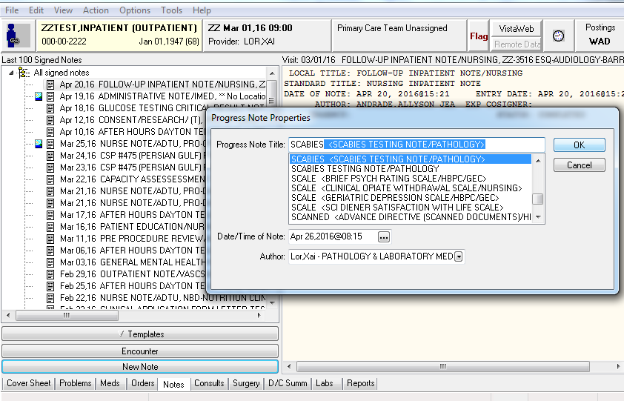

1. Enter in all the necessary result elements.

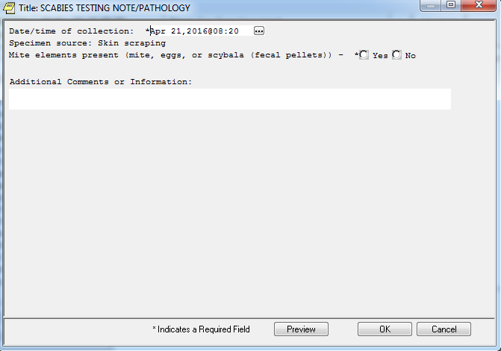

1. Arthropod will be sent to the laboratory for verification by a trained pathologist.

**Test Verification:**

The identification of arthropods is verified before reporting to ensure the accuracy and reliability of the laboratory results. This includes repeating tests were indicated, integrating the new laboratory findings and previous test results, and reviewing results in view of patient history. I.e. Foreign travel.

Tests results are verified by:

1. Identification of all arthropods is verified by pathologist.
2. Review of previous test results for similar findings and clinical history of patient if available.
3. Results are entered in VistA via a Surgical Pathology case number.

**RESULTS:**

Recognition and differentiation of arthropods requires strict adherence to established morphologic criteria and an experienced parasitologist to prevent misidentification. Reference materials are available and should be used when identifying arthropods.

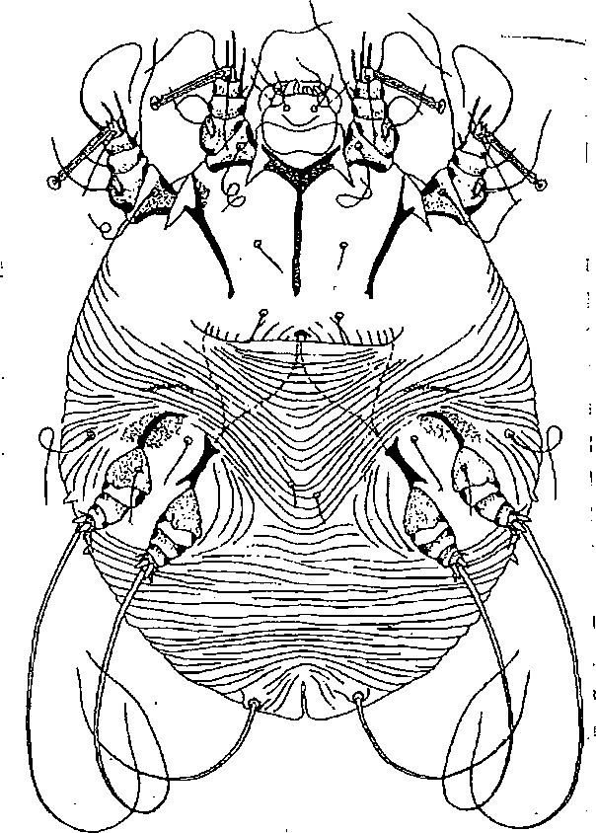

**Sarcoptes scabiei:**

**Morphology:** S. scabiei is a microscopic arthropod of ovoid contour, with chelate chelicerae, no special respiratory apparatus, and its anterior two pairs of legs well separated from its posterior two pairs. The anterior legs terminate in delicate staked discs; the posterior legs both end in long hair bristles in the female, while in the male the third pair has bristles and the fourth pair discs. The males and females are also differentiated by their size and genitalia. The female measures 330 to 450 um in length by 250 to 350 um in breadth, and the male, 200 to 240 um by 50 to 200 um. On the dorsal surface of the body there are numerous more or less parallel ridges, except for a small, smooth median area just behind the head, several mid-dorsal tooth-like spines, and in other areas longer, finger-like spines and long and short hairs. The number, type, and position of these several integumentary structures are of diagnostic importance. The ventral surface is smooth except for a few hairs and bristles. The legs are supported at their bases by chitinous-rods (epimera).

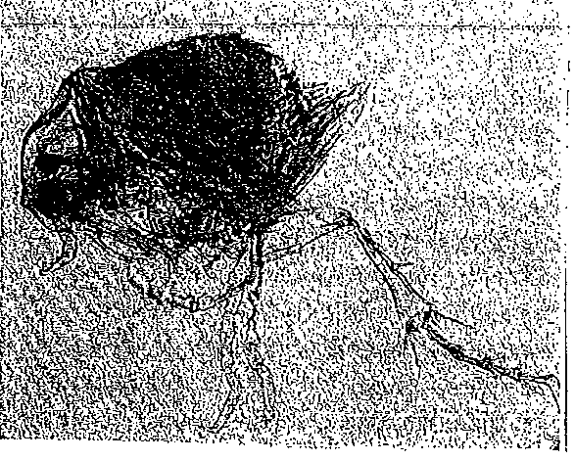

Tunga penetrans (sand flea):

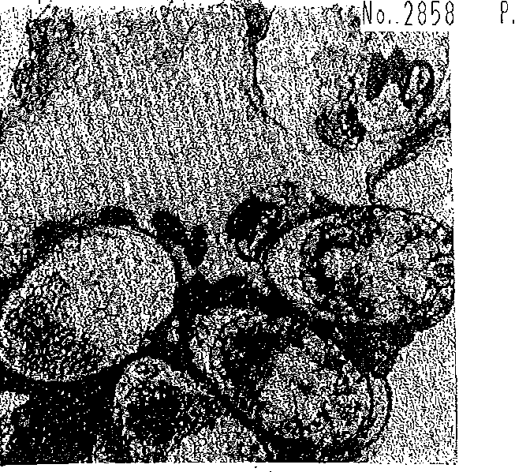

Fecal elements and eggs: Sarcoptes scabiei

**Morphology:** The frons of this species is sharply angled and proportionately larger than the head of most other fleas. The maxillae are long, stiff and distinctly serrated. The three thoracic segments are markedly foreshortened. There is no suture from the base of the antennal groove of the vortex.

**Pediculus corporis:**

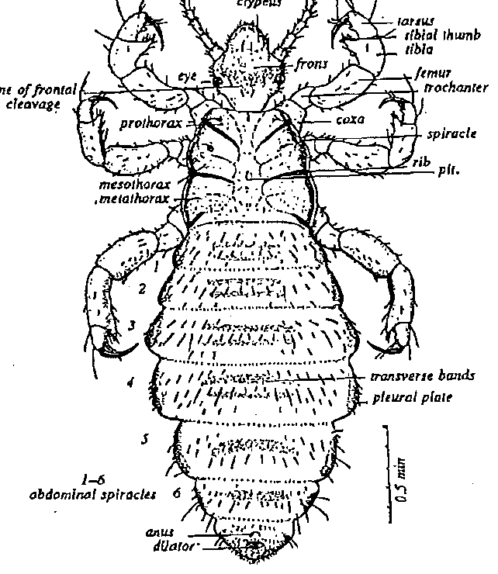

onitnna tarsal ctew

**Morphology:** Sucking lice have six legs provided with claws adapted for clinging to hairs or fibers. The head is rectangular-ovoid from the dorsal aspect. Between the eyes is the frons, anterior to which is the culpeus. The distal prolongation of the clypeus constitutes the labrum, or upper lip, which is armed internally with six pairs of minute denticles, the prestomal teeth which are everted when the louse feeds and serve to anchor its mouth to the skin of the host. When taking a blood meal, the louse first inserts its prestomal teeth into the epidermis, forces the stylets of the stabbing apparatus into the skin, deposits droplets of saliva into the wound, and with its pharyngeal pump draws blood or tissue juice up through the buccal funnel into the pharynx. The abdomen is 9-segmented, but in some species the anterior segments have become fused.

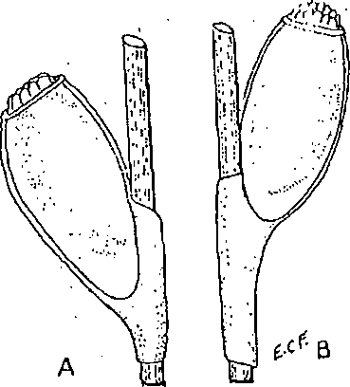 Eggs of human lice attached to hair.

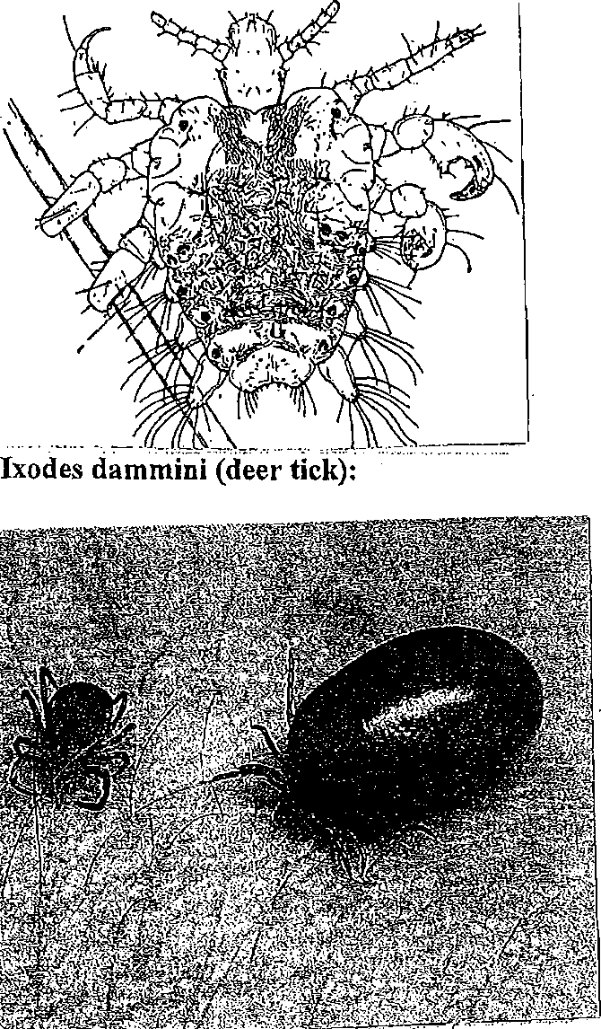

**Morphology**: The dorsal plate or shield covers the entire surface of the male, but only the anterior portion of the female, nymph, and larva. A granusoma or capitulum is attached to the anterior end of the body. Its basal portion consists of a broad chitinous ring, the posterior constricted portion of which constitutes the connection with the body. The gnathosoma carries the mouth parts consisting of the toothed hypostome, a more or less median, finger-like process, ventral to the mouth. The dorsal surface of the tick's body is characterized by having sculpturing, furrows, or color patterns that are frequently helpful in diagnosis

Another aspect of tick morphology that is useful in identification is the orientation of the anal grove. In the deer tick the anal groove is pronounced and curves toward the posterior end of the body. The anal groove of the dog tick is small and curves toward the anterior end.

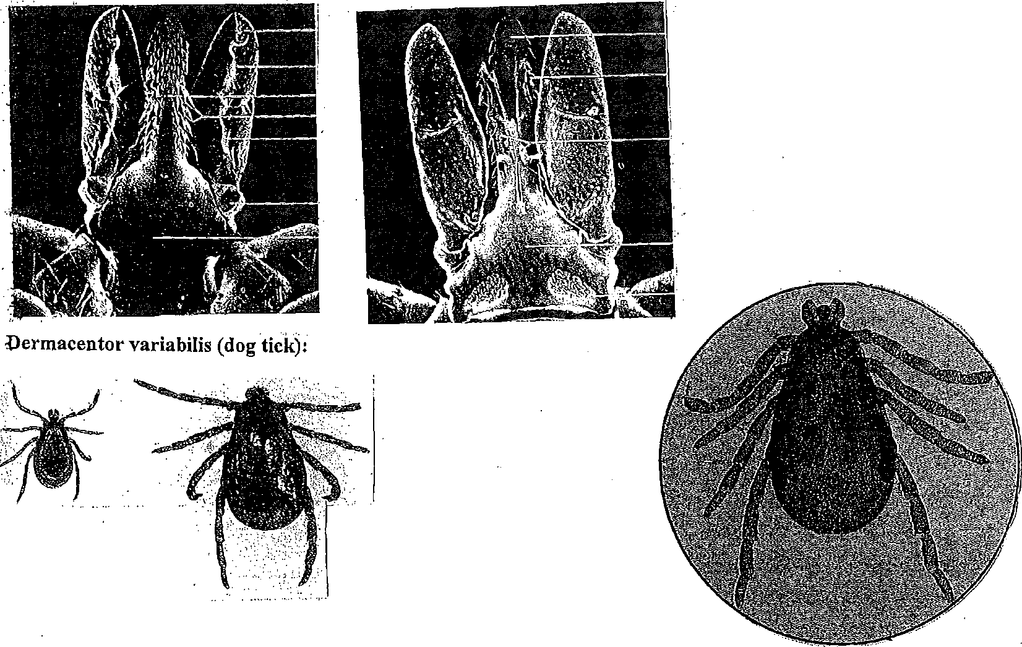

Dorsal and ventral view of mouth parts of deer tick.

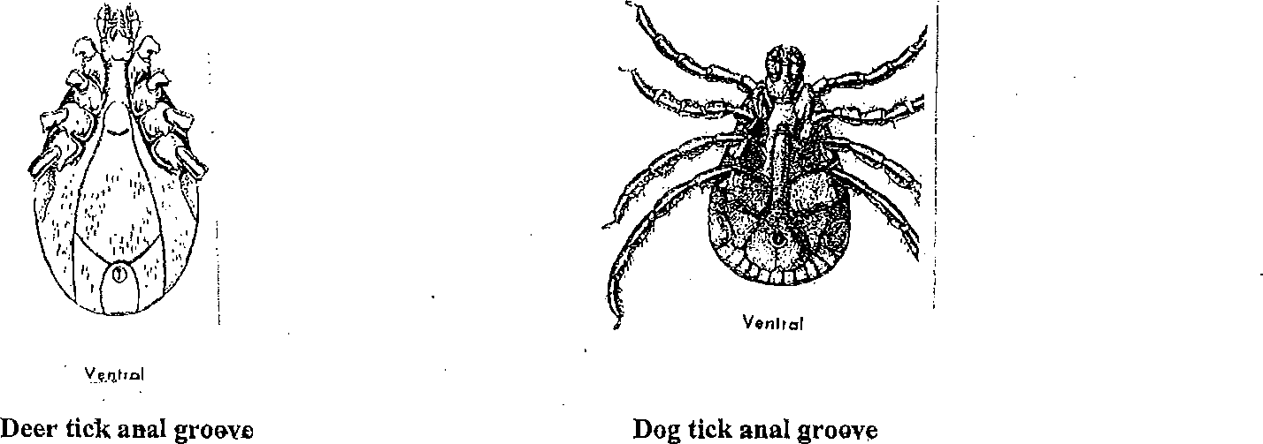

Another aspect of tick morphology that is useful in identification is the orientation of the anal grove. In the deer tick the anal groove is pronounced and curves toward the posterior end of the body. The anal groove of the dog tick is small and curves toward the anterior

The lone star tick, *Amblyomma americanum,* is another species that often attaches in both its nymphal and adult stages to humans. Although abundant in other regions of the U.S., it is not evenly distributed throughout Rhode Island.

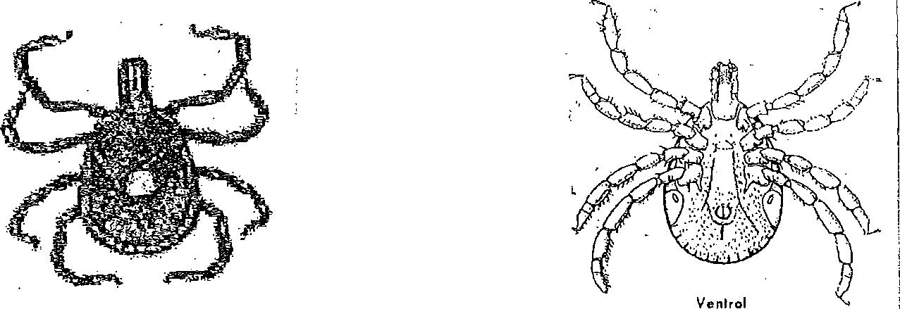

Dorsal Ventral

**Tick Troubleshooting:**

Occasionally, ticks that have not been carefully removed from patients are missing body parts that make identification more challenging.

If the body morphology resembles a deer tick but the head structures and/or genitalia are missing, the following result is suggested:

*Body morphology suggestive of a deer tick. No head structures or genitalia present to make a definitive identification.*

If the specimen appears to be a tick, but speciation is not possible, the following result is suggested:

*Body morphology suggestive of a tick. No head structures or genitalia present to definitively identify this*

*arthropod.*

If the specimen submitted is so incomplete as to make identification impossible, the following result is suggested: *Unable to identify arthropod. No head structures or genitalia present on specimen received.*

**REFERENCE:**

Beaver, Jung and Cupp, Clinical Parasitology, 9th edition. Lea and Febiger, Philadelphia

Cable, Raymond, An Illustrated Laboratory Manual of Parasitology, 5th edition, Burgess publishing Company, Minneapolis, Minnesota, 1977

IMPLEMENTATION Date

|  |  |  |  |
| --- | --- | --- | --- |
| Author | Christine Long, MT |  | 10/15/2015 |
| Supervisor Approval | Olga De Jesus, MT, HT |  | 10/16/2015 |
| Director Approval | Dr. Dongfen Chen, Chief of Staff , Acting |  | 10/16/2015 |

***REVIEW***

Supervisor Name Signature Date

|  |  |  |
| --- | --- | --- |
| Olga De Jesus |  | 10/16/2015 |
|  |  |  |
|  |  |  |
|  |  |  |
|  |  |  |
|  |  |  |

***REVISIONS***

|  |
| --- |
| Description: New Procedure written |
| Author: Christine Long |
| Supervisor approval: |
| Director Approval (major revisions only): |
| New Procedure Number: PROC.ANC.007v1.0 |

|  |
| --- |
| Description: Added Surgical Pathology sample processing, dermatology consult note is added in patient chart, record microscope maintenance on the KOH QC and Maintenance Log. 10/16/2015 |
| Author: Olga De Jesus 10/16/2015 |
| Supervisor approval: |
| Director Approval (major revisions only): |
| New Procedure Number: |
| Description: Added result entry to a CPRS Progress Note Title – Scabies and no longer in a Dermatology note. CE will be performing maintenance on microscopes. Training/competency. |
| Author: William S. Cheves 4/22/16 |
| Supervisor approval: William S. Cheves 4/22/16 |
| Director Approval (major revisions only): Dr. Dongfen Chen 4/22/16 |
| New Procedure Number: PROC.ANC.007.v2.0 |
| Description: |
| Author: |
| Supervisor approval: |
| Director Approval (major revisions only): |
| New Procedure Number: |