Hello, Linda @ VA Wilkes-Barre, PA | My Account | Support | Logout
Manage:

First Name

Last Name

Email / Username

Password

Group Settings

Group name

Assignments Due Date

Open the calendar popup.
<< | < | July 2017 | > | <<

 | S | M | T | W | T | F | S
26 | 25 | 26 | 27 | 28 | 29 | 30 | 1
27 | 2 | 3 | 4 | 5 | 6 | 7 | 8
28 | 9 | 10 | 11 | 12 | 13 | 14 | 15
29 | 16 | 17 | 18 | 19 | 20 | 21 | 22
30 | 23 | 24 | 25 | 26 | 27 | 28 | 29
31 | 30 | 31 | 1 | 2 | 3 | 4 | 5

Program

Administrators

Competency Test

Coaguchek XS Plus INR Meter

Teresa Achey
Score: 100% Reset Score
Test Date: 5/5/2017 1:26:11 PM

1 | The code chip contains information about the ...  Lot Number  Test Method  Expiration Date  All of the above  Answer required | 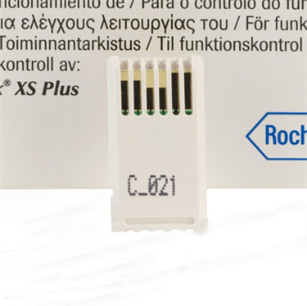 | Explanation  The code chip contains information the meter needs to perform the coagulation test. The chip contains information about the lot number, test method and expiration date. the code chip must match the code on the test strip container.
2 | Apply the blood sample to the target area of the test strip within ______ of sticking the fingertip.  15 Seconds  1 minute  30 seconds  5 minutes  Answer required | 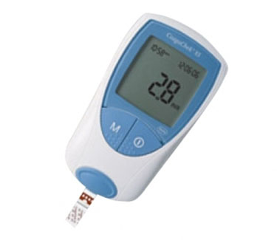 | Explanation  The blood sample must be added to the test strip within 15 seconds of sticking the fingertip. The test strip must be inserted into the instrument before adding the sample.

3 | Which end of the test strip is inserted into the Coaguchek XS Plus Meter?  A  B  Either  Answer required |  | 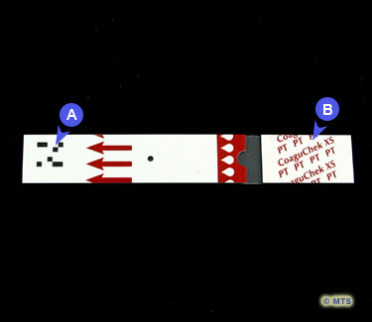 |  |  | Explanation  The end with the arrows (A in the image) is inserted into the instrument. Hold the test strip at the end labeled B in the image.
4 |  | How are the test strips stored?  Refrigerated 2-8 C  Room Temperature 2-30C  Frozen  With the lid off  Answer required |  |  | Explanation  The test strips are stored at room temperature 2-30C.

5 | If you obtain an INR Result 5.0 or greater, what should you do?  Nothing  Repeat using a new finger stick  Call the ambulance  Answer required |  | Explanation  Any INR result 5.0 or greater must be repeated using anew finger stick.
6 | If you get a result of <0.8 or >8.0 on the INR meter what do you do?  Nothing  Report to Pharmacist a reading of 0.8 or 8.0  Repeat the test using a new finger stick and report to the Pharmacist the (<) or (>) message. Follow instructions from the Pharmacists.  Get a new meter  Answer required |  | Explanation  It is important to always relay the < or > sign to the Pharmacists. Treatment is different for an INR of 8 and >8.0.

7 | When should you perform the finger stick on the patient?  As soon as the patient enters the room  When you put the strip in the meter  After the 180 sec countdown begins on the meter  Answer required |  | Explanation  You should wait until the meter countdown begins before performing the finger stick. this will allow you to dose the meter within 15 seconds of performing the finger stick,.
8 | Controls are to be run on the 1st of every month or the next working day afer.  True  False  Answer required |  | Explanation  The controls lock-out on the 1st of every month. Controls cannot be run prior to the 1st of the month as lock-out will still occur on the 1st.

9 | The Coaguchek XS Plus meter should be cleaned with hospital approved wipes after each use  True  False  Answer required |  |  | Explanation  The Coaguchek XS Plus meters are considered a RME (reusable medical equipment) and must be cleaned after each use with hospital approved wipes.
10 |  | The Coaguchek XS Plus Meter measures blood clotting time for patients that are taking anticoagulation medications such as Coumadin and Warfarin  True  False  Answer required |  |  |  | Explanation  NOTE: The Coaguchek XS Plus Meter may NOT be used for patients being treated with any direct thrombin inhibitor.

