2 | What component is highlighted?  Objective  Oculars  Tube  Turret  Condenser  Answer required |  |  |  | Flip  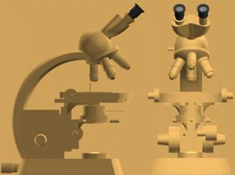 |  |  |  |  |  | Explanation  The oculars, or eye pieces, of the microscope are highlighted. On standard binocular microscopes, there are two oculars, one for each eye. Oculars magnify the primary image formed by the objective lens and project it onto your retina, allowing you to see a greatly enlarged virtual image of the specimen you are studying
3 | What component is highlighted?  Objective  Tube  Turret  Field aperture  Condenser  Answer required |  |  |  |  | Flip  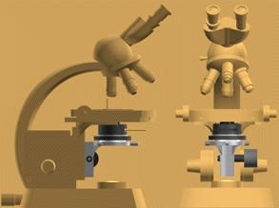 |  |  |  |  | Explanation  The sub-stage condenser is highlighted here. The condenser is second in importance only to the objective lens, in terms of resolving power of the microscope. Basically, the condenser acts as a “light pump” to focus light onto the specimen. The condenser and objective lens contribute equally to resolution, and ideally the NAs of these two components are matched
7 |  |  | Which of the following is the best method for aligning the microscope and illuminating the specimens?  Abbé illumination  Aperture illumiation  Aperture matching  Quartz-halogen illumination  Köhler illumination  Answer required |  |  |  |  |  | 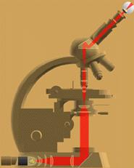  Illuminating Rays  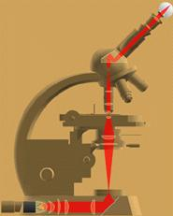  Image- forming rays | Explanation  The most common method of illuminating microscope specimens was introduced by August Köhler in the 1890s, and the technique is named for him. The goal of Köhler illumination is to provide uniform, intense, high angle illumination across the image plane. Learning how to set up Köhler illumination is an important part of learning
8 |  | Which of the following components is involved in the most steps when aligning Köhler illumination?  The condenser  The stage  The objective  The oculars  The field diaphragm  Answer required |  |  |  |  | Flip  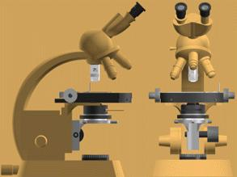 |  |  |  | Explanation  Most of the steps involved in aligning Köhler illumiation are carried out at or below the microscope stage, and many of them involve the condenser. Illuminating the specimen properly allows the objective lens to be used to full advantage in extracting all the information it is capable of from the specimen.
12 |  |  |  | What is the first thing you should suspect if you are using a microscope and the image quality suddenly deteriorates from that seen in A to that seen in B?  Dirty oculars  Inadequate objective NA  Dirty objective  Condenser diaphragm misadjusted  Poor specimen  Answer required |  |  |  | Flip     |  |  | Explanation  A dirty objective lens is the most common cause of rapid deterioration of image quality. This may be caused by dragging a dry objective through immersion oil, getting a fingerprint on an objective, or an accumulation of dust on the lens surface. Proper cleaning technique can restore image quality, but it is always best to keep objective lenses clean in the first place

