Safety Message | When possible, set up your work station to be ergonomically correct for your body specifications.

Purpose or Principle or Introduction | This procedure provides instructions for the phlebotomist on the proper use and setup of the Chaparral blood draw stations.

Scope | This procedure is intended for all users.

Policy | - This procedure must be followed prior to performing any phlebotomy procedure.  - Phlebotomy procedure must be performed standing up.

Safety or Special Safety Precautions | Refer to the safety manual for general safety requirements for phlebotomy procedure.

Procedure | Follow the steps below to
 | Step | Action
 | 1 | Adjust the phlebotomy table to your height and comfort. Adjust the chair height up or down for the patient’s arm to lie flat on the phlebotomy table
 | 2 | Adjust the computer monitor and keyboard height
 | 3 | Loosen the knob that locks the monitor in place and turn counter-clockwise  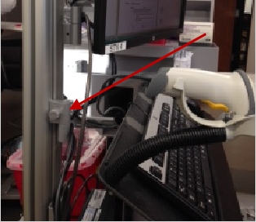
 | 4 | Slightly lift the monitor up as you are applying pressure, to move either up or down.  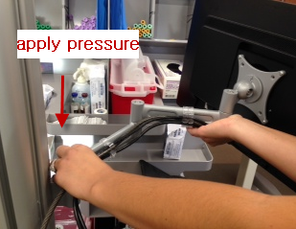
 | 5 | Tighten knob to lock monitor/keyboard in place.

Author | Eleanor Ilagan, CLS, ASCP,

Distribution | - Carson Medical Office Laboratory  - Coastline MOB Laboratory  - Gardena MOB Laboratory  - Long Beach MOB Laboratory  - Normandie North MOB Laboratory  - Torrance MOB Laboratory

Document History Page
Effective Date: 12/02/2013

Change type: New, Major, Minor etc. | Changes Made to SOP – describe | Signature responsible person/date | Med. Dir. Reviewed/ Date | Lab Manager reviewed/ date | Date change implemented
New

