**EQC Handout for CLS (Excerpts from Beckman EQC Handbook; revised for Kaiser LAMC use only)**

1. **Visualizing / reviewing**
   1. ***Result EQC flags in Remisol***

Results in Remisol are displayed with a little flag icon next to them, flags indicating the EQC status for the last collected result for the parameter:



White: no protocol defined / no datavailable Green: No mistake

Yellow: Protocol in warning or Time-out Red: Protocol in error or blocked result

When you double click on one of these flags, you will get an indication of the protocol that actually affected the last collected result for the parameter; it may show both a material flag and a patient flag:

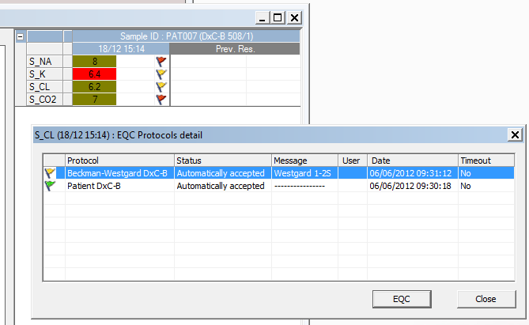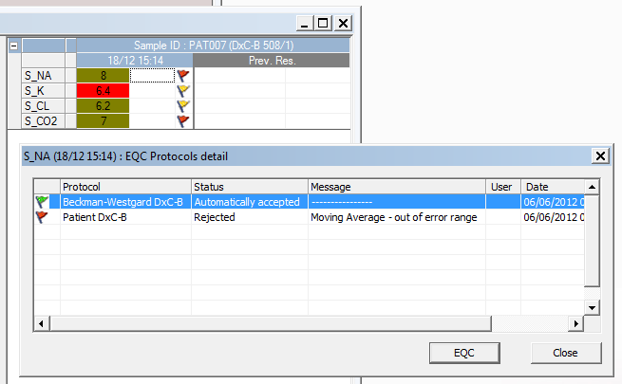

Page 1

* 1. ***Visualizing / reviewing collected data***

***Through the QC Explorer***

On opening EQC, the first thing the user will see is a new button:



It opens the **QC explorer** window:

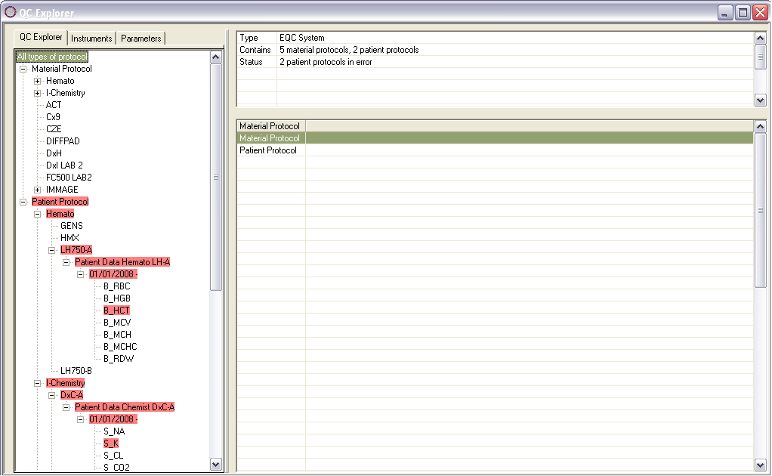

Page 2

From this window, the user can visualize all the information recorded in EQC. The left panel is devoted to a tree view which displays the same information in 3 different ways for each one of the tabs at the top of the panel:

The **Protocols** tab lists the information by:

* Type of protocol, Material or Patient,
* Group of instruments, if any, and / or instruments, in alphabetical order,
* Name of the protocol attached to the (group of) instrument(s),
* Period available for the protocol,
* Parameter(s) attached to the protocol.

The **Instruments** tab lists the information by:

* Instrument, regardless of any group,
* Name of the protocol ,
* Period available for the protocol,
* Parameter(s) attached to the protocol.

The **Parameters** tab list the information by:

* Parameter
* Instrument,
* Protocol name,
* Period available for the protocol,
* Parameter(s) attached to the protocol.



Note: EQC only displays current (i.e. active) lots and periods.

The status of the last collected result for a parameter will also be highlighted in the tree view from the type of protocol,

the type of instrument,

the instrument,

the protocol,

the period,

down to the parameter,

by the color code that can be found in the **Results by Parameters**:



On selection of a parameter in the tree view in the left panel, further information is provided for this parameter, results collected in the successive runs as well as an graphical history whose options may be modified and that gets updated once you click on the **OK button**:

Page 3

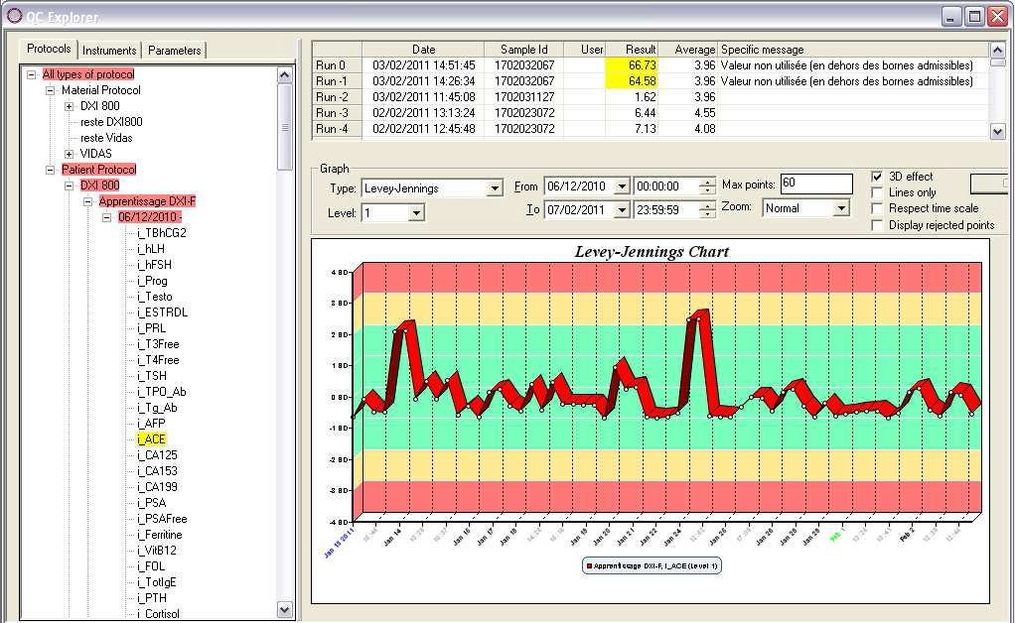

*QC Explorer improvements*

When upgrading, the conversion of date to this new format / style will slightly extend the optimization process at the beginning but this is a one-off.

From Remisol Advance 1.6, the lot information is displayed along the period item, for example, 12/02/2011- (lot: 587297):

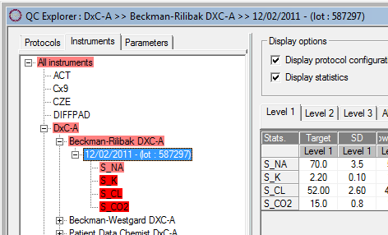

Please also notice how the information is also recalled in the title bar (this avoids scrolling).

Also, the Remisol screen styling, where we have 1 line for 1 parameter, that can now be found in the **Results by run** window (please refer to the dedicated section below), has been made available in the ***QC Explorer*** window too thus providing a more synthetic & lisible screen:

Page 4

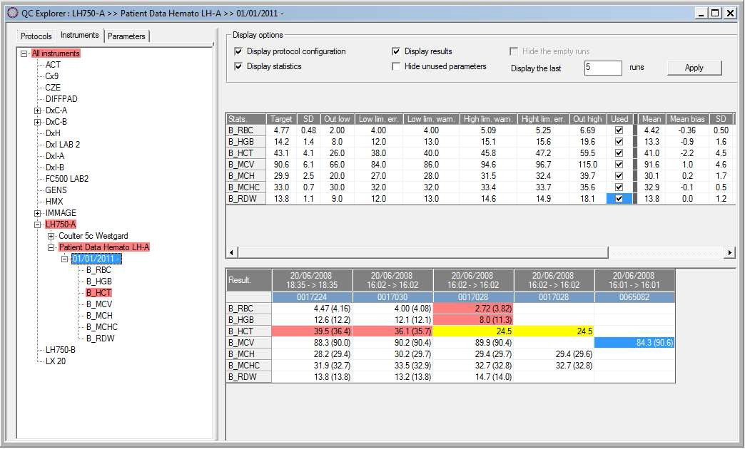

***Through the various windows allowing result review***

For both QC Patient / QC Material protocols, collected results can be accessed via: the QC Patient / QC Material > Results by Parameter menu:

The list of result values that were collected is presented per protocol, period, and parameter; where Run0 is stands for the latest collected value.

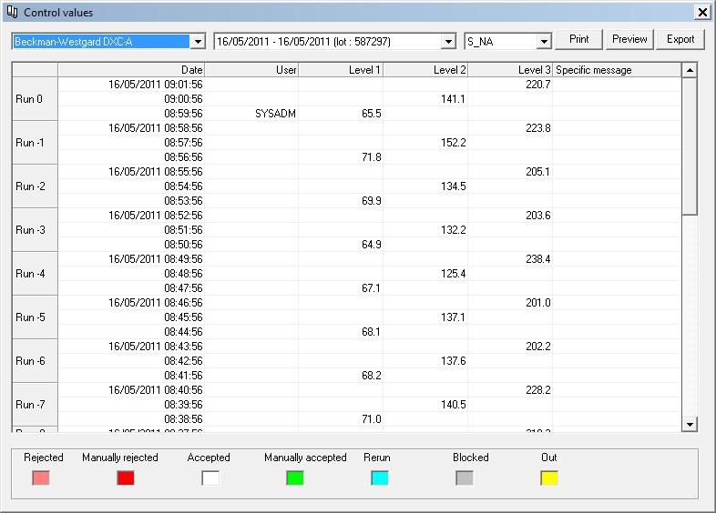

In addition to a review of the **Print** button, 2 new buttons we added to this screen: **Preview** & **Export**.

The **Print** button was reviewed; previously, clicking on the button displayed a preview straightaway.

Now, clicking on the button will display a filter allowing a choice between:

The currently selected parameter or all of the parameters in **Parameter filter**,

Page 5

Only points in error or All points in Status filter.

This explains why a **Preview** button was created to display the previous preview screen.

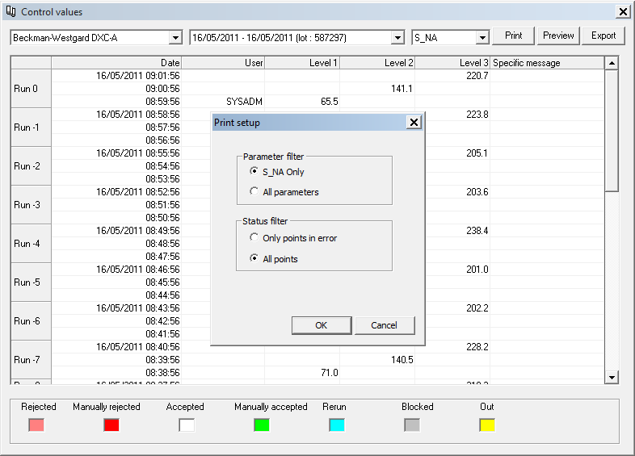

Also an export button was created so that the user may export the data currently displayed in this screen. Please refer to the ***Export Results*** section below for further details.

the QC Patient / QC Material > Results by run menu:

The list of result values that were collected is presented per protocol, period, and runs; where Run0 is stands for the latest collected value, with a reminder of the values defined in the protocol and some statistics.

1.6window: 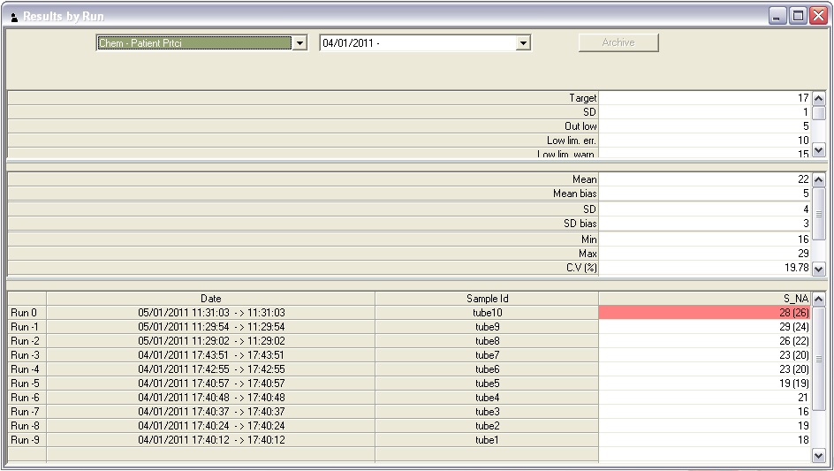

Page 6

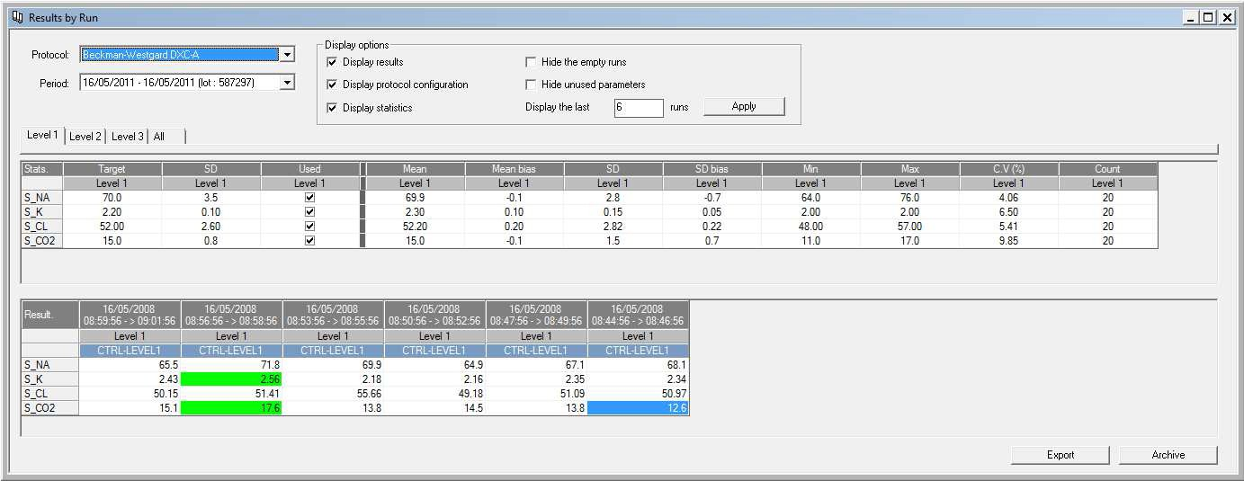

The data loaded in this window is not a dynamic calculation anymore; everything is drawn from the database (meaning it is recorded there) which brings an improvement on the overall reactivity & load time of the EQC module; the idea behind this presentation of the data is inspired by the Remisol screen styling where 1 line is dedicated to 1 parameter.

the QC Patient / QC Material > Last collected results menu:

The list of the latest 200 result values that were collected is presented per protocol, period, and parameter; where Run0 is stands for the latest collected value.

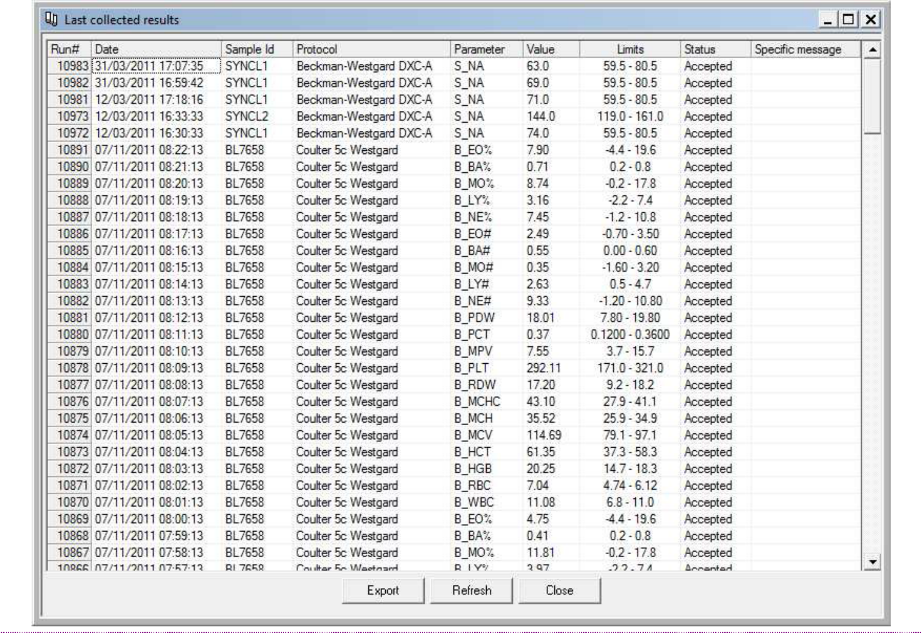

Page 7

Please note be aware a result which triggered a warning is merely displayed in white in the Last collected results.

This window is resizable now, which avoids scrolling horizontally to see all the information. the QC Patient / QC Material > Statistics menu:

Statistics are calculated from the result values that were collected and are presented by protocol and period.

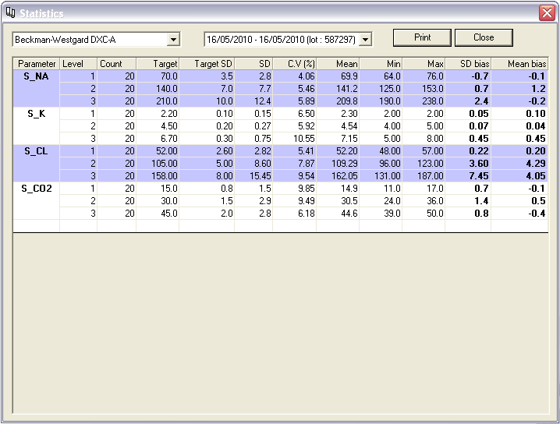

the QC Patient / QC Material > Date to date statistics menu:

Statistics can be computed from the result values that were collected and will be presented by protocol and date to date.

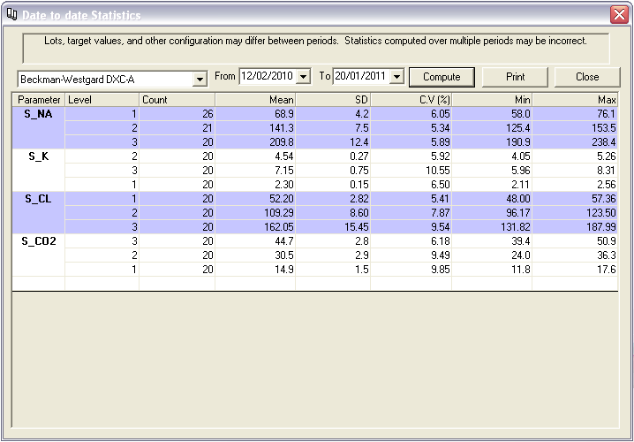

Page 8

* 1. ***Visualizing / reviewing EQC warning and error messages & unblocking***

The reviewing of EQC warning and error messages is done in 2 stages:

 First, the review of messages in EQC and Remisol

     Second, if actions, **Stop validation** and / or **Stop instr. Download** or **Stop param. Download**, were set up for particular rules, these actions need to be unblocked.

***Visual alerts***

When there is not blocked result, we should have the following visual indications:

|  |  |
| --- | --- |
| **In EQC** | **In Remisol Advance** |
|  |  |

As EQC collects a result set up to trigger a message and / or an action; a message is displayed in EQC and Remisol (as defined in the **Setup** > **QC Message Filter Setup** menu precisely; please refer to the *Filtering EQC messages* above section)

When a collected result is blocked by EQC, these visuals indications will turn:

|  |  |
| --- | --- |
| **In EQC** | **In Remisol Advance** |
|  |  |

Messages may be closed by the user but the above alerts remain until a user with appropriate rights comes along to unlock EQC.

In addition, if the EQC blocked, through the protocol rules, the programming or the parameter validation, the instrument LED will turn orange instead of the normal dark green yet it continues blinking the normal bright green colour when communicating with the instrument.



Note: If there is a communication error with the instrument, the led will turn red as this is the priority display in such case.

In case an instrument filter was setup (please refer to the *Filtering the displayed instruments in EQC* above section), be aware EQC may trigger a message that is not relevant to the instruments currently filtered, in which case an indication of such a situation will be displayed by such a warning in Remisol

|  |  |
| --- | --- |
| **In EQC** | **In Remisol Advance** |
|  |  |

Page 9

***EQC messages***

The different messages are:

**Warning**: EQC will simply display a warning message when a collected result break the warning rule set up for the protocol; this will not block EQC:

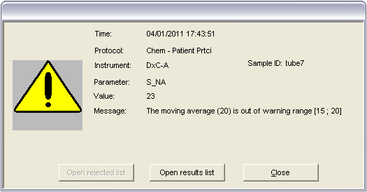

Simultaneously, a message is also displayed in EQC’s Event Log window:

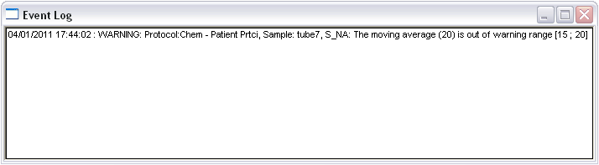

The same warning message will also be displayed in the Remisol Advance interface so that the user is aware of what is happening in EQC running in the background:

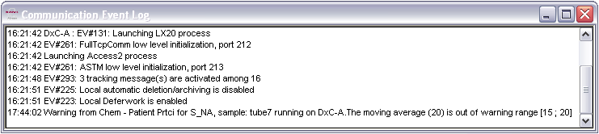

Page 10

**Error**: EQC will display an error message when a result is collected and it breaks the error rule set up for the protocol; this will block EQC:

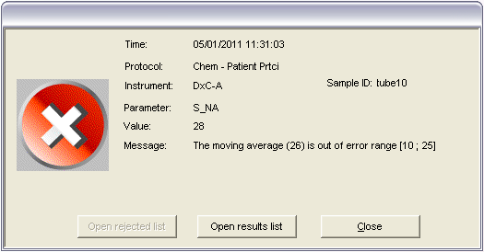

Simultaneously, a message is also displayed in the EQC’s **Event Log** window:

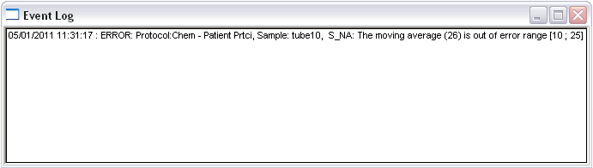

The same error message will also be displayed in the Remisol Advance interface so that the user is aware of what is happening in EQC running in the background:

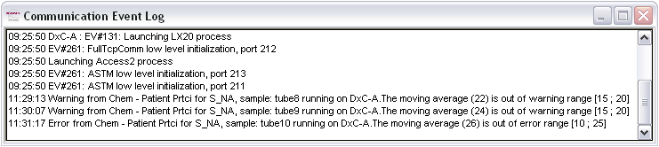

In addition, a **Quality control Message** popup window is displayed so the user does not miss the information, either they can acknowledge the message by clicking on the tick button or switching to EQC by clicking on the EQC button (another option would be to click on the EQC button in the toolbar)

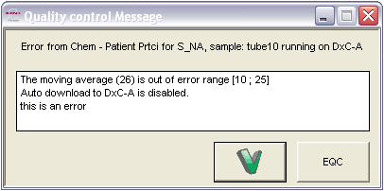

Page 11

***Managing blocked results***

Once one of the above message described above appears on screen, a user with appropriate rights (**Clear EQC blocking** in **Environment** > **Users Setup** > **Access Rights**) should come to EQC and unblock the results so that whatever action that was set up, download or validation, may resume.

Indeed a user may close all the messages by closing the message windows by clicking the  or Close buttons both in EQC and in Remisol yet these visual indications will remain until the situation is unblocked in EQC:



|  |  |
| --- | --- |
| **In EQC** | **In Remisol Advance** |
|  |  |



You have to unblock a result blocked by EQC in EQC.

If necessary switch from Remisol to EQC by clicking:

On the EQC button in the Remisol tool bar,

On the EQC button in the Quality control Message.

Once in EQC, you may access to the 2 relevant windows here in 2 different ways:

Either by clicking the **Open rejected list** button in the error message (greyed out in the warning message) or directly via the **CQ Material** > **Error Points** menu.

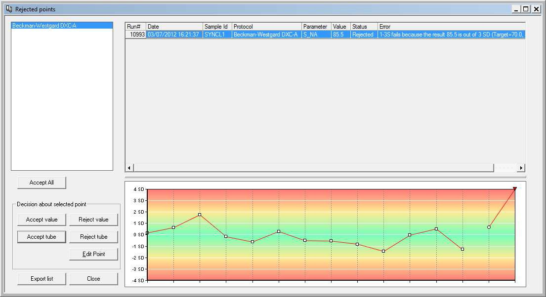

Note: These 2 options are not available in the QC Patient: the **Open rejected list** button is greyed out in both warning and error message windows; furthermore there is no menu to access error points.

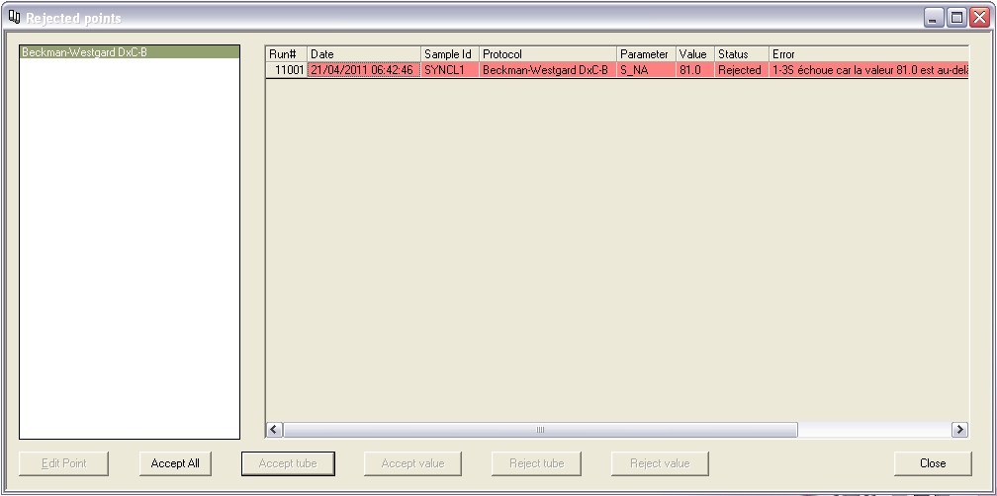

Page 12

This window was reviewed to display a graph showing the last collected point / result, the furthest on the right; it allows visualizing its position in regards with the previous points to be able to make a decision on whether to accept / reject it in light of accurate information.

In this window, by selecting the result, it is possible to:

* **Edit point**: you may edit the result and add a comment:

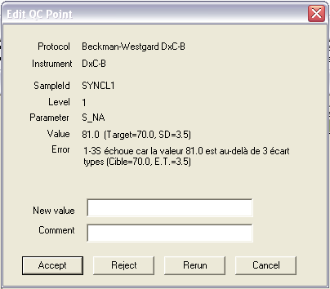

In this **Edit QC Point** window, you can still **Reject** the collected value or even **Rerun** the sample,

* Accept All: the current value is accepted as well as all the following values.
* Accept tube: only the sample is accepted,
* Accept value: Only the numerical value is accepted for this parameter,
* Reject tube: the whole of the sample is rejected,
* Reject value: only the value is rejected here

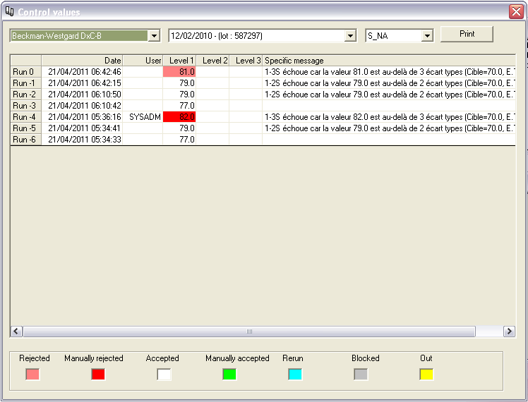

Page 13

Collected results are hereby visible by Protocol, Period and Parameter where Run 0 stands for the most recent run; these results are color-coded based on the code provided underneath.

**Note**: we are only talking about numerical values here; if a result is a non-numerical value, it will have to be reviewed by the user. Should you sue the **Accept All** option, all the numerical values will be deleted up to the point where there is a non-numerical value, which will stop the acceptation of subsequent numerical values.

Or by clicking on the **Open results list** in the warning or error message or directly through the **QC Patient** / **QC Material** > **Results by Parameters** menu to open the **Control values** window:

***Unblocking rule actions in Remisol Advance***

Reviewing and acting on the EQC warning and error messages is not sufficient when actions were set up for particular rules; once messages have been reviewed, it is also necessary to unblock these actions; this is done in Remisol Advance by clicking on the “Stop” button > **Blocking Status** window

> **By EQC** tab (the window titles changes to **Validation Blocking**):

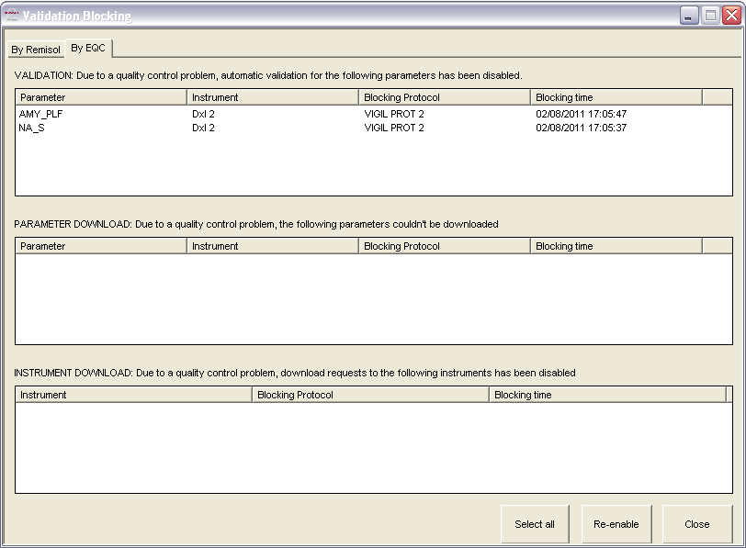

Depending on the action(s) defined for rules, select the blocked action(s) in the adequate field(s),

**VALIDATION**, **PARAMETER DOWNLOAD** or **INSTRUMENT DOWNLOAD**, and click the

**Re-enable** button to unblock the action(s).

:

Page 14