**Validation for “Unable to Calculate” on 24 Hour Urines**

24 Hour Urine Electrolytes (DXC800#1 MP):

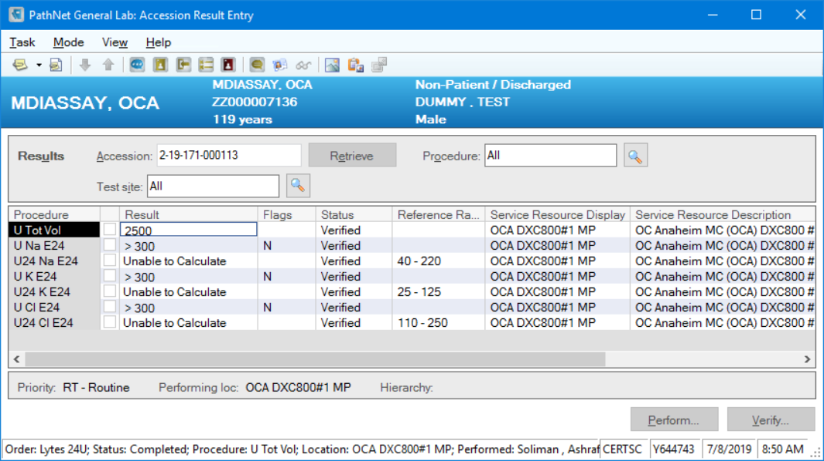

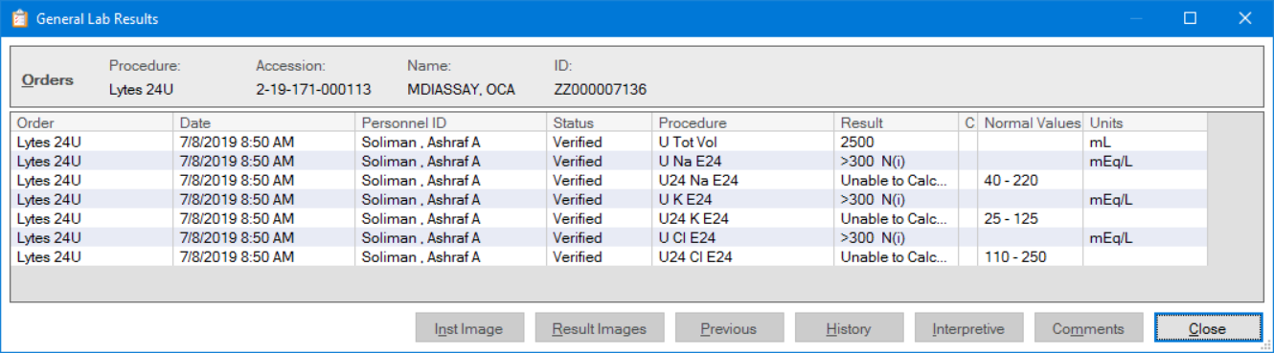

24 Hour Urine Creatinine (DXC800#1 MP):

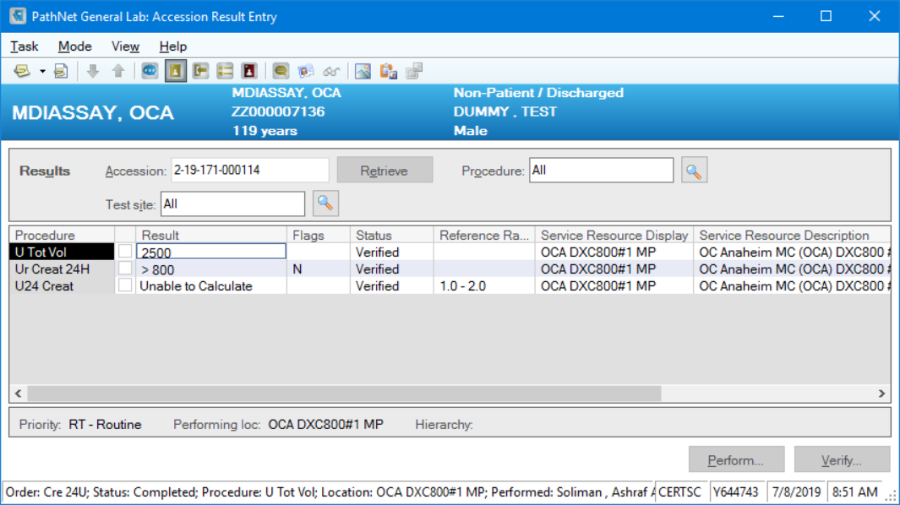

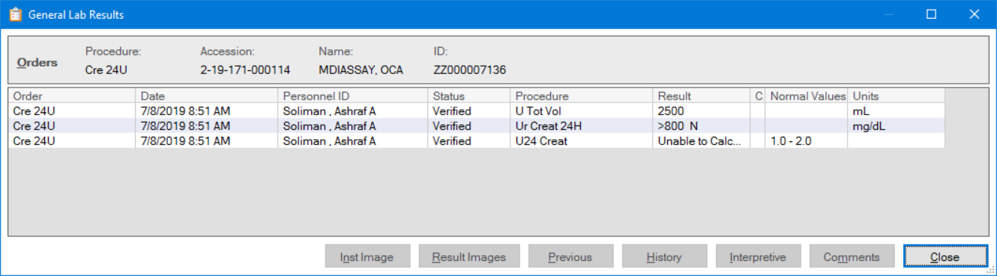

24 Hour Urine Creatinine Clearance (DXC800#1 MP):

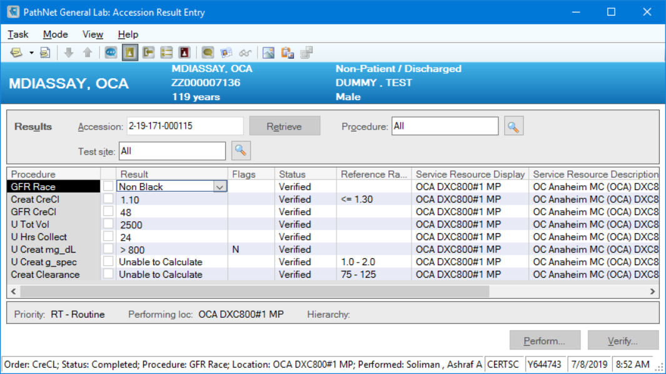

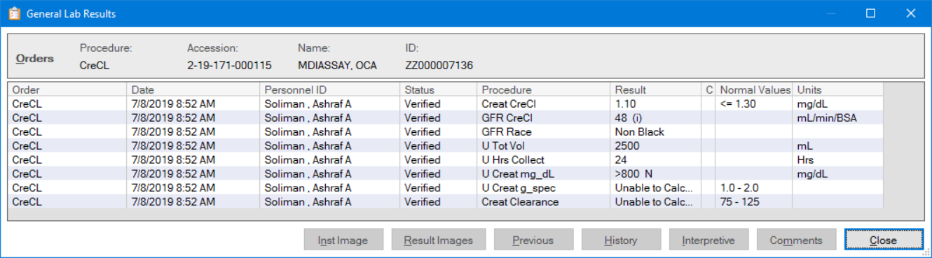

24 Hour Urine Electrolytes (DxC800#2 MP):

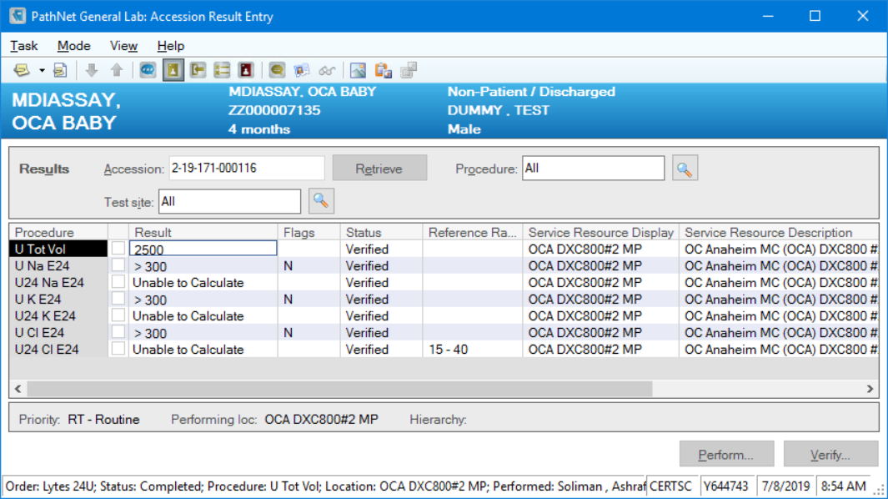

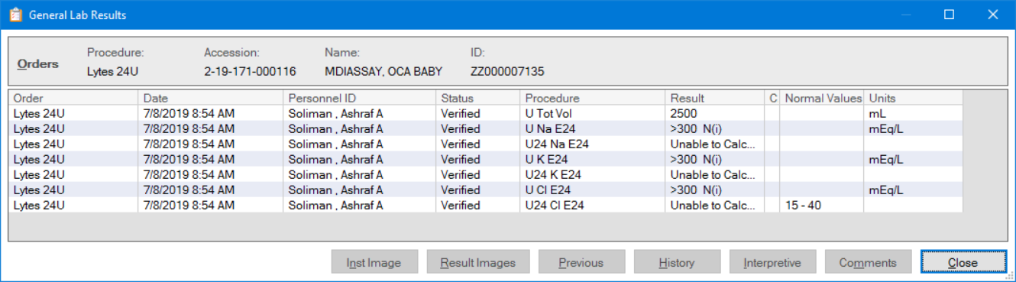

24 Hour Urine Creatinine (DxC800#2 MP):

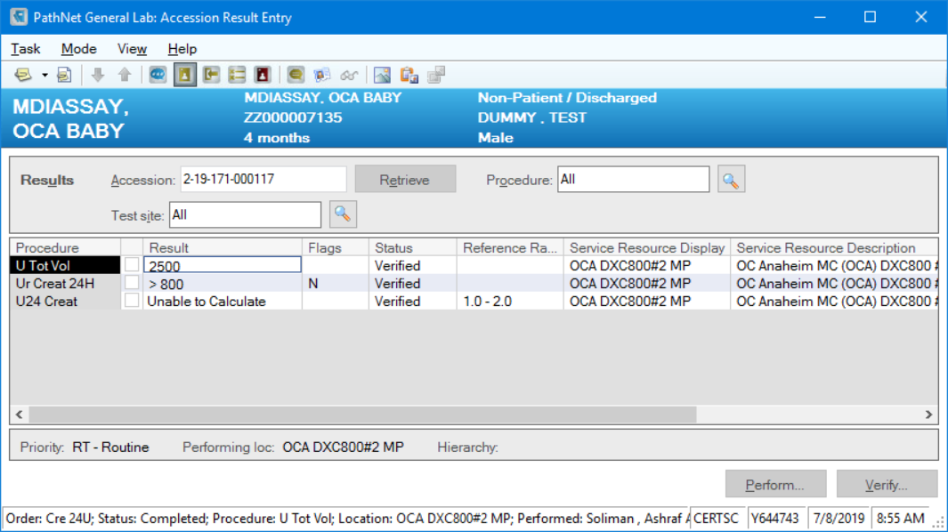

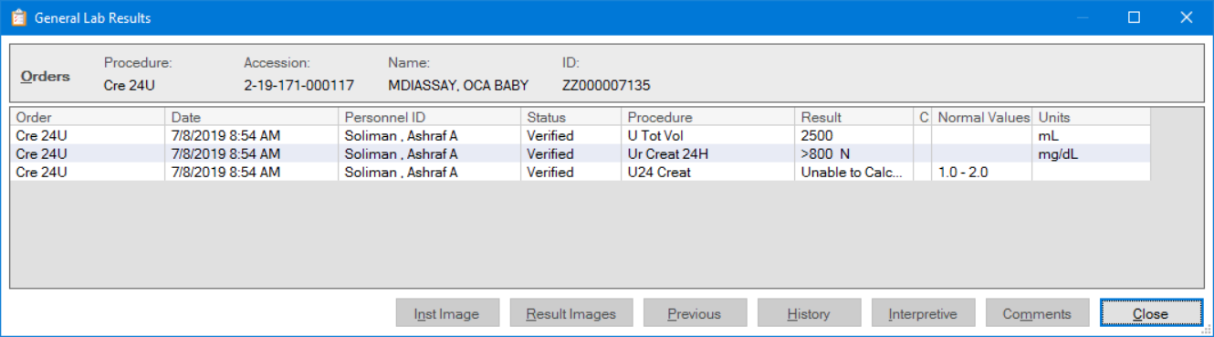

24 Hour Urine Creatinine Clearance (DxC800#2 MP):

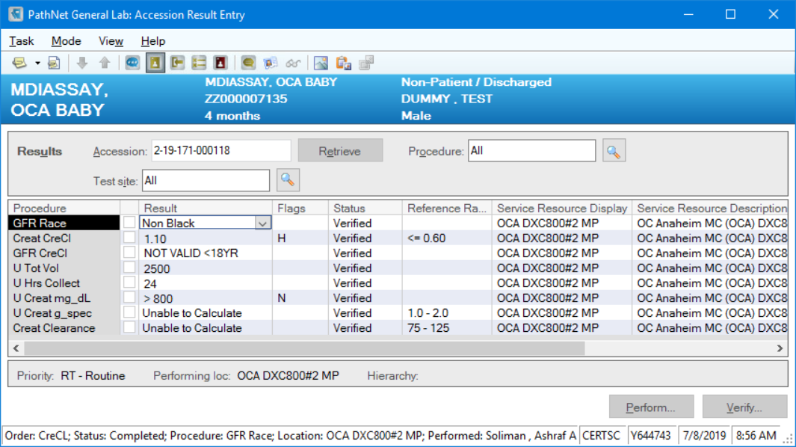

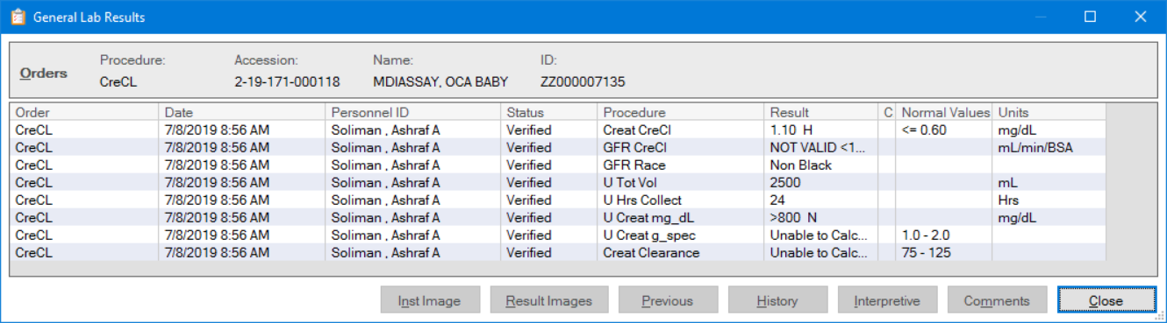

OCA Accessioned Tests (OCA Remisol #1 MP ss)

24 Hour Urine Electrolytes:

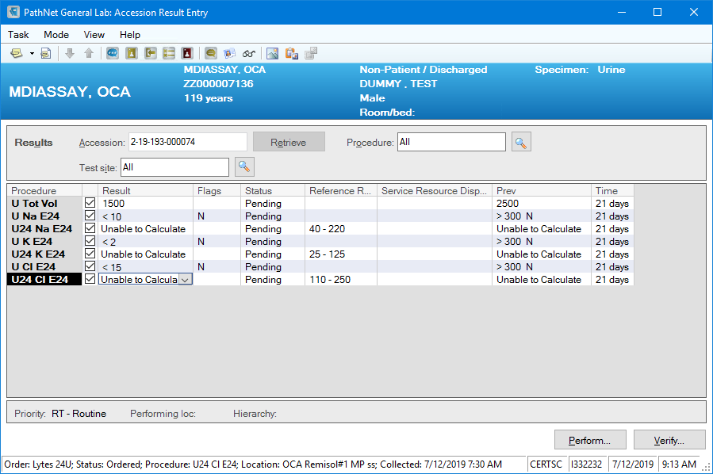

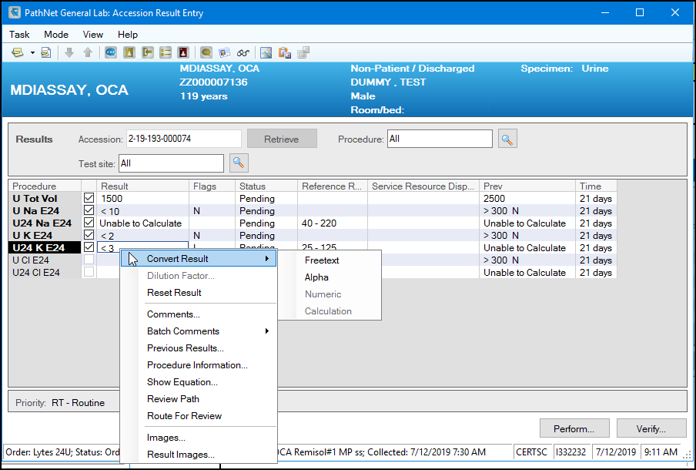

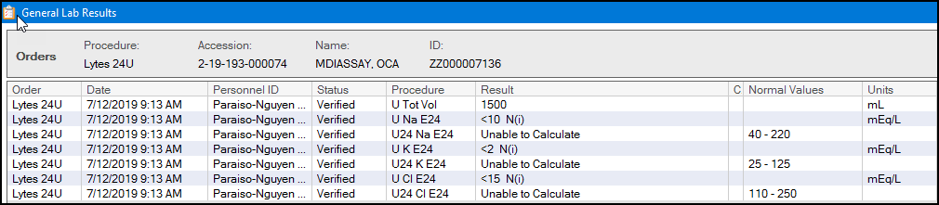

24 Hour Urine Creatinine:

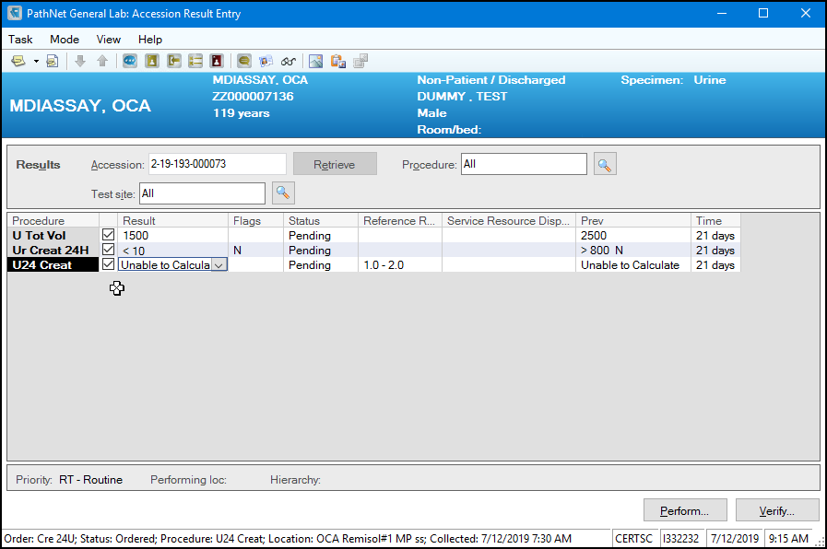

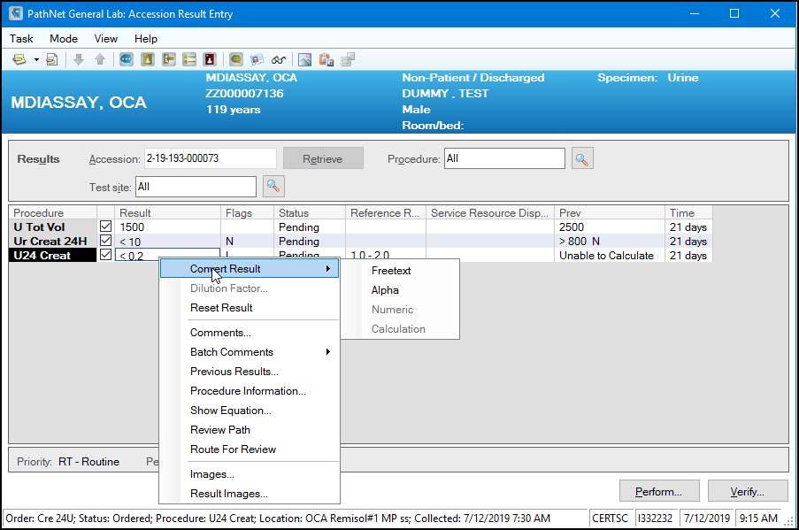

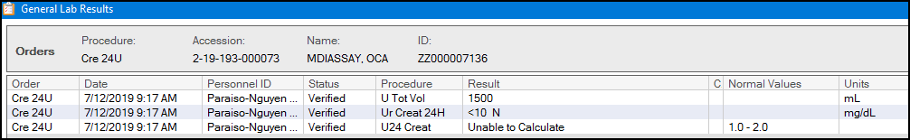

Creatinine Clearance:

