**Correction of Laboratory Records Mandatory**

Employee Name: __________________________ Date Completed: ____________

The following is the CAP requirement for correction of laboratory records.

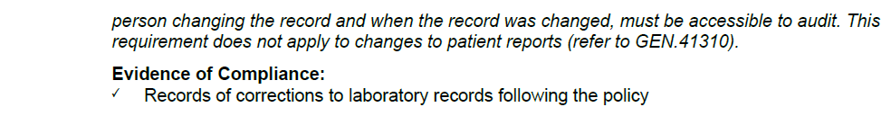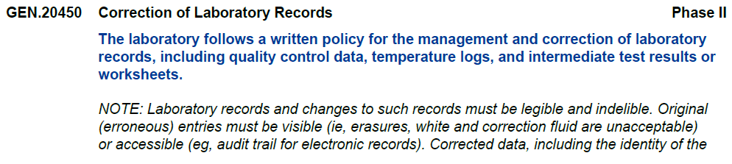

Beaumont Dearborn, Taylor, Trenton, and Wayne Laboratory uses the policy Correction of Laboratory Records PolicyStat # 6741889 to direct all staff on correction of laboratory records. All managers are required to review logs monthly. The following is taken from this Procedure:

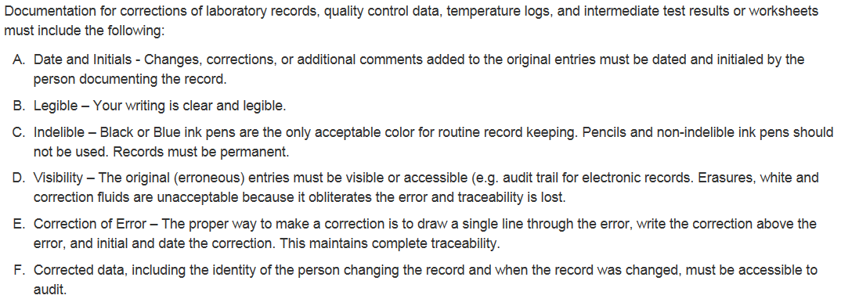

Answer ***True or False*** for the following questions regarding the CAP requirement and Beaumont’s policy.

1. The use of white out on laboratory documents is permissible. **TRUE** or **FALSE**
2. When correcting a laboratory document after writing a number 6 instead of 7, the staff member should draw a single line through the 6, add initials, date and write the number 7.

**TRUE** or **FALSE**

1. Ditto marks can be used when the same data will be recorded. **TRUE** or **FALSE**
2. Only blue or black pens can be used for laboratory documents. **TRUE** or **FALSE**