**Trace Element Tubes (Royal Blue top tube)**

There are two types of trace element tubes, both have Royal blue caps

**EDTA additive**

* This additive allows the blood to remain in the tube as whole blood
* Royal blue EDTA tubes have a lavender label

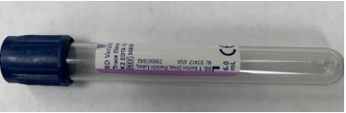

**No additive**

* With no additive in the tube, the blood will separate into RBCs and serum
* Royal blue top tubes with no additive have a red label

