**2021 Hematology Competency**

1. Which is true about the Coulter controls open vial stability?
2. Coulter 6C 16 days, Coulter Retic-X 14 days and Latron CP-X 30 days
3. Coulter 6C 16 days, Coulter Retic-X 16 days and Latron CP-X 16 days
4. **Latron CP-X 30 days, Coulter Retic-X 16 days and Coulter 6C 16 days**
5. When replacing a new lot of Retic Pack reagent in the DxH800 instrument, what do you need to

perform?

1. **Run Daily checks/background checks and test Level 1 of Retic Control or previously tested patient. Review and print results and File QC in DxH Reagent Change binder**
2. Run daily Checks/background checks only. Review and print results and file in DxH Reagent change binder
3. Scan the new Retic Pack information on the Setup DxH supplies dialog box and use the reagent for patient testing.

Explanation: For Diluent and Diff Pack run daily checks and background check should be given as your QC. For Retic Pack, test 1 level of the Retic controls.

1. What are the parameters that are affected when you run a hemolyzed CBC sample?
2. Hgb, Hct, MCH and Platelet
3. **RBC, Hgb, MCHC, Platelet and MPV**
4. RBC, Hgb, Hct and WBC

Explanation: RBC, Hgb, MCHC, Platelet and MPV. Cancel as hemolyzed. If redraw is

Hemolyzed, consider as in vivo.

1. In Cell location, a result of ____ % or greater must be obtained for passing?
2. 95%
3. 90%
4. **97%**

Explanation: A result of 97% must be obtained. If the result is less than 97%, re-clean the objectives with isopropyl alcohol and repeat the QC.

1. For preparing a slide for manual differential, a good slide smear should meet the following criteria, except?
2. **Should have a homogenous spread from thick to thin areas, with no waves, streaks, troughs, holes, or bubbles**
3. Should cover at almost full length of the glass slide.
4. Should terminate in a straight or very slightly curved feathered end.
5. If the Post Vasectomy semen received more than 60 minutes, but less than 2 hours after collection. What do you do with the specimen?
6. **Perform the testing and note the age of specimen as a result comment.**
7. Do not analyzed the specimen and notify the ordering provider
8. Cancel the test as “Stability exceeded”. No call needed
9. Stool WBC slide preparation is performed within _____ of receipt of the stool in the laboratory and stored _______ until they can be processed.
10. 8 hours; Room temp
11. **4 hours; Refrigerated**
12. 2 hours; Refrigerated

1. For Alcor iSED ESR Analyzer, Deep Clean Procedure is performed when?
2. Perform Daily prior running controls
3. **Perform Monthly and when the analyzer prompts the user to perform Deep Clean**
4. Only when clotted specimen is aspirated by the instrument
5. When do you perform external quality control for Alere Determine HIV-1/2 Ag/Ab Combo.
6. Each day of use
7. Whenever a new shipment of test kits is received
8. **Both a and b**
9. What do you use to standardize the polarizing microscope for crystal examination?
10. **Known positive slide**
11. Know negative slide
12. Blank slide
13. XB Batch Analysis: If one batch out of limits but no shift or trend is noted. What action should be taken?
14. **Run Quality control and if controls are in limits, continue to operate but monitor each XB batch.**
15. Do not use the instrument and call Beckman Coulter Tech support for service
16. Delete the batch
17. What tube number do you use for CSF cell count and to set up cultures?
18. Tube #1 for cell count and #2 for cultures
19. **Tube #3 for cell count and tube #1 for cultures**
20. Tube #2 for both cell count and cultures
21. Calculate the cell count results: The specimen counted undiluted, and the CLS counted TNC chamber 1 = 495 and chamber 2 = 535 and the number of squares counted 4 large WBC squares. What is the total TNC cell count result?
22. **TNC count 2575/uL**
23. TNC count 575/uL
24. TNC count 515/uL
25. Body Fluid differential is not indicated when the count is:
26. *<* 5 white blood cells are present
27. Specimen contains more than 5 white blood cells
28. < 1 white blood cells are present
29. Body Fluid calculation: Specimen was diluted 1:5, loaded into both counting

chambers of the hemacytometer, and the average count of 425 nucleated cells in 4 large squares. What is the TNC cell count?

1. 531
2. 1062
3. 5312
4. If a bloody CSF received in the lab, what solution do you use for diluting the specimen?
5. DI water
6. Sterile saline
7. NERL water
8. All statements are true except for:
9. If count was performed on a dilution, multiply the average count from both chambers by 1.1 (if 9 squares counted) and by the dilution factor.
10. One small WBC square can be counted and multiply the count by 16, is equivalent to 1 large square
11. Five small RBC squares can be counted and multiply the count by 5, is equivalent to 1 large RBC square
12. If a BAL specimen cannot be processed immediately, how many hours is allowed to keep the specimen in the refrigerator.
13. 8 hours
14. 4 hours
15. 2 hours
16. For processing Urine smear, centrifuge 8mL of fresh, well mixed urine at ___________.
17. 3000 rpm for 5 minutes
18. 3000 rpm for 3 minutes
19. 1000 rpm for 6 minutes
20. How do you prepare Malaria Binax Now Negative control?
21. Aliquot 100uL of EDTA whole blood sample from a 1 presumptive negative individual
22. Pool of equal volume of EDTA whole blood sample from 2-3 presumptive negative individuals
23. Use Malaria Positive Control kit
24. What is the Quality Control process in Hematology department?
25. When controls are out of range, a step by step approach must be taken to resolve the out of control results on commercial control.
26. It is the responsibility of the Clinical Laboratory Scientist assigned in the department to ensure that quality controls are run and meet the acceptable criteria prior to releasing patient results.
27. Both A and B are correct

**Blood Cell Identification**

1. 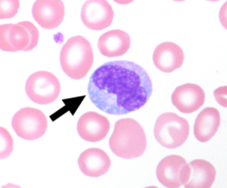
2. **Monocyte**
3. Metamyelocyte
4. Myelocyte

**Explanation:** Monocytes are slightly larger than neutrophils, ranging from 12 to 20 µm in diameter. The majority of monocytes are round with smooth edges, but some may have pseudopod-like cytoplasmic extensions. The cytoplasm is abundant, with a gray or gray-blue ground-glass appearance, and may contain vacuoles or fine, evenly distributed azurophilic granules.

1. 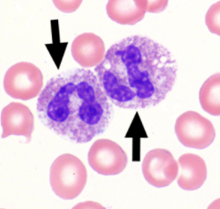
2. Neutrophils (Seg or band)
3. **Toxic Neutrophils**
4. Basophils

**Explanation:** The arrowed cells are toxic neutrophils. Toxic granulation is defined by the presence of large, purple or dark blue cytoplasmic granules in neutrophils, bands, and metamyelocytes. Toxic changes result from the action of cytokines released in response to infection, burns, trauma, and granulocyte colony stimulating factor (G-CSF).

1. 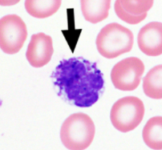
2. Toxic granulation of Neutrophil
3. Neutrophil with ingestion of bacteria
4. **Basophil**

**Explanation:** The arrowed cell is a basophil are characterized by the presence of numerous coarse and densely stained granules of varying sizes and shapes. The granules are larger than the granules of neutrophils and most are roughly spherical. The granules are typically blue-black, but some may be purple-red when stained using Wright-Giemsa preparations

1. 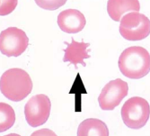
2. Echinocyte (burr cell)
3. **Acanthocyte (spur cell)**
4. Smudge cell

**Explanation:** The arrowed cell is an acanthocyte. Acanthocytes are densely stained, spheroidal red blood cells that lack central pallor and have multiple (usually three to 20), irregularly distributed, thorn-like spicules of variable size, often with drumstick ends. Spicules may occasionally have branches

1. 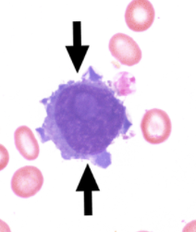
2. Plasma cell
3. Lymphocyte
4. Blast cells

Explanation: The arrowed cell is a Blast. Blasts are large, round-to-oval cells, with high nuclear-to-cytoplasmic ratios, often with large nuclei demonstrating lacy.

1. 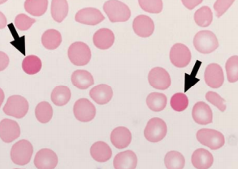
2. Spherocyte
3. Microcyte
4. Normal red blood cell

Explanation: The arrowed cells are spherocytes. Spherocytes are identified as densely staining and spherical. These cells appear denser than normal red blood cells and are commonly found in hereditary spherocytosis and immune hemolytic anemias.

1. 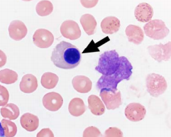
2. Lymphocyte
3. Plasma cell
4. Nucleated RBC

**Explanation:** The arrowed cell is a normal nucleated red blood cell (nRBC). The term nRBC is used to state the presence of normoblasts in the peripheral blood and includes all normoblasts regardless of the stage of maturation.

1. 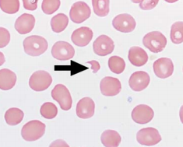
2. Schistocyte
3. Acanthocyte
4. Stomatocyte

**Explanation:** The arrowed cell is a schistocyte, a fragmented red blood cell. Fragmented red blood cells include helmet cells, keratocytes (horn cells), triangulocytes and a more inclusive term, schistocytes.

1. 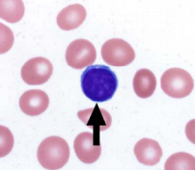
2. Nucleated RBC
3. Lymphocyte
4. Basophil

**Explanation:** The arrowed cell represents a lymphocyte. The lymphocyte is a small cell (7 to 15 μm) with rounded nuclear contours, coarse or clumped chromatin, and a scant to modest amount of pale blue cytoplasm.

1. 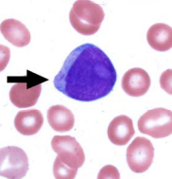
2. Myeloblast with auer rod
3. Lymphocyte
4. Monocyte

**Explanation:** The arrowed cells are myeloblasts with Auer rods. The cell and nucleus are usually round, although irregularly shaped or folded nuclei may be present. The myeloblast nucleus has a characteristically finely reticulated chromatin pattern with distinct nucleoli present.

1. 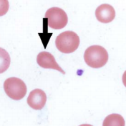
2. Ovalocyte
3. Elliptocyte
4. Teardrop (Dacrocyte)

**Explanation:** The arrowed cell is a teardrop cell. The teardrop cell (dacrocyte) is an abnormally shaped red blood cell with a single elongated, tapered tail, resulting in the shape of a teardrop or pear.

1. 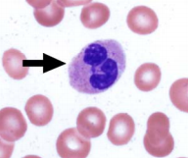
2. Neutrophil
3. Metamyelocyte
4. Eosinophil

Explanation: The arrowed cell is a neutrophil. The cytoplasm is characterized by fine, lilac/pink granulation. The nucleus shows condensed chromatin with distinct nuclear lobes, each separated by a thin filament.

Body Fluid cell Identification:

1. 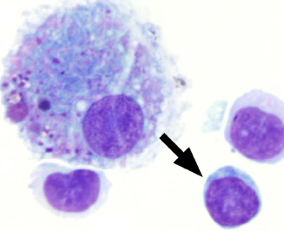Peritoneal Fluid
2. Lymphocyte
3. Nucleated RBC
4. Monocyte

**Explanation**: The arrowed cell is a lymphocyte. The cytologic features of lymphocytes in body fluids prepared by cytocentrifugation may differ from those in blood smears. Changes induced by cytocentrifugation may include cytoplasmic spreading, nuclear convolutions, and nucleolar prominence.

1. 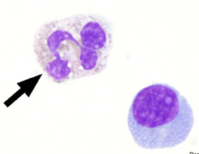Peritoneal Fluid
2. Eosinophil
3. Basophil
4. Neutrophil

Explanation: The arrowed cell is a neutrophil, segmented or band.

1. 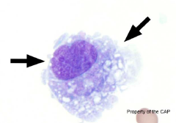Peritoneal Fluid
2. Mesothelial cell
3. Monocyte/Macrophage
4. Plasma cell

**Explanation:** The arrowed cell is a monocyte/macrophage. Monocytes are bone marrow-derived cells that circulate in the blood. Macrophages arise from bone marrow-derived cells that migrate into tissues and evolve morphologically. Monocyte/macrophage morphology in fluids is quite variable, ranging from the typical monocyte of the peripheral blood to a vacuolated, activated stage with the morphology of a typical macrophage.

1. 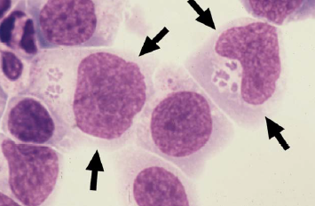CSF, Cytocentrifuge
2. Neutrophil/macrophage containing bacteria (*Ehrlichia/Anaplasma*)
3. Monocyte/macrophage
4. Lining cells

**Explanation:** The arrowed object(s) are leukocytes containing *Ehrlichia/Anaplasma* organisms or Neutrophil/Macrophage Containing Bacteria. On Wright-stained preparations, *Anaplasma* species appear as round, dark purple-stained dots or clusters of dots (morulae) in the cytoplasm of either neutrophils. Bacteria within a neutrophil or macrophage are notable for their uniform appearance, round or rod-shaped, single, diploid, or in small chains depending upon the species present. It is important to distinguish bacteria from the normal cytoplasmic granules or debris.

1. 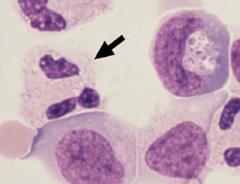 CSF, Cytocentrifuge
2. Metamyelocyte
3. Eosinophil
4. Neutrophil

**Explanation**: The arrowed object is neutrophil. The nuclear lobes appear eccentric in cytocentrifuge preparations.

1. 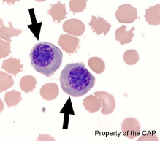Pleural Fluid
2. Erythrocytes Nucleated
3. Plasma cells
4. Lymphocytes

**Explanation:** The arrowed cells are erythrocytes, nucleated. These cells are found uncommonly in body fluids and are usually derived from peripheral blood contamination in which circulating nucleated red blood cells are present. Occasionally, they may arise from accidental aspiration of the bone marrow in an infant, or adult with osteoporosis

1. 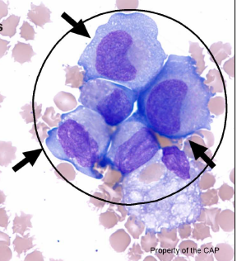Pleural Fluid
2. Mesothelial cells
3. Monocytes/Macrophages
4. Malignant cells

**Explanation:** The arrowed cells are malignant cells. Malignant cells may be numerous and clustered or appear as rare single cells. Cytologic features of malignant cells on cytocentrifuge preparations include high nuclear to cytoplasmic ratio, increased cell and nuclear size, irregularly shaped nuclei, atypical nuclear chromatin patterns, large nucleoli, and a tendency to form large clusters, frequently with nuclear molding.

1. 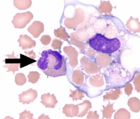Pleural Fluid
2. Eosinophil
3. Neutrophil
4. Monocyte
5. 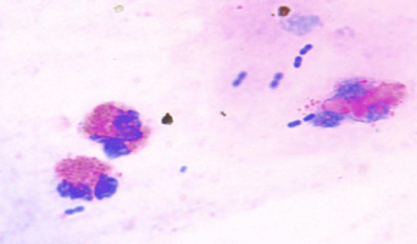Nasal Smear Eosinophil
6. Eosinophils Present
7. Eosinophils Absent

**Explanation:** Two eosinophils with bright orange-red spherical granules are seen.

1. 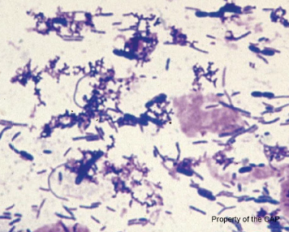 Stool Smear
2. Leukocytes Present
3. Leukocytes Absent

**Explanation:** No neutrophils are present in this stool smear which contains only bacteria.