[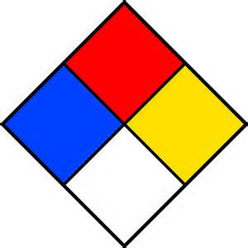](http://www.bing.com/images/search?q=nfpa+label+printable&view=detailv2&&&id=665D76307A6439A78D2A0F7CF5CF0C8F6DFE0710&selectedIndex=0&ccid=7J74H8vR&simid=608021748656114423&thid=HN.608021748656114423)

4

1 0